|  |
| --- |
| Group 1 |
| Controlled Environment Monitors |
| Design Document |

Contents

**Design Process** 5

Interpreters 6

Summarized Input from the Interpreters 6

Agricultural Side 6

Technological Side 6

Product Goals 7

Function: What do we need? 7

Estimated Cost 7

Expected Volume of production 7

Design Specifications 8

Conceptual Designs 10

Enclosure 10

Evaluation of the conceptual designs 12

Flow Charts 13

Evaluation of the Flow Charts 15

Circuit Block Diagrams 16

Evaluation of The Circuit Block Diagrams 17

**Manufacture** 18

Sensor Unit Manufacture 19

Sensor Unit Enclosure 19

Top Cover 20

Bottom Cover 22

Battery Cover 24

Battery Lock 26

Sensor Unit PCB Manufacture 27

Bill of Materials for PCB 27

Bill of Materials - Non-PCB Components 27

Circuit Schematics 28

Hierarchical view 28

Battery Level Sensor 29

Power Regulator 29

Processor 29

Circuit Layout 30

Display Unit Manufacture 38

Display Unit Enclosure 38

Components 39

Top Cover 39

Bottom Cover 41

Battery Cover 43

Display Unit PCB Manufacture 45

Bill of Materials 45

External Component Bill of Materials 45

Circuit Schematics 47

Hierarchical View 47

Alarm Unit 48

Battery Indicator 48

RF communication 48

Power regulator 49

Processor 49

Circuit Layout 50

**Testing** 56

Sensor Unit PCB Testing 57

Display Unit PCB Testing 60

**Assembly** 63

Sensor Unit Assembly 64

Assembly Steps 64

Display Unit Assembly 65

Assembly Steps 65

Processor Code 66

Sensor Unit Code 72

LCD CODE 73

**Usage** 75

Basics 76

Product View 76

Overview 76

Key Features 76

Getting Started 77

Location 77

Setting up 77

Installing the sensor unit 77

Installing the display unit 78

Battery Performance 78

Getting to know your product 79

Sensor Unit 79

Display Unit 80

Using the product 82

Sensor Unit 82

Display Unit 82

**Servicing** 84

Display Unit 85

Tools 85

Warning 85

Disassembly and Repair 86

Replacing the Battery 86

Part Location 86

Procedure 86

Opening the Display Unit 86

Closing the Display Unit 87

Replacing the LCD 87

Part Location 87

Procedure 87

Replacing the Keypad 87

Part Location 87

Procedure 87

Replacing the Buzzer 88

Part Location 88

Procedure 88

Replacing the SD Card Reader 88

Part Location 88

Procedure 88

Replacing the Switch / LEDs 89

Part Location 89

Procedure 89

Replacing Printed Circuit Board 89

Part Location Procedure 89

Sensor Unit 90

Parts and Procedures 90

Tools 90

Warning 90

Disassembly and Repair 91

Replacing the Battery 91

Part Location 91

Procedure 91

Accessing Internal Components 91

Replacing the Humidity Sensor / Light Sensor 92

Part Location 92

Procedure 92

Replacing the Switch / LED 92

Part Location 92

Procedure 92

Replacing Printed Circuit Board 93

Part Location 93

Procedure 93

Exploded Views 94

Exploded View 95

**Datasheets** 96

|  |
| --- |
| Group 1 |
| Controlled Environment Monitors |
| **Design Process** |

# Interpreters

1. Mr. Buddhika Dassanayake (Curator – University of Wayamba)
2. Prof. J.A.K.S. Jayasinghe (Senior Professor – ENTC, University of Moratuwa)
3. Prof. Gamini Pushpakumara (Dean – Faculty of Agriculture, University of Peradeinya) (Department of Crop Sciences)
4. Dasun Tharinda (Communication Consultant)
5. AdaFruit (Suppliers – Waterproof Temperature and RH Sensor Modules)

# Summarized Input from the Interpreters

## Agricultural Side

Mr. Buddhika Dassanayake

* Temperature and relative humidity are the main factors to be controlled/monitored
* Propagators are used to keep the temperature above the outside temperature
* No standard temperatures have been published for different plants grown in propagators
* Usually the propagators are designed to main a temperature above the environment temperature (> 37 0C)
* High temperature (Around 45 0C) is an issue in the dry zone as it has high probability that the plants may be burnt
* Need two thresholds: High and low temperature thresholds to maintain the plants in the optimum range of temperature
* Propagators are designed to maintain around 100% relative humidity
* A lower threshold should be set (around 80%) to detect whether the RF goes below that
* No fertilizer is added to the plants in a propagator

Prof. Gamini Pushpakumara

* Light is also an important parameter
* No need to monitor the soil moisture level or soil temperature, because if the air humidity and temperature is sufficient, the soil conditions will also be ideal.
* Currently there are systems to control the light systems, using sensors and automatic openings.
* The type of covering depends on the plant being grown.
* The CO2 level does not need to be monitored during the time the plant is in the propagator.

## Technological Side

Prof. J A K S Jayasinghe

* With the set up used in the dry zone areas, need portability for the product
* Battery powered sensors, display unit and alarm unit
* The thresholds (RH and the temperature) needs to be set manually by the farmer
* Either 3 sensors per propagator or a sensor per propagator should be installed and as per the installation plan the temperature values and RH values should be displayed in the display
* Wireless Communication between the modules need to there
* Modular Design is required
* Waterproofed sensors/ a mechanism to easily remove and install the sensors should be there
* An Alarm and a light should be used to alert the farmer about any of the factors exceeding the thresholds
* Mechanism to record the data sampled on hourly basis for the two weeks’ time of the plant in the propagator should be present
* Better if the scalability is there even for a bigger greenhouse for monitoring and controlling system

Mr Dasun Tharinda

* Near field communication for sensors - All sensors need to communicate only with the display unit
* Far field communication / storage needed only for the central display unit

# Product Goals

## Function: What do we need?

A product to read the temperature and the humidity inside an outdoor propagator and display on a LCD screen and store the data on a SD card on an hourly basis. Further, based on two separate thresholds, an alarm should be triggered when those thresholds are exceeded.

The product comprises of three main components:

1. **Sensor Unit**: A unit with humidity, temperature and light sensor that is battery powered and transmits the data to the Display Unit
2. **Display Unit**: A battery powered unit with display, removable storage, a key pad and communicating capabilities with the sensors
3. **Alarm Unit**: A unit with a light and a buzzer that will be triggered when the temperature and/or humidity goes beyond the corresponding thresholds

## Estimated Cost

The cost of the product will be approximately 2500 including 3 sensor units, main display unit and alarming unit. The profit will be a 20% margin of this. (Selling price = LKR 3000)

## Expected Volume of production

5000 products per annum for 5 years. 100 units to be produced during the initial trial period of 6 months

# Design Specifications

Performance:

1. Sensing and displaying the temperature with an accuracy around $± 2 ℃$ and humidity with an accuracy $± 3\%$ and light level inside the propagator at the corresponding locations of the propagator
2. Storing the temperature, humidity and light data hourly during the day on a SD card that can be removed
3. Alarming the farmer when the temperature exceeds its threshold or humidity, or light goes below the threshold to take necessary actions.
4. Battery powered with the ability to operate a minimum of 1-day duration by one battery
5. Three Sensor units being enough to accurately represent the temperature, humidity and light level distribution of the propagator

Impact from the environment

1. The sensor units should be waterproofed
2. Anti-rusting
3. Should not interact with any chemicals used for the plants in the propagator as fertilizer
4. Should be able to operate at a moderate range of temperature from $10℃$ to $60℃$
5. Damages from the farmers due to the negligence when using the sensors and Display Unit
6. RF communication between the Display Unit and the sensors should not be susceptible to the interference

Impact on the environment

1. Device is made of non-toxic materials
2. Micro particles occur from the wearing and tearing will not alter the controlled environmental factors inside the propagator
3. No poisonous by-products
4. Minimum wastage during the production

Lifetime

1. The Display Unit and the alarming unit should last a minimum of 2 years while the sensors are to last a minimum of 1 years.
2. The product should ideally last the duration of three cultivations of plants

Maintenance

1. The batteries should be replaced when the indicators display a charge of 5%
2. Modular components. Burned out or broken parts are easily replaceable
3. Zero Day to Day maintenance
4. It should not require a maintenance for more than 2 weeks
5. One technical person who is aware about the product will be needed to maintain the product

Production Cost

1. Maximum cost per sensing unit LKR 530: Max cost of sensing units per product LKR 1650
2. Maximum cost per Display Unit LKR 850

Package, Size and Weight

1. One package will include 3 sensor units, a Display Unit and an alarming unit

* Sensor Units: 3 x 1.5 x 2 inches 200g
* Display Unit: 5 x 6 x 3 inches 500g

1. No packaging needed post installation

**Appearance and Finish**

1. Able to input thresholds manually using the keypad
2. The temperature, humidity and light values for each sensor in a propagator should be displayed separately on the LCD screen
3. The battery level is indicated using few levels with three different colors of LEDs (eg:- Red – 2% to 20%, Green – 20% to 100%)

**Types of material**

1. Plastic
2. Acrylic
3. Wood

Reliability/ Accuracy

1. 6 sigma Standard failure rate 1 in a million

Safety

1. Surge Protection
2. Waterproofed sensor and Display Units
3. Accurate Battery Level indicator

Installation

1. Can be installed during or after the construction of the propagator
2. Can be scaled down to smaller propagators that read values using one sensor unit only
3. Extendable even to the mass scale Green House production
4. Do not require expertise knowledge for installation
5. Installation cost is free of charge
6. Less than 1-man hours to set up the product per propagator

Operations

1. Autonomous in sensing and displaying the temperature and humidity values inside the propagator
2. Saving the logs in the main frame is manual i.e. the SD card need to be removed and read manually in the computer to save the data in the main frame
3. The LCD screen will be switched off automatically after 5 min and can be switched on using a button

Reuse

1. Modular design that makes it easily removable for use elsewhere

Disposal

1. E waste centers
2. None of the components are classified as hazardous waste

Recycling

1. 80% recyclable

# Conceptual Designs

## Enclosure

Conceptual Design 01

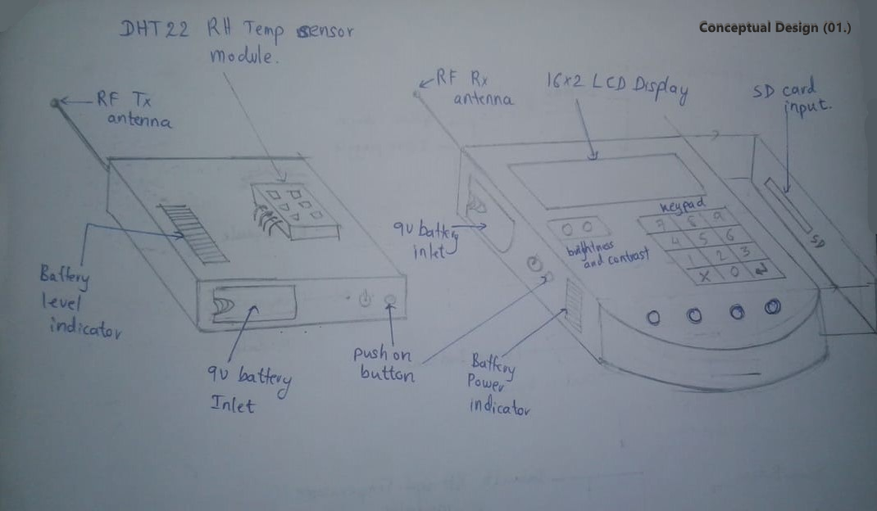

Conceptual Design 02 - Sensor Module

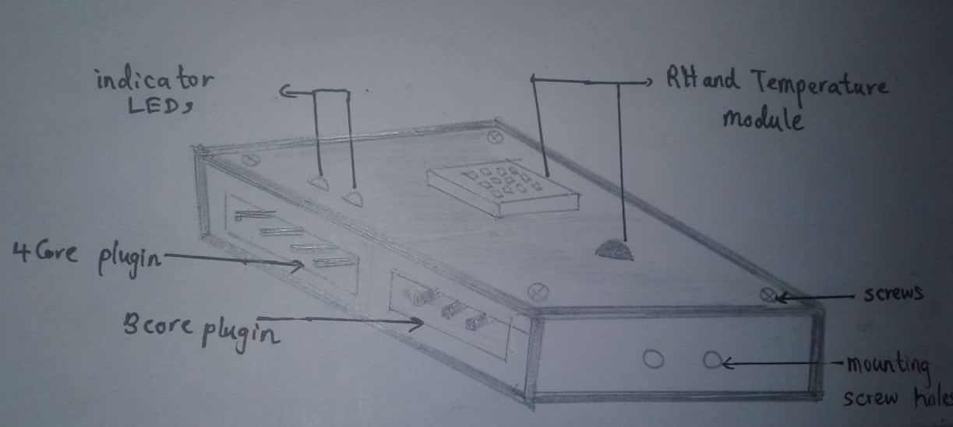

Conceptual Design 02 – Display Module

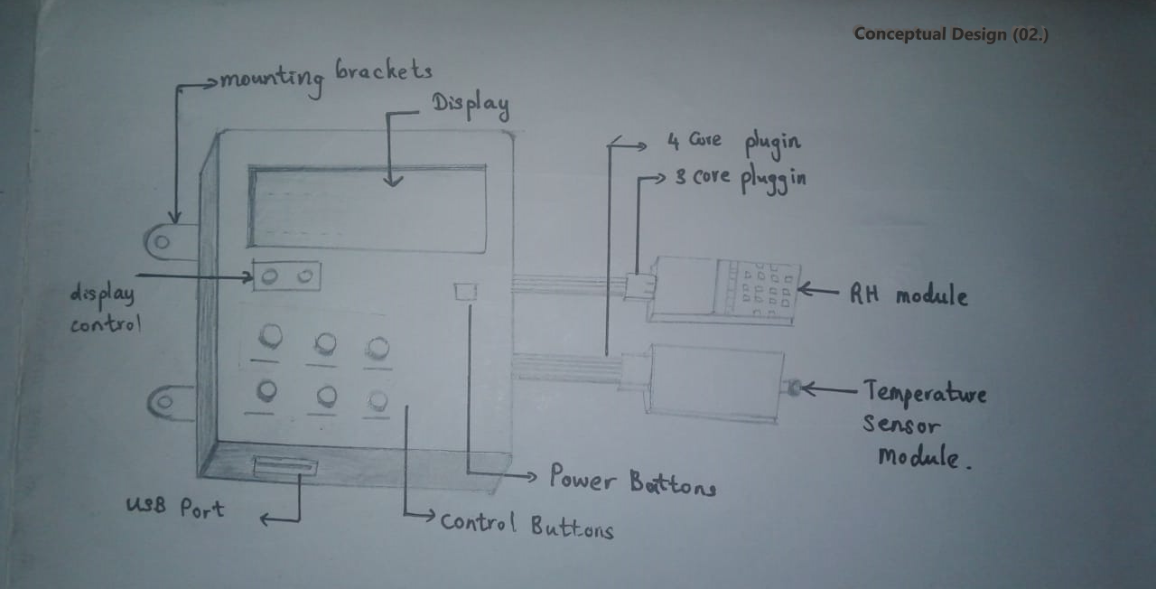

Conceptual Design 03

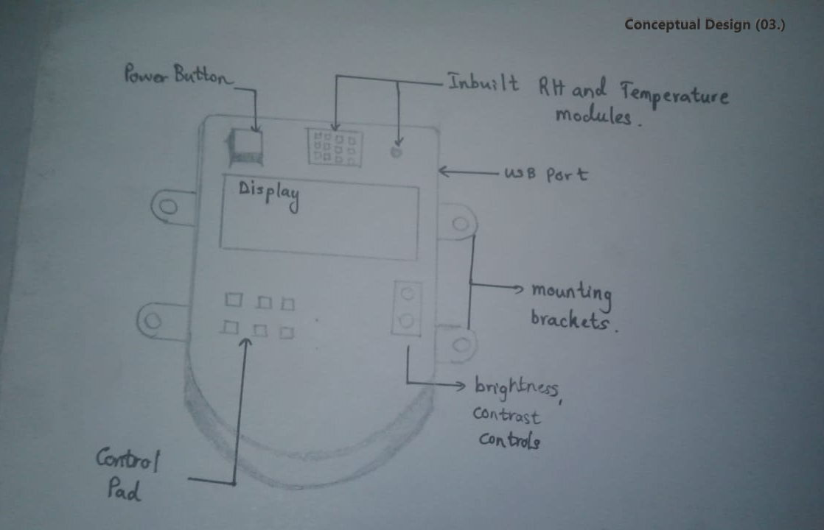

## Evaluation of the conceptual designs

|  |  |  |
| --- | --- | --- |
| **Enclosure** | **Advantages** | **Disadvantages** |
| 01 | * The sensor units and Display Units are portable (both are battery powered) * Wireless communication hence less bulky in wiring * Can input the threshold values manually using the key pad of the Display Unit * Can detect the battery charge level using the indicator * The Display Unit can be installed further from the propagator due to wireless communication * Installation and maintenance is easy | * The data can be erroneous due to certain interferences caused by other frequencies * Batteries need to be replaced on a daily basis/ more bulky and expensive batteries need to used * Communication Latency can be high * If multiple propagators are located nearby, occurrence of errors can be high due to interferences |
| 02 | * Wire Connections between the sensors, alarm and the display unit hence the latency is less * Less susceptible to the interferences * More accurate performance in temperature and humidity reading and displaying and alarming | * Bulky as more wires need to be installed * The Display Unit needs to be located very close to the propagator * External power should be given which makes the portability an issue * No SD card slot – hence the computer to store the values should be closer to the propagator * More electronic components (for example, a step-down transformer, rectifier) is needed as external power is being used * Costly installation |
| 03 | * All in one unit – Less manufacturing cost * Sensor unit, Display Unit and alarm should be installed within the propagator * Can read and store the temperature and humidity values directly from the unit on to a computer using the USB cable | * The damages that can occur due to the negligence of farmers can occur frequently * High cost to be undertaken to safeguard them against the chemicals, water and fire * No SD card slot – hence the computer to store the values should be closer to the propagator * Not a modular design – If a part is burnt the whole product needs to be replaced. * More electronic components (for example, a step-down transformer, rectifier) is needed as external power is being used |

Conclusion:

Since our product is to sense the temperature, humidity and light level in an outdoor propagator, and that the pros outweighs the cons, we choose the Conceptual Design (01.) as our design to proceed the project.

## Flow Charts

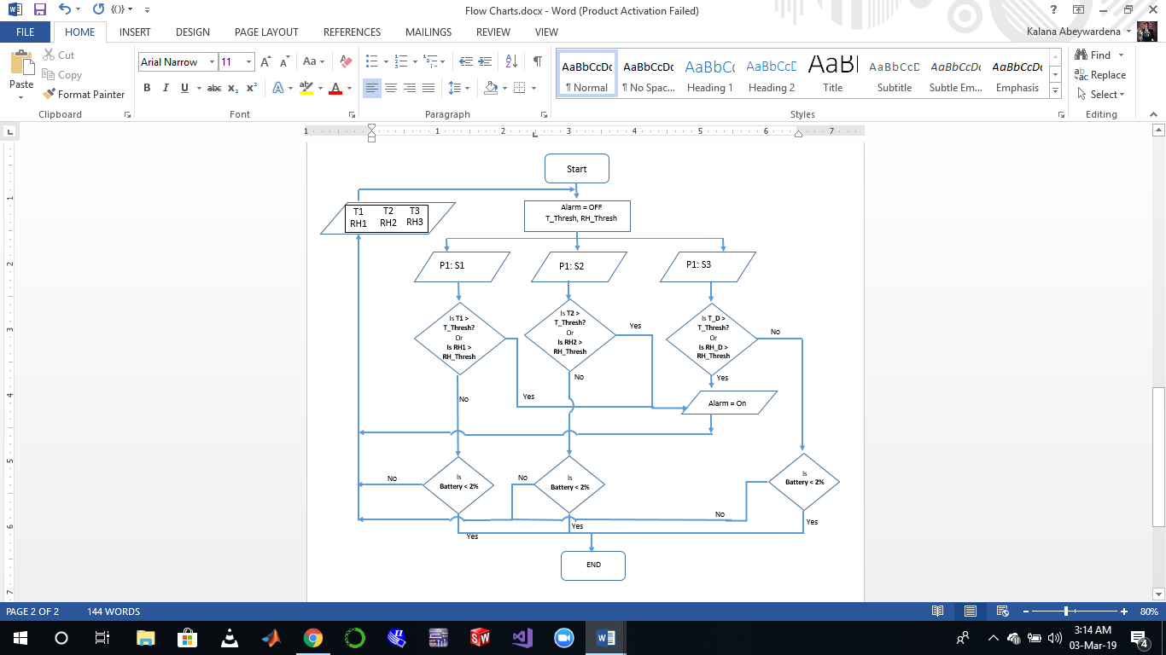**Flow Chart 01**

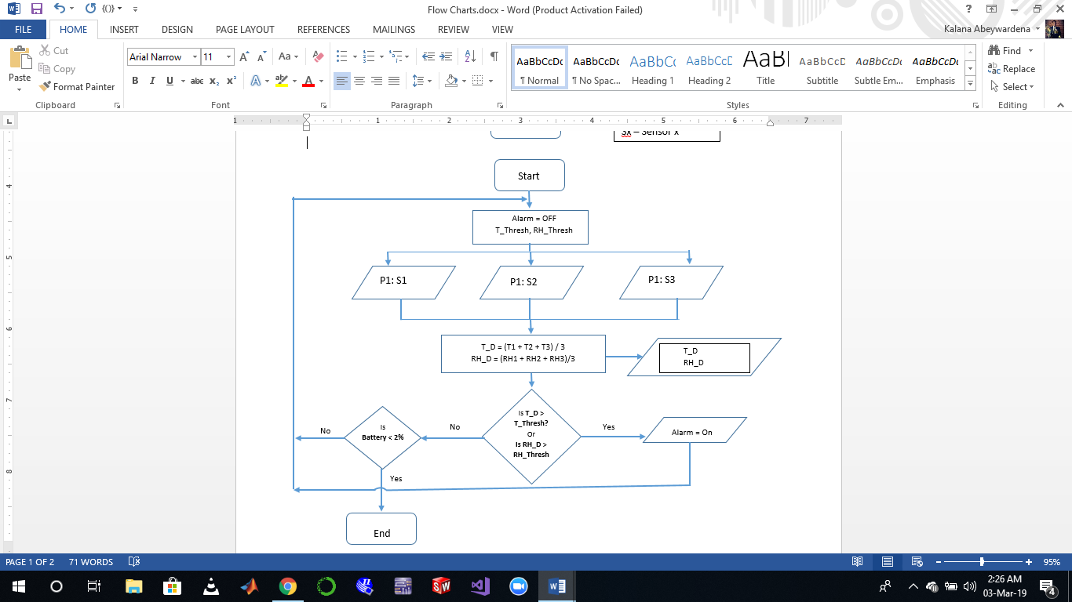**Flow Chart 02**

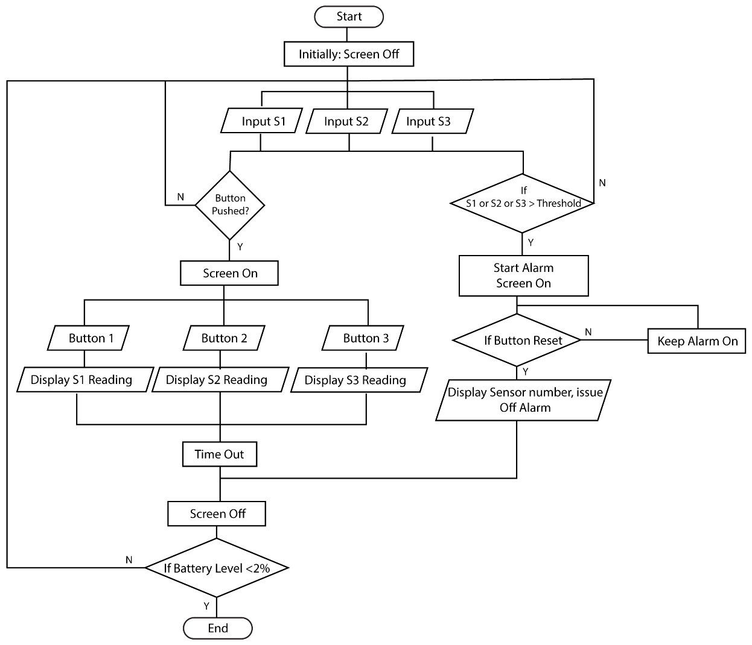**Flow Chart 3**

## Evaluation of the Flow Charts

|  |  |  |
| --- | --- | --- |
| **Flow Chart** | **Advantages** | **Disadvantages** |
| 01 | * Considers the temperature and the humidity at each point of the propagator ( from 3 sensors installed) * Better accuracy in detecting the temperature and humidity exceeding the thresholds * Display showing the temperature and humidity for each sensor in the propagator | * Logics should be evaluated for each sensor in the propagator hence computationally heavy |
| 02 | * Computationally easy * A single value represents the temperature, humidity and light level of the propagator | * The alarm get triggered when the average exceeds the threshold – For longer propagators, assuming the temperature and humidity distribution is uniform might be erroneous * 2 of the sensors are redundant – this type of algorithm can be run using one sensor * Less Accurate |
| 03 | * Computationally easy * Battery can be conserved * Can get pointwise readings for the temperature, light, and humidity * Display showing the temperature, humidity and light for each sensor. * Can use the sensors for separate propagators if they are small enough | * Have to manually push buttons to get readings from all the sensors |

Conclusion:

Based on the information gathered from the interpreter, it would be great if we can read and display the temperature and humidity at three different points in the propagator. This helps the farmer to locate the region at which the temperature has risen above the threshold and rectify it at that region. Hence the most appropriate flow chart is the Flow Chart 03.

Apart from the main functionality, the product will sample the temperature, humidity and light level values at each point hourly and store it in a SD card for further purposes.

## Circuit Block Diagrams

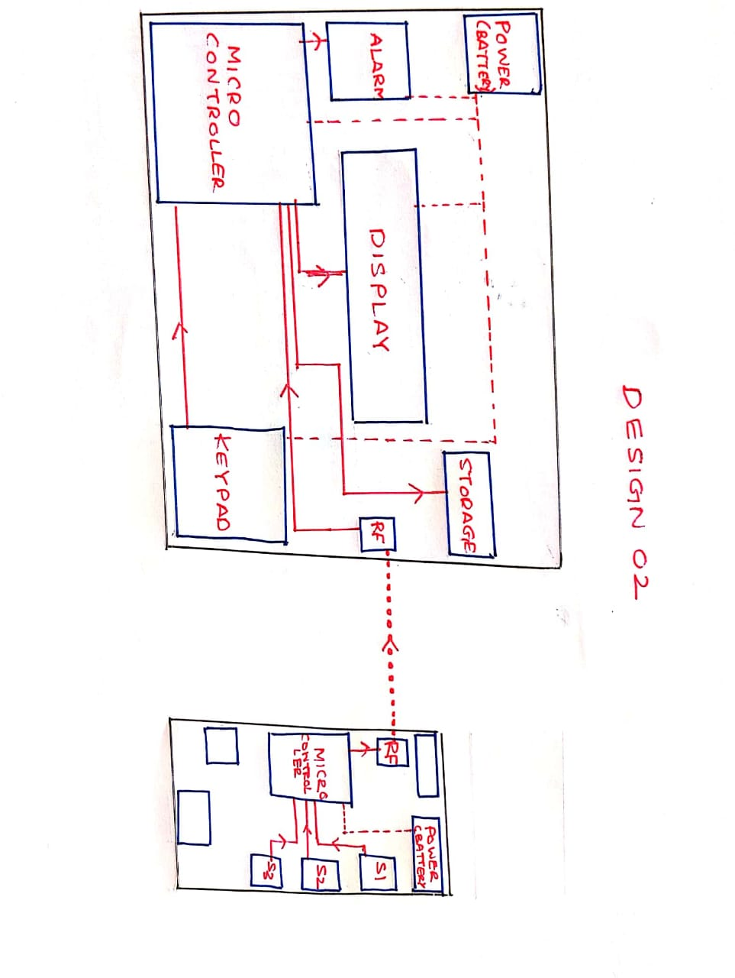Circuit Block Diagram 1

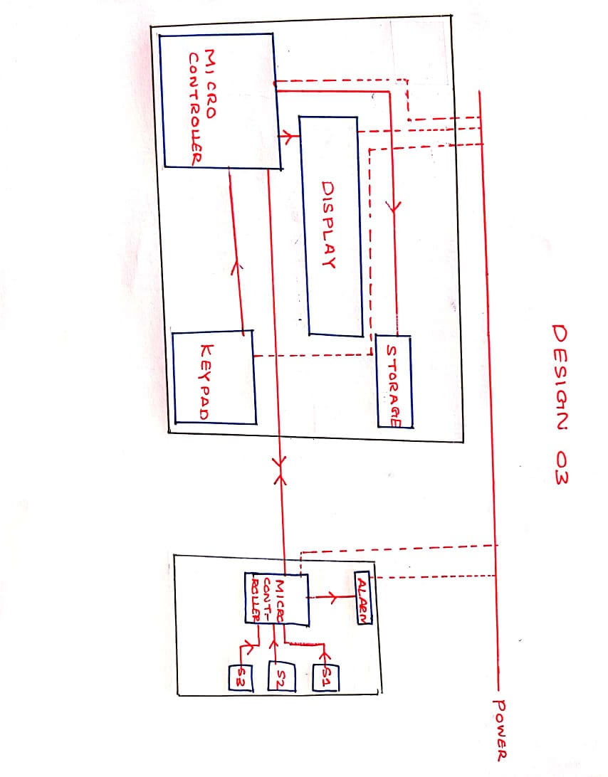Circuit Block Diagram 2

Circuit Block Diagram 3

## Evaluation of The Circuit Block Diagrams

|  |  |  |
| --- | --- | --- |
| **Circuit Black Diagram** | **Advantages** | **Disadvantages** |
| 01 | * Does not need power drawn externally. * Highly Modular due to lack of data lines between sensor and display modules. * Alarm coupled with sensor automatically indicates where the conditions have been violated. | * Battery needs to be changed occasionally * Usage of RF to communicate has risk of data loss * Alarm hidden by the propagator cover |
| 02 | * Does not need power drawn externally. * Highly Modular due to lack of data lines between sensor and display modules. * Alarm integrated into the display module. Increases modularity, simplicity and portability * Alarm externally visible to the user | * Battery needs to be changed occasionally * Usage of RF to communicate has risk of data loss |
| 03 | * Battery changes are not necessary * Alarm coupled with sensor automatically indicates where the conditions have been violated. | * Power needs to be drawn from an external source * Data and power lines reduce the modularity and portability * Lines may get damaged due to water and other weather conditions, affecting power and data transmission * Alarm hidden by the propagator cover |

Conclusion

Considering that both portability and modularity are very important considerations when designing the system, Design 2 had the best options. Therefore, considering all advantages and disadvantages, Circuit diagram Design 2 was selected for the preliminary design.

|  |
| --- |
| Group 1 |
| Controlled Environment Monitors |
| **Manufacture** |

# Sensor Unit Manufacture

## Sensor Unit Enclosure

Sensor Unit

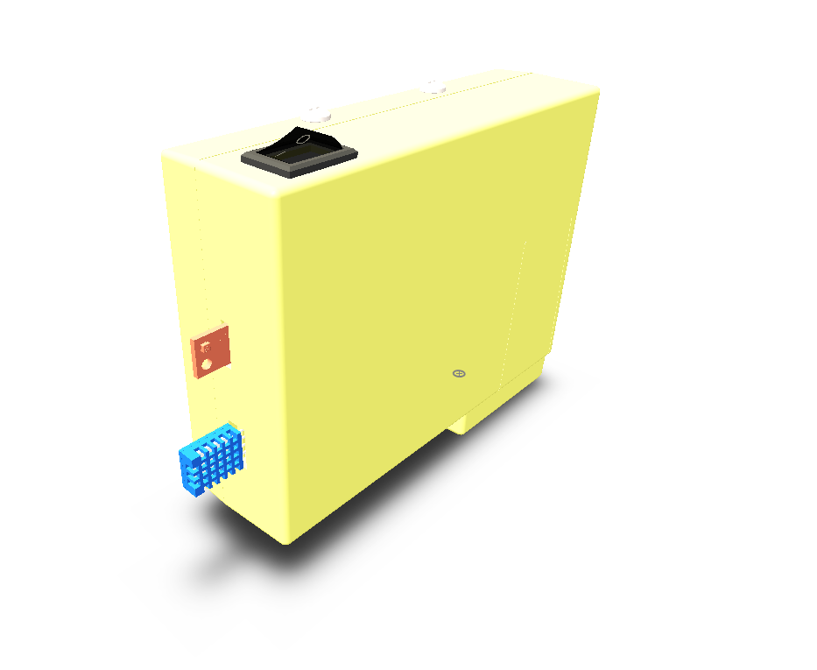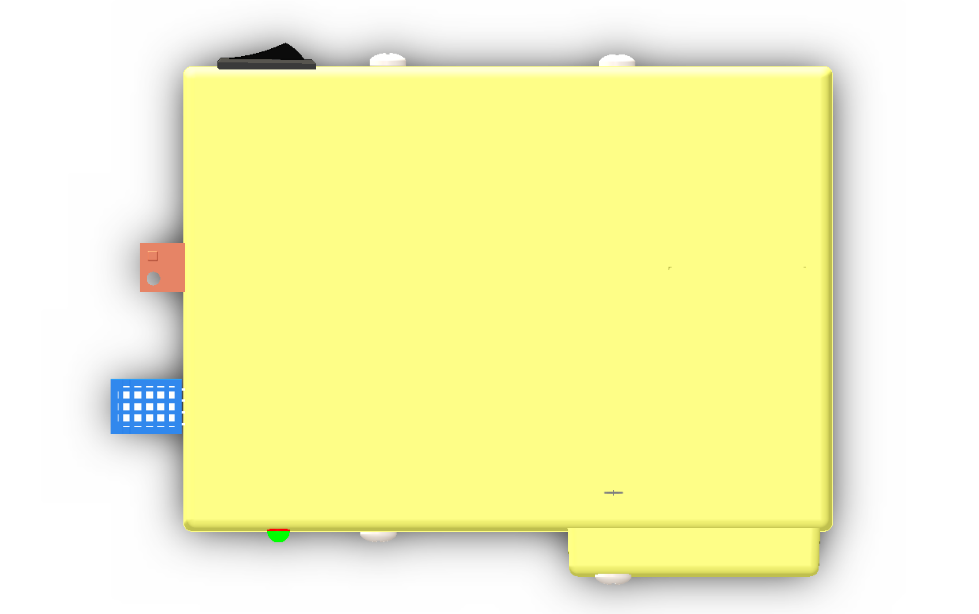

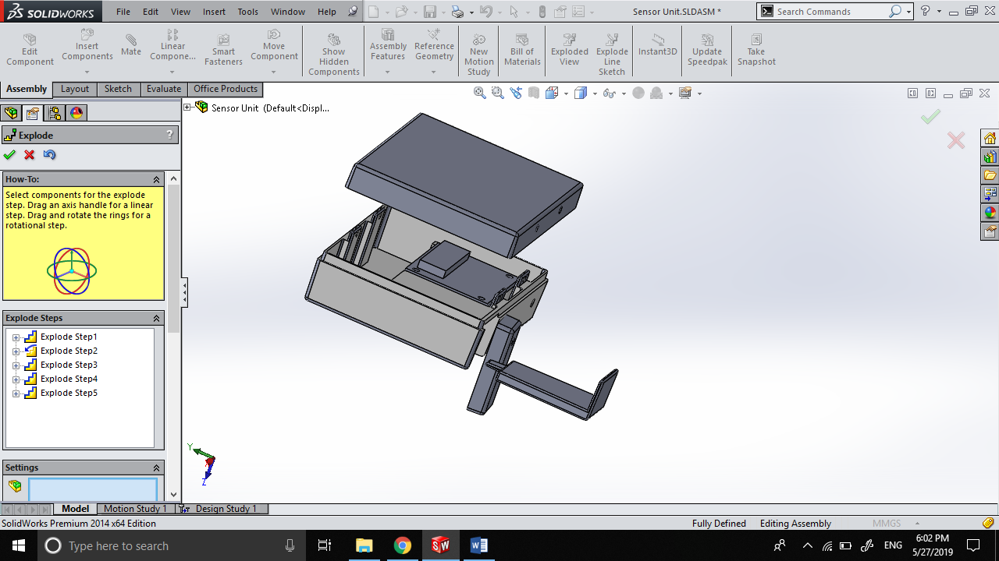

Components

The Sensor Unit Enclosure consists of 4 components that are to be manufactured by injection molding. All units are to be molded using hard plastic

Components to be molded are:

1. Top Cover
2. Bottom Cover
3. Battery Cover
4. Battery Lock

### Top Cover

Draft Analysis of Top Cover

Top Cover Mold Components

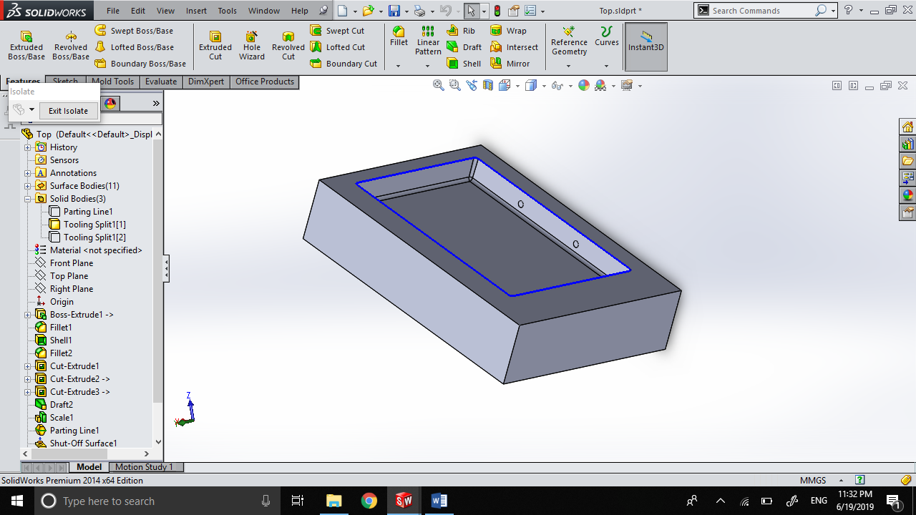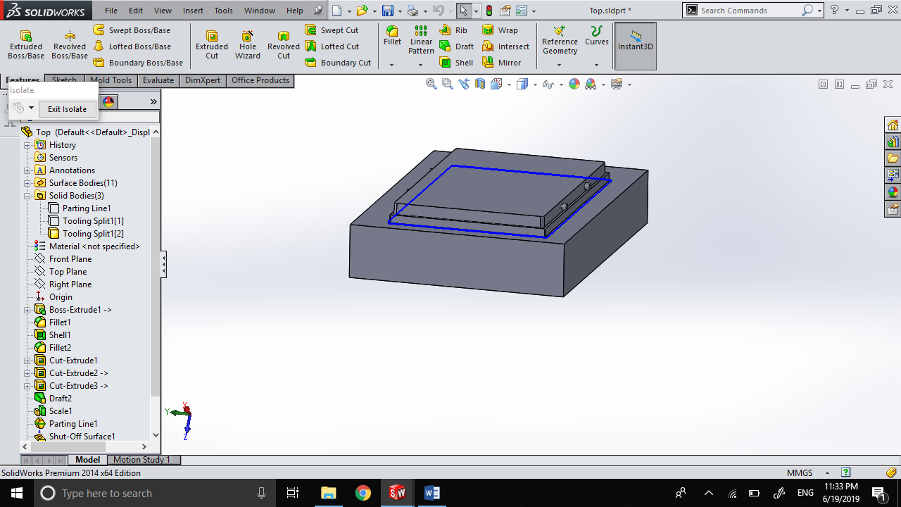

Core

Cavity

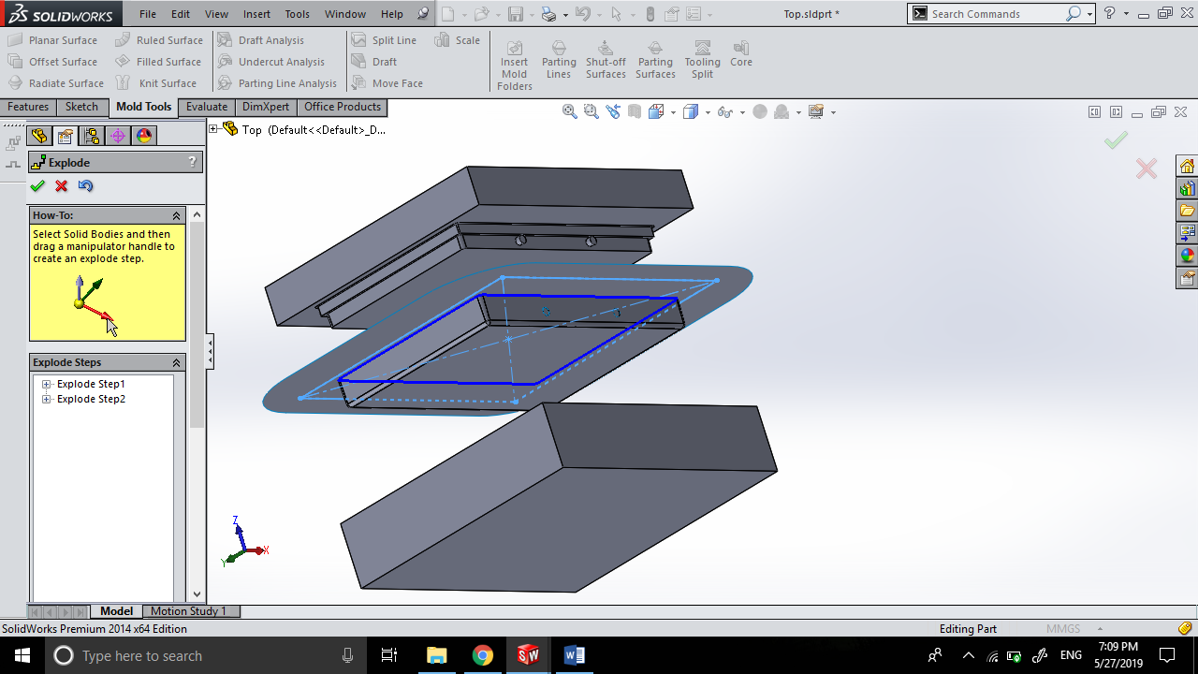

**Exploded View of Mold**

### Bottom Cover

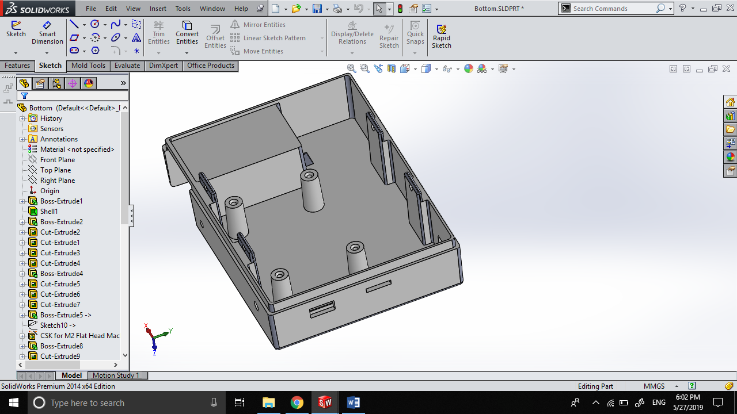

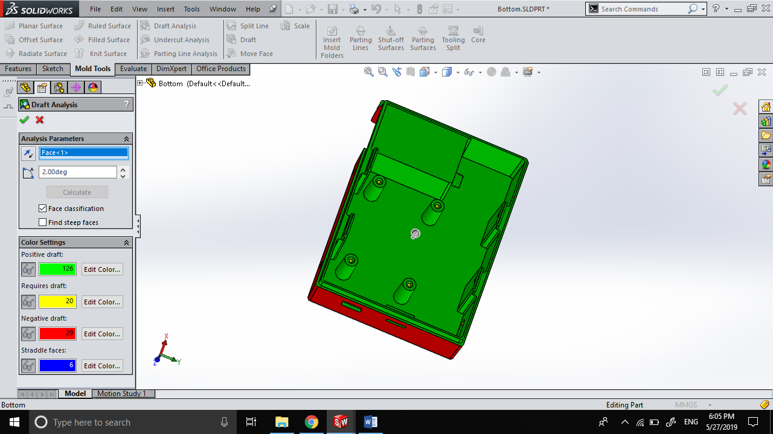Draft Analysis of Bottom Cover

Bottom Cover Mold Components

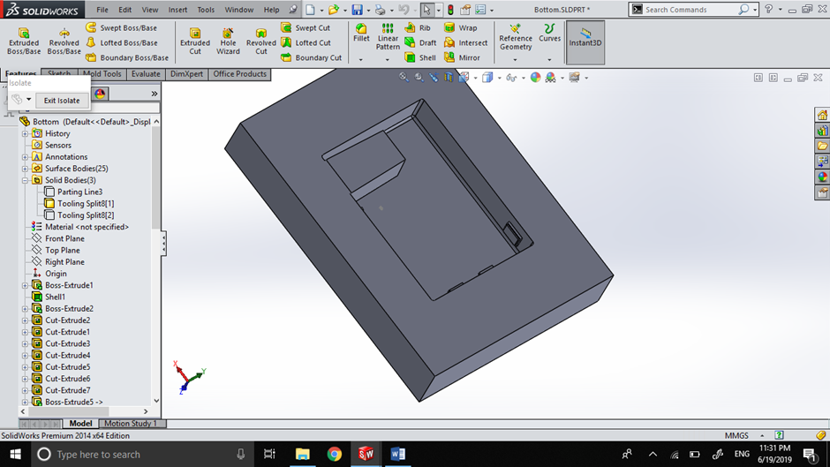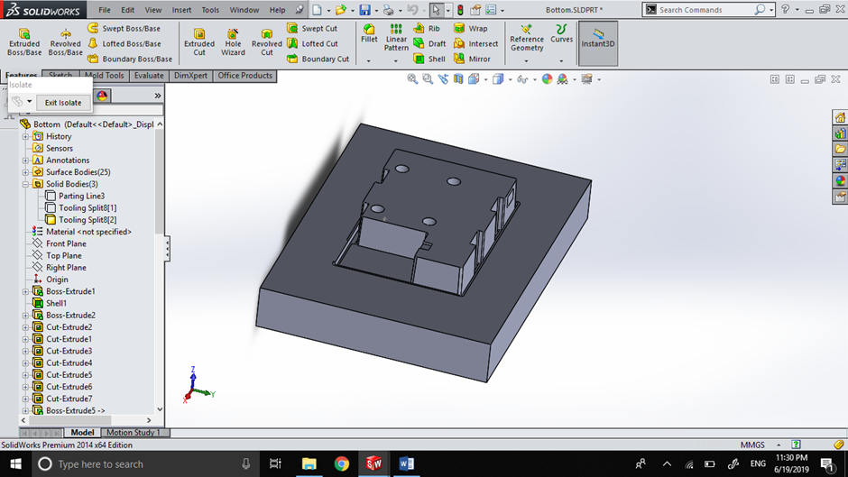

Core

Cavity

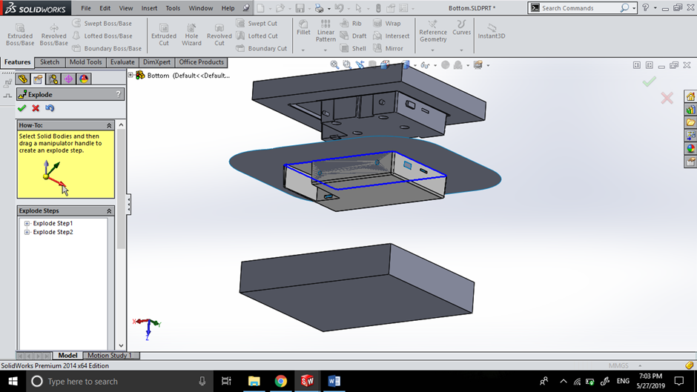

Exploded View of Mold

### Battery Cover

Draft Analysis of Battery Cover

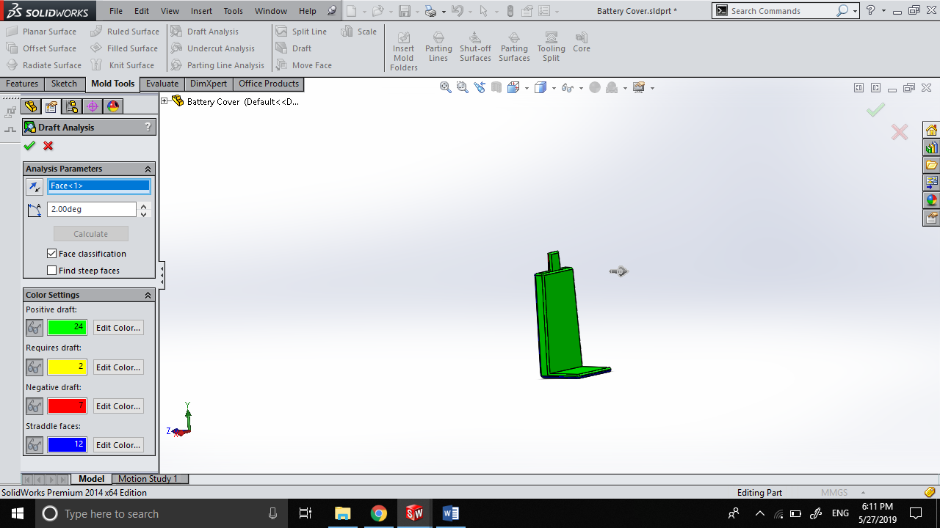

Battery Cover Mold Components

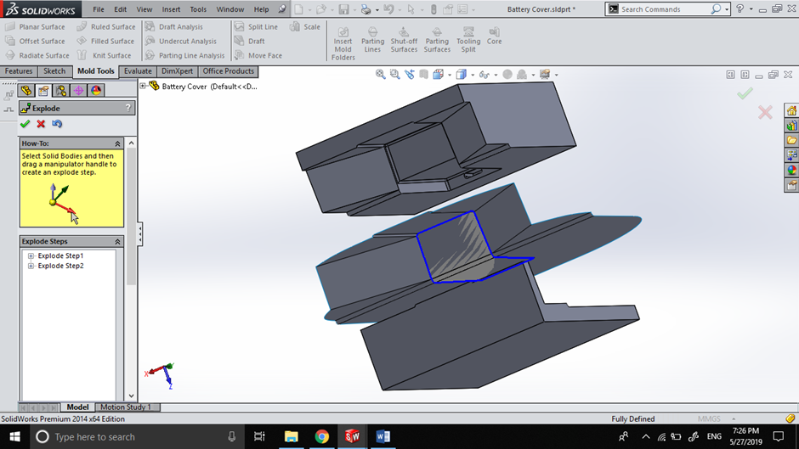

Exploded View of Mold

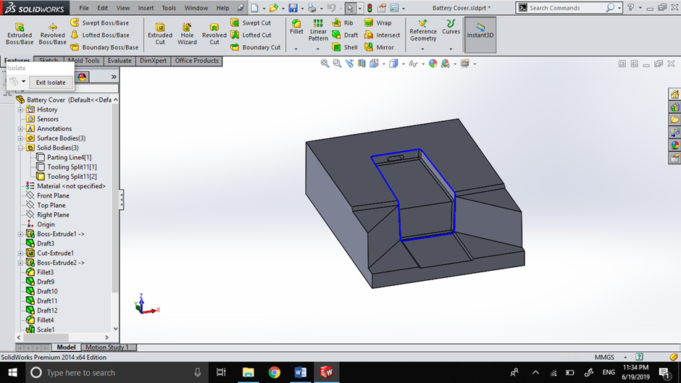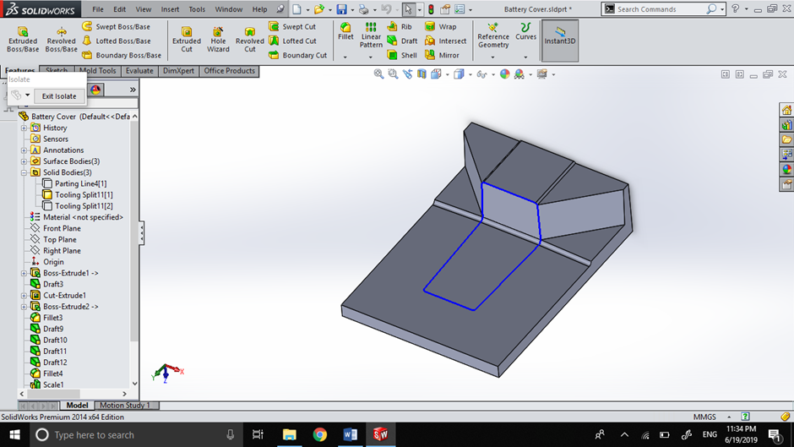

Core

Cavity

### Battery Lock

Draft Analysis of Battery Lock

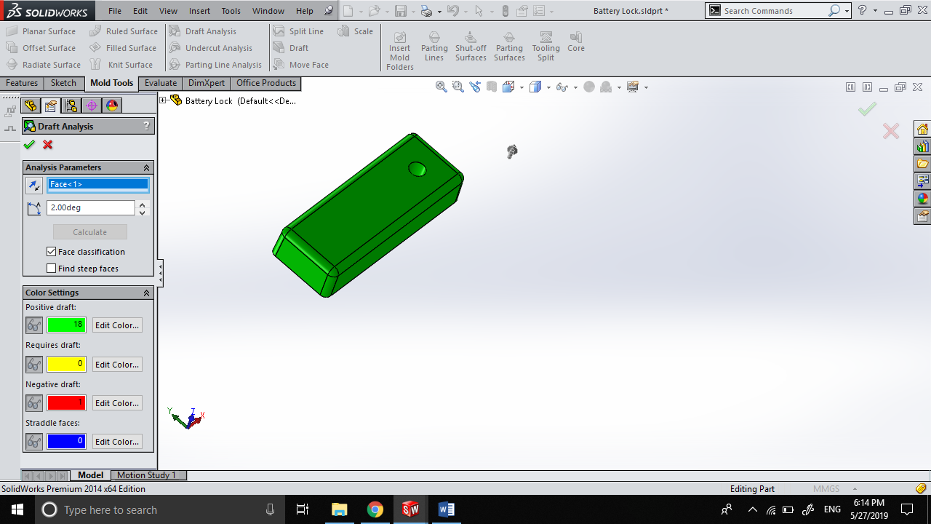

# Sensor Unit PCB Manufacture

## Bill of Materials for PCB

|  |  |  |  |  |  |
| --- | --- | --- | --- | --- | --- |
| **SYM_NAME** | **COMP_DEVICE_TYPE** | **COMP_VALUE** | **COMP_TOL** | **COMP_CLASS** | **REFDES** |
| RESISTOR | CAP NP_RESISTOR_0.33UF | 0.33uF |  | IC | C11 |
| RESISTOR | CAP NP_RESISTOR_0.1UF | 0.1uF |  | IC | C12 |
| RESISTOR | CAP NP_RESISTOR_22PF | 22pF |  | IC | C13 |
| RESISTOR | CAP NP_RESISTOR_22PF | 22pF |  | IC | C14 |
| RESISTOR | DIODE ZENER_0_RESISTOR_1N4735A | 1N4735A |  | IC | D1 |
| JACK | HEADER 2_JACK_HEADER 2 | HEADER 2 |  | IC | J1 |
| CONN2 | HEADER 2_CONN2_HEADER 2 | HEADER 2 |  | IC | J2 |
| CONN2 | HEADER 2_CONN2_HEADER 2 | HEADER 2 |  | IC | J3 |
| CONN4 | HEADER 4_CONN4_HEADER 4 | HEADER 4 |  | IC | J4 |
| CONN3 | HEADER 3_CONN3_HEADER 3 | HEADER 3 |  | IC | J5 |
| CONN3 | HEADER 3_CONN3_HEADER 3 | HEADER 3 |  | IC | J6 |
| CONN3 | HEADER 3_CONN3_TRANSMITTER | Transmitter |  | IC | J7 |
| REGULATOR | LM7805CTNOPB_0_REGULATOR_LM7805 | LM7805CTNOPB |  | IC | Q11 |
| BC547 | 2N3904TFR_BC547_BC547A | BC547A |  | IC | Q12 |
| BC547 | 2N3904TFR_BC547_BC547A | BC547A |  | IC | Q13 |
| RESISTOR | RESISTOR_RESISTOR_7.5K | 7.5K |  | IC | R11 |
| RESISTOR | RESISTOR_RESISTOR_39K | 39K |  | IC | R12 |
| RESISTOR | RESISTOR_RESISTOR_680 | 680 |  | IC | R13 |
| RESISTOR | RESISTOR_RESISTOR_30K | 30K |  | IC | R14 |
| RESISTOR | RESISTOR_RESISTOR_RESISTOR | RESISTOR |  | IC | R15 |
| RESISTOR | RESISTOR_RESISTOR_10K | 10k |  | IC | R16 |
| RESISTOR | SW PUSHBUTTON_0_RESISTOR_RESET | RESET |  | IC | SW1 |
| SCREWCONN | SW PUSHBUTTON_0_SCREWCONN_RESET | RESET |  | IC | SW2 |
| ICSOCKET | ATMEGA32A-PU_0_ICSOCKET_ATMEGA3 | ATMEGA32A-PU |  | IC | U1 |
| RESISTOR | CRYSTAL_RESISTOR_16MHZ | 16MHz |  | IC | Y1 |

### Bill of Materials - Non-PCB Components

|  |  |  |
| --- | --- | --- |
| **COMPONENT NAME** | **MANUFACTURER** | **QUANTITY** |
| ATMEGA32A | MICROCHIP | 1 |
| DHT11 | ADAFRUIT | 1 |
| TEMT6000 | ADAFRUIT | 1 |
| SOIL MOISTURE SENSOR | ADAFRUIT | 1 |
| ROCKER SWITCH | NTE ELECTRONICS | 1 |
| 433 MHZ TRANSMITTER | ADAFRUIT | 1 |
| LED GREEN | GENERIC | 1 |

## Circuit Schematics

### Hierarchical view

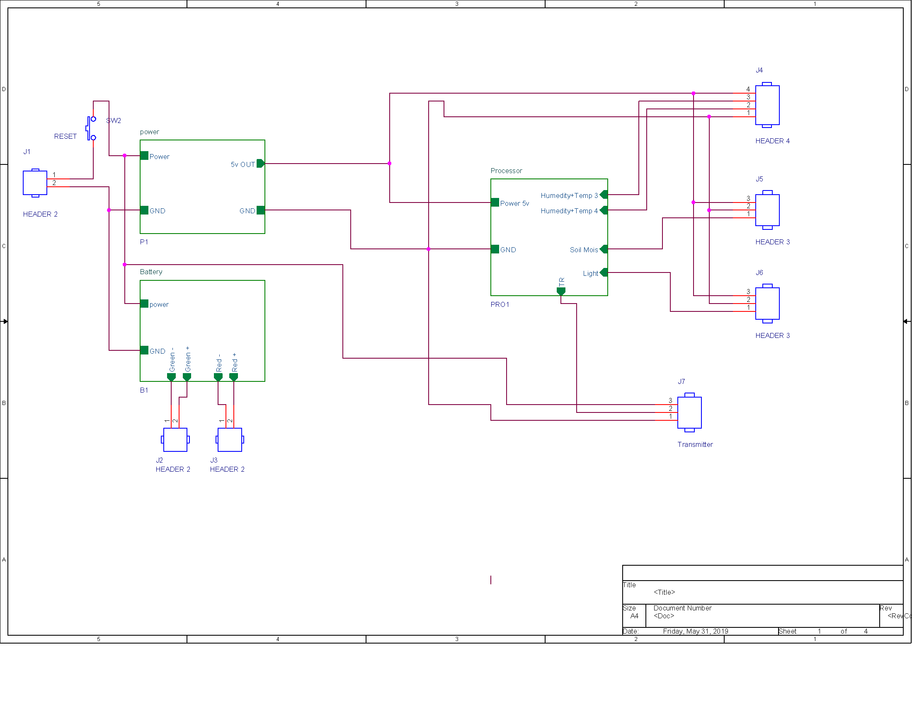

### Battery Level Sensor

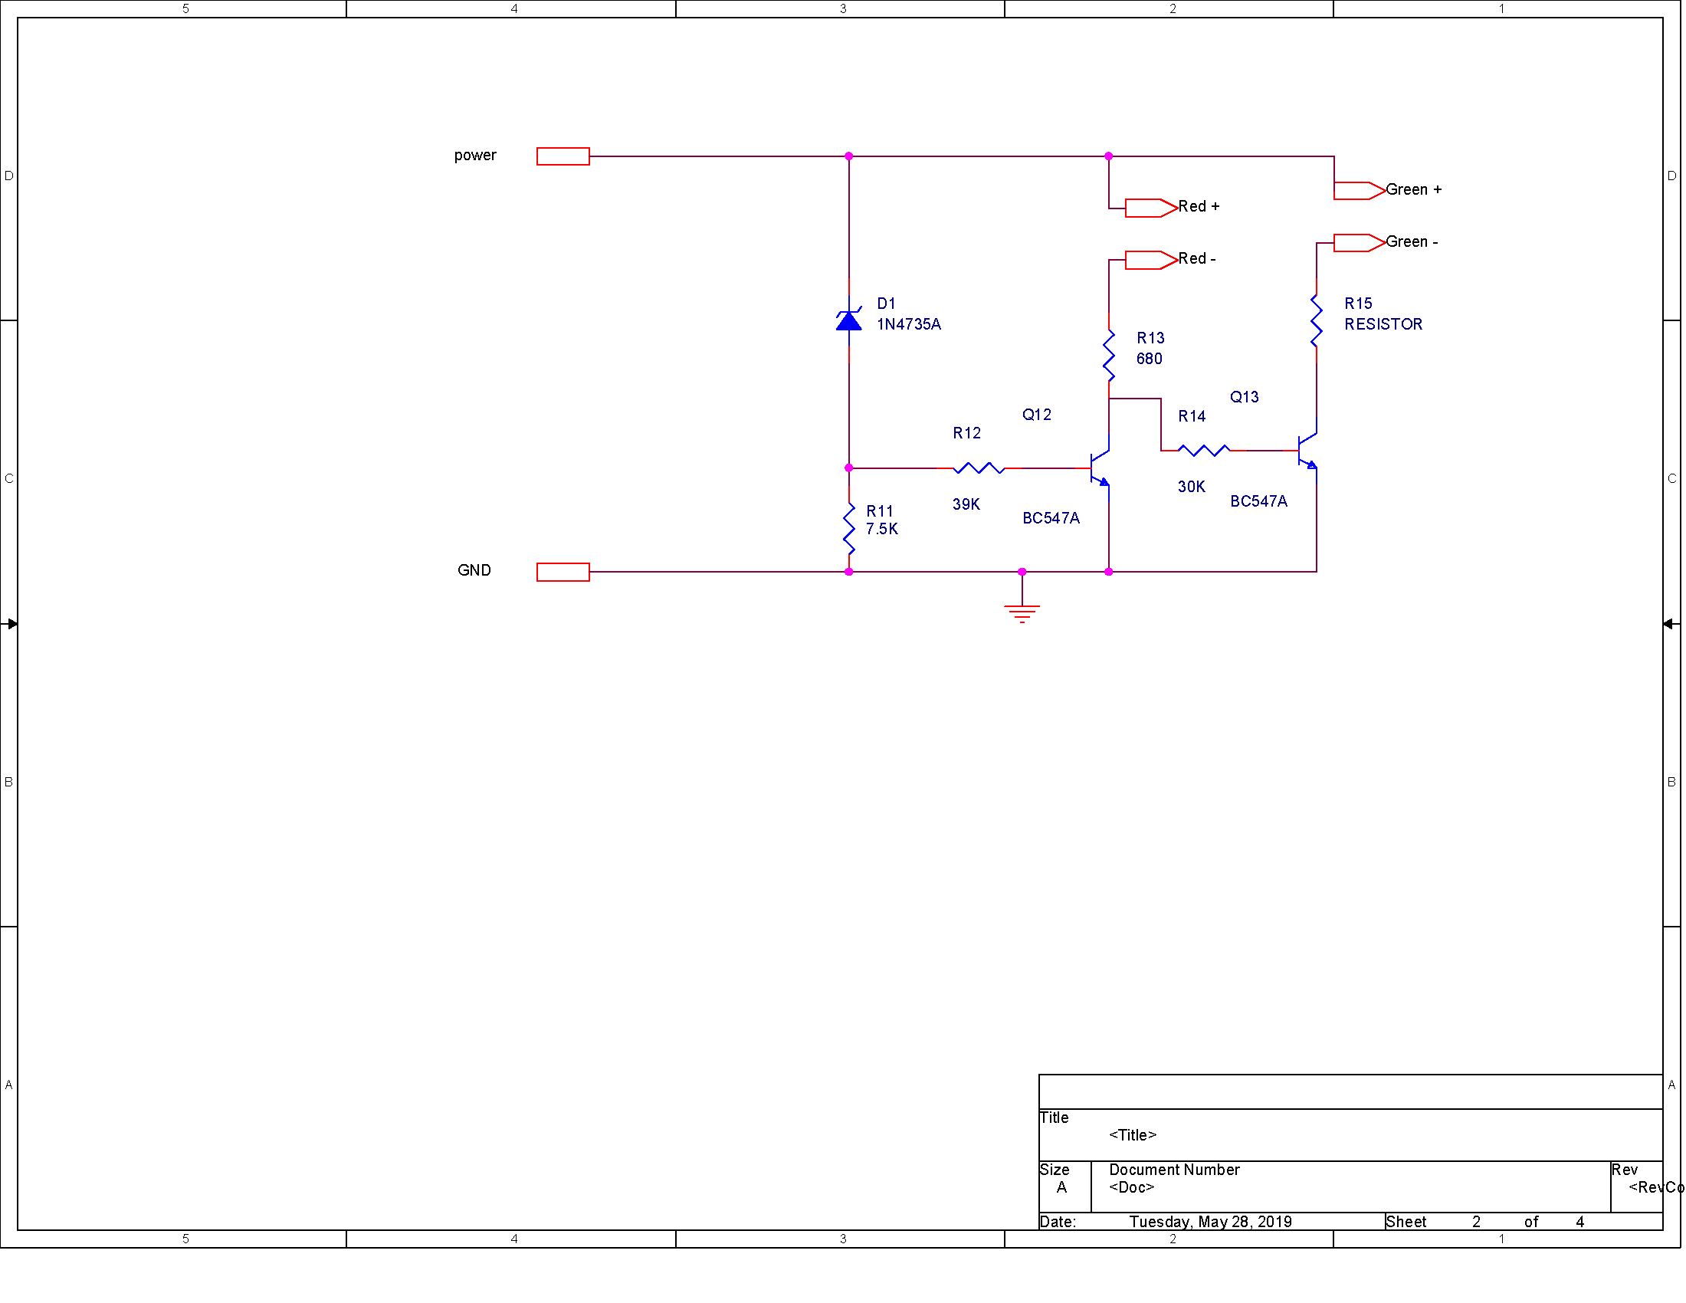

### Power Regulator

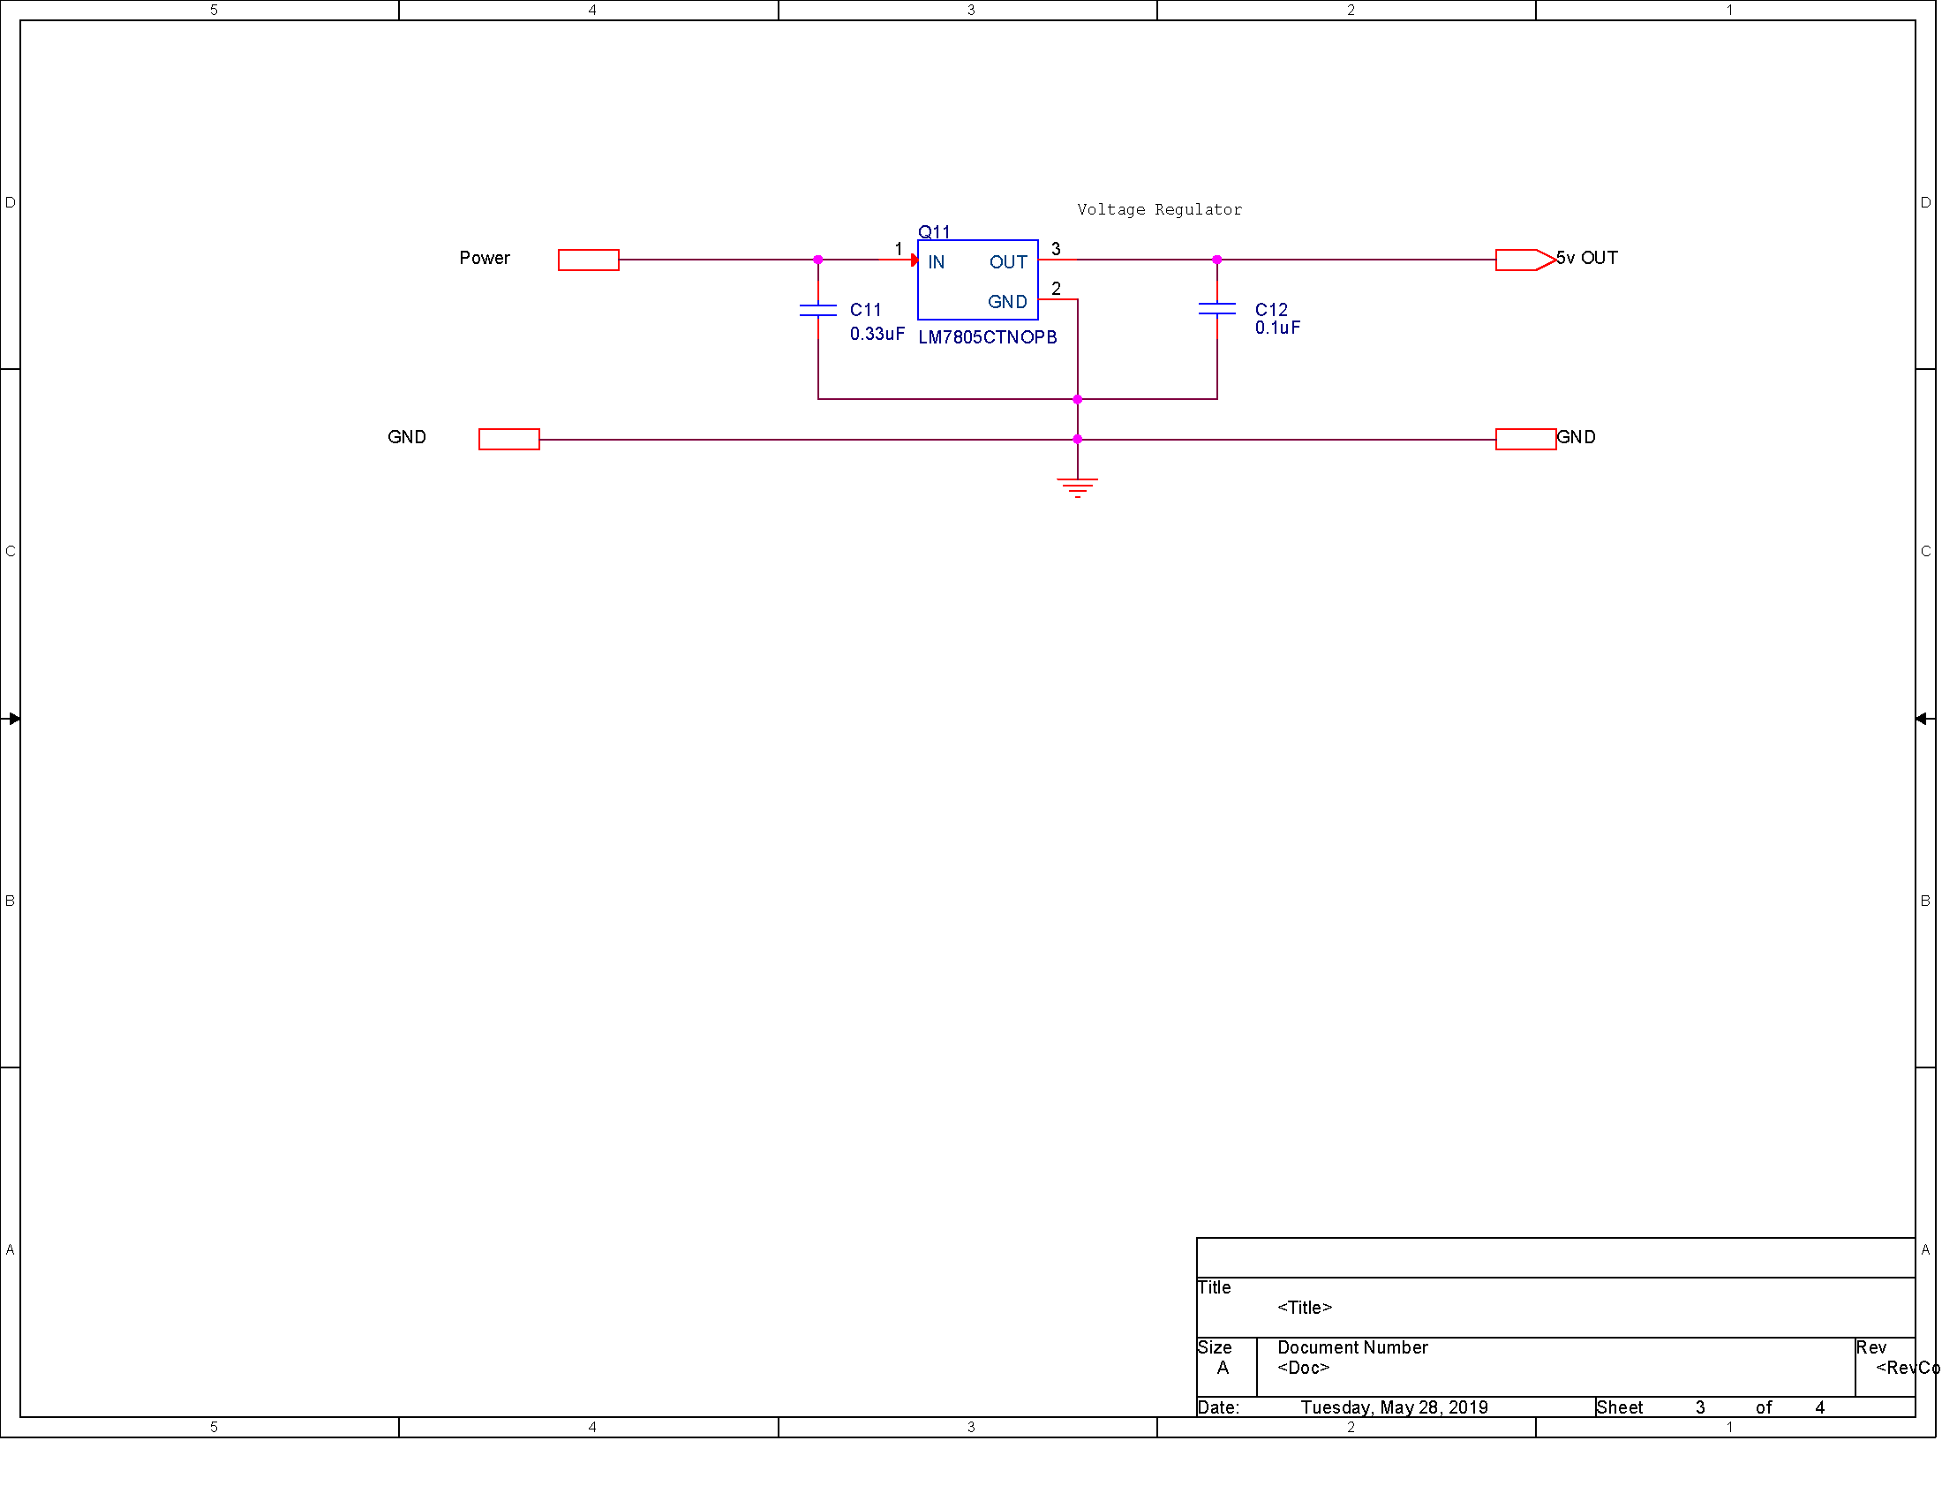

### A close up of a map Description automatically generatedProcessor

## Circuit Layout

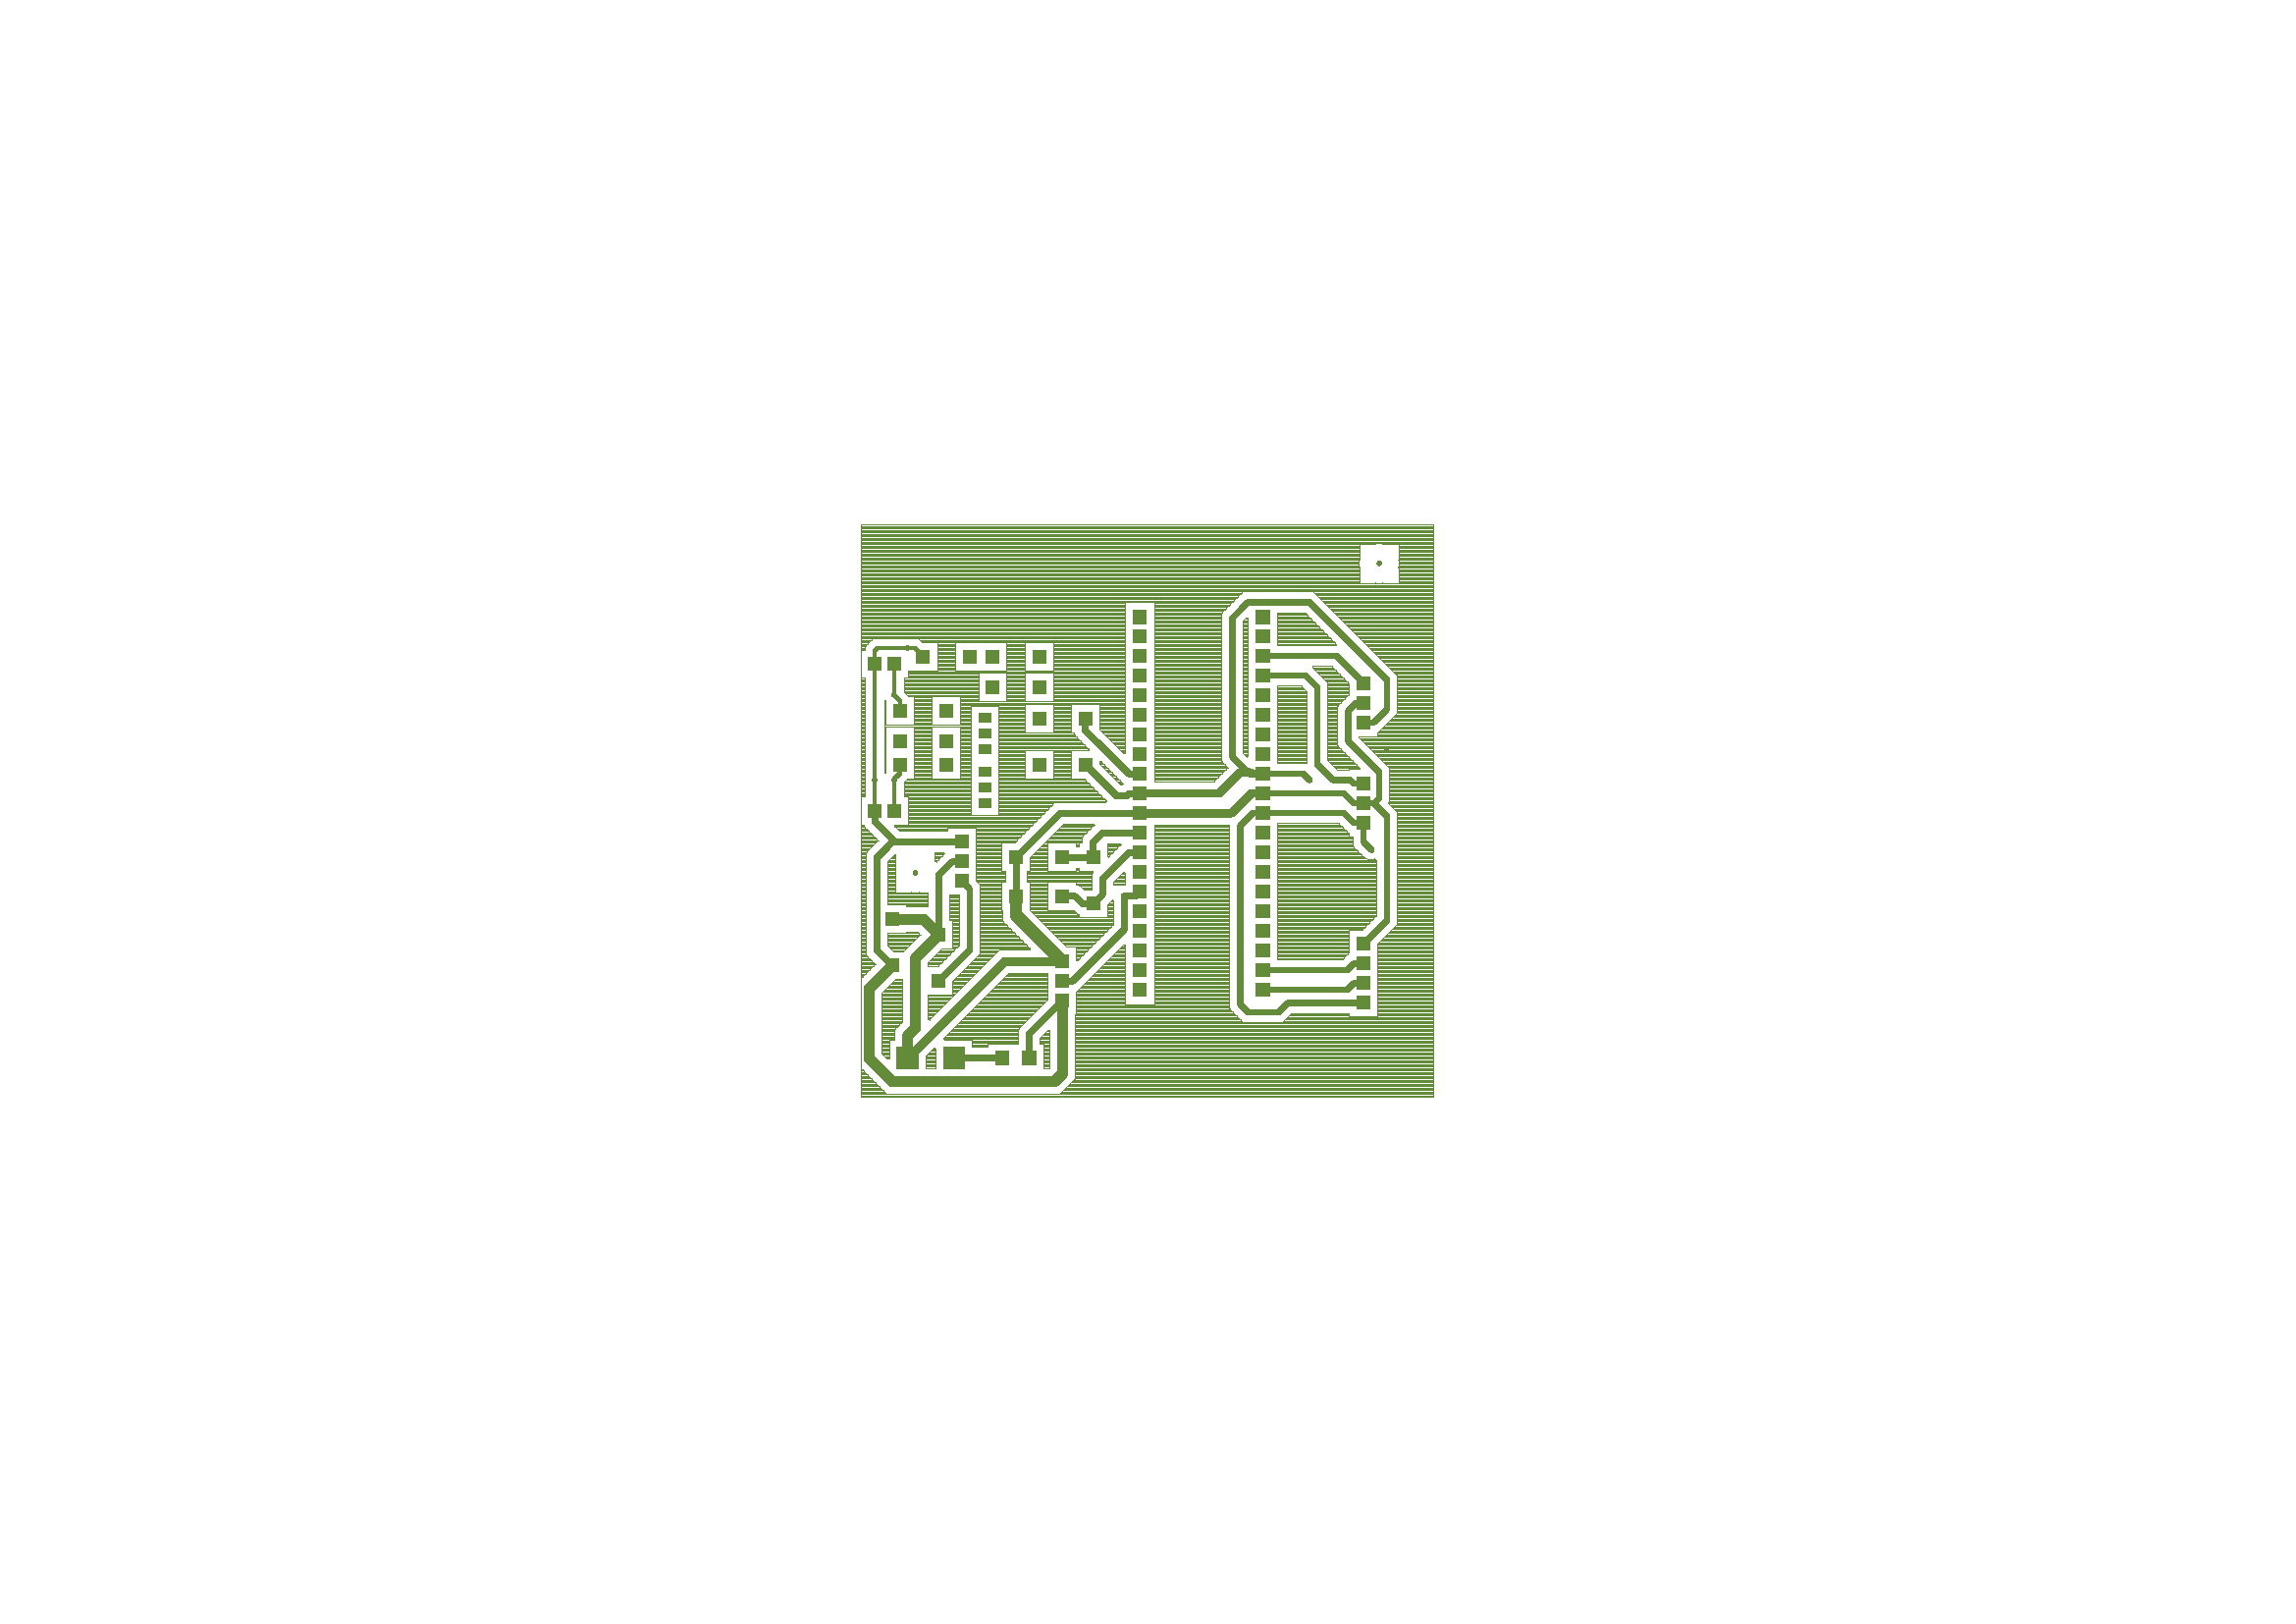Sensor Unit BottomSilkscreen

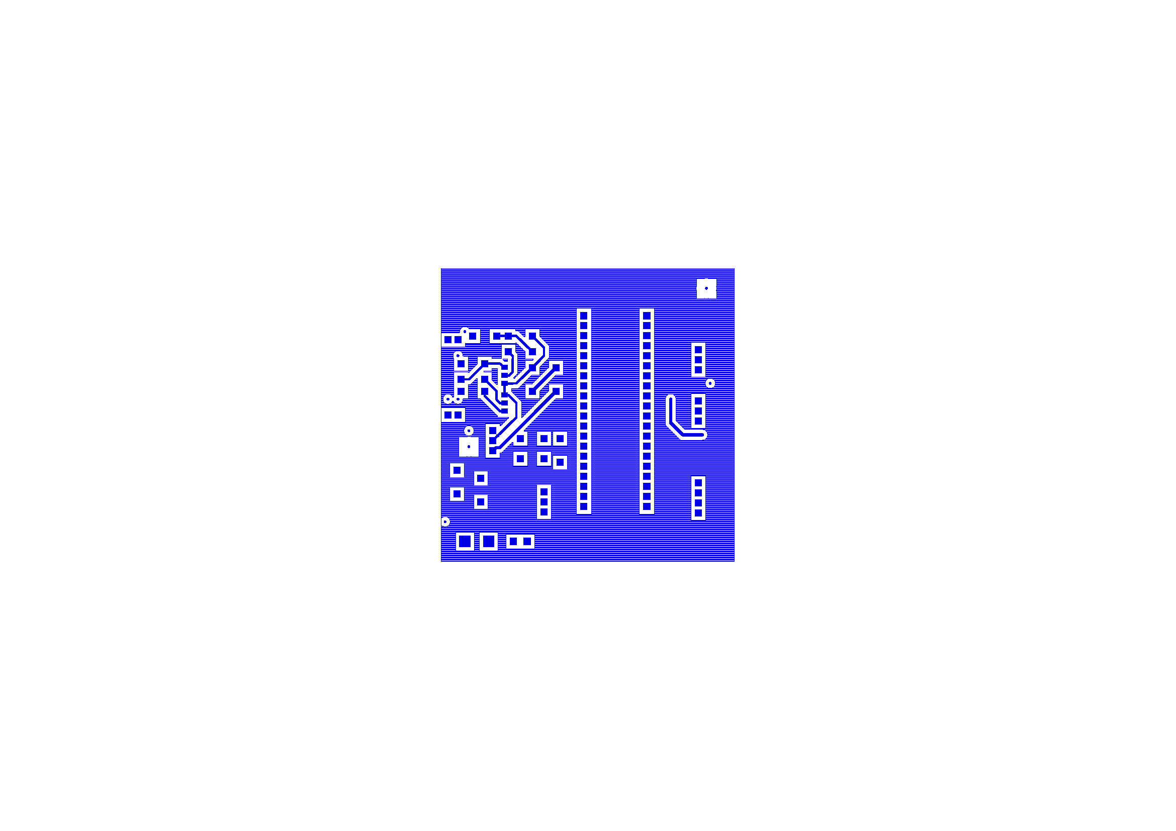Sensor Unit Top

INSert 7 pages

# Display Unit Manufacture

## Display Unit Enclosure

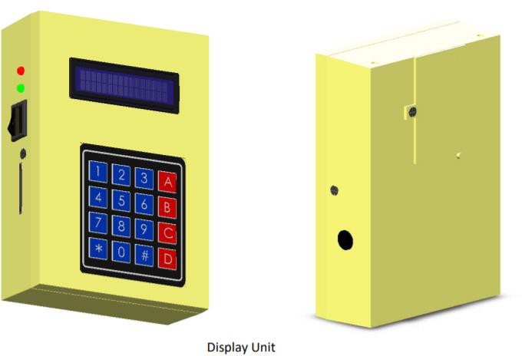

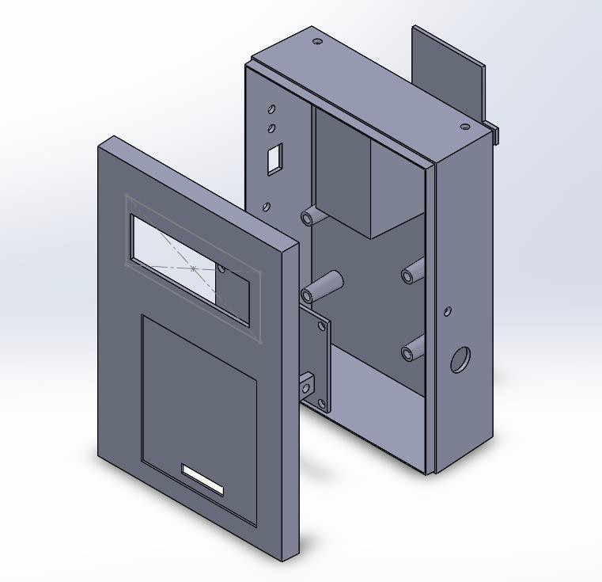

## Components

The display unit enclosure consists of 3 components that are manufactured by injection molding. All units are to be molded using hard plastic.

1. Top Cover
2. Bottom Cover
3. Battery Cover

## Top Cover

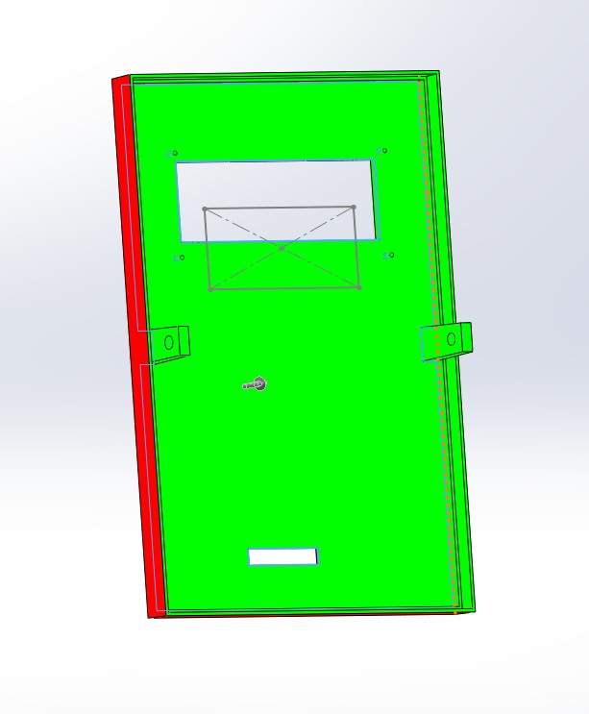Draft Analysis of Top Cover

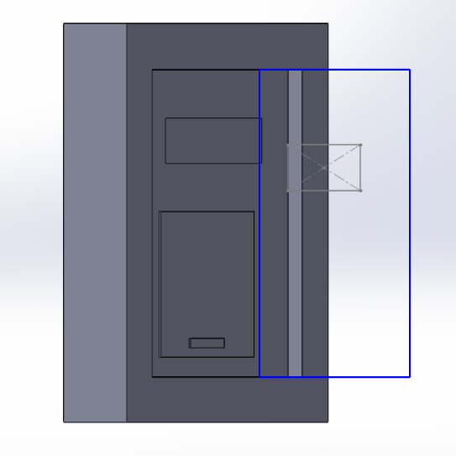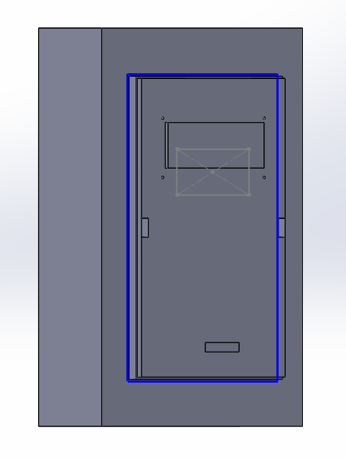Mold Components of Top Cover

Cavity Core

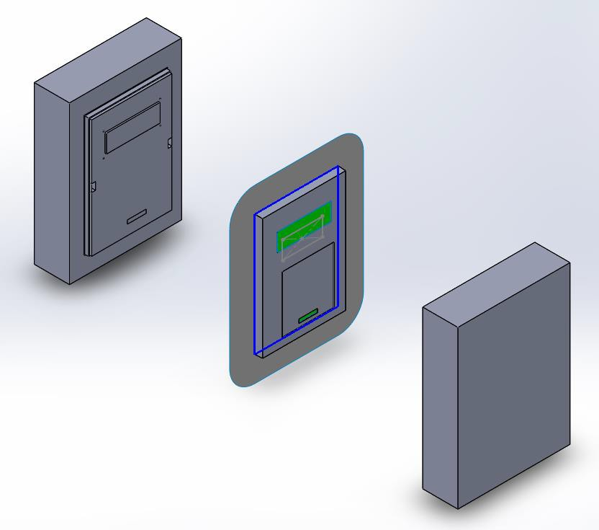

Exploded view of mold

## Bottom Cover

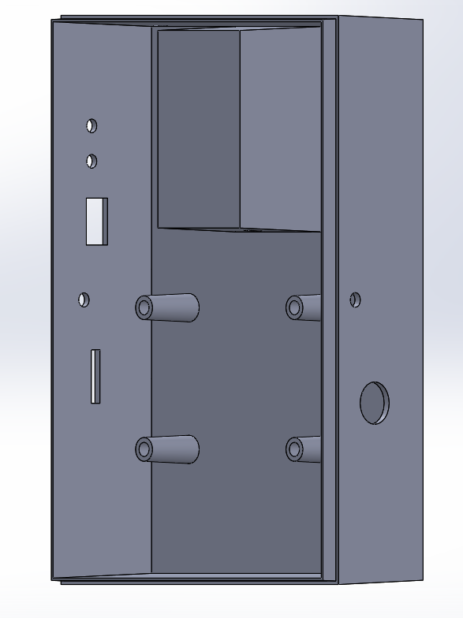

Draft Analysis of Bottom Cover

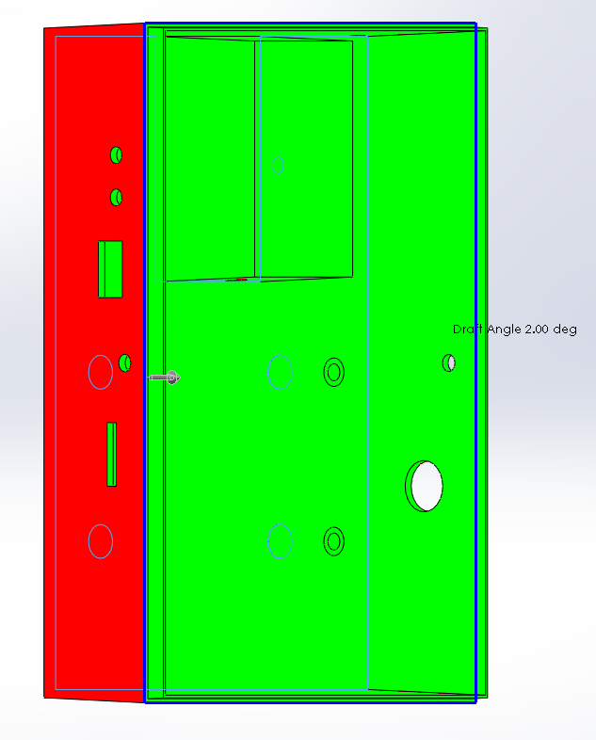

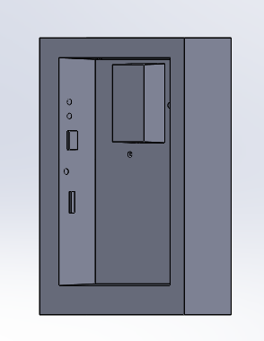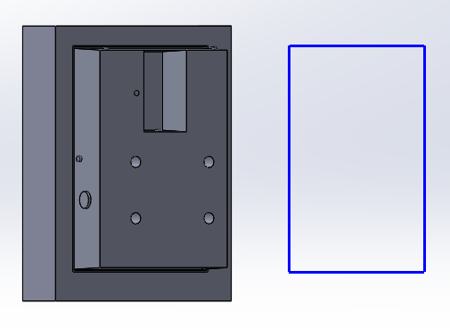Mold Components

Core Cavity

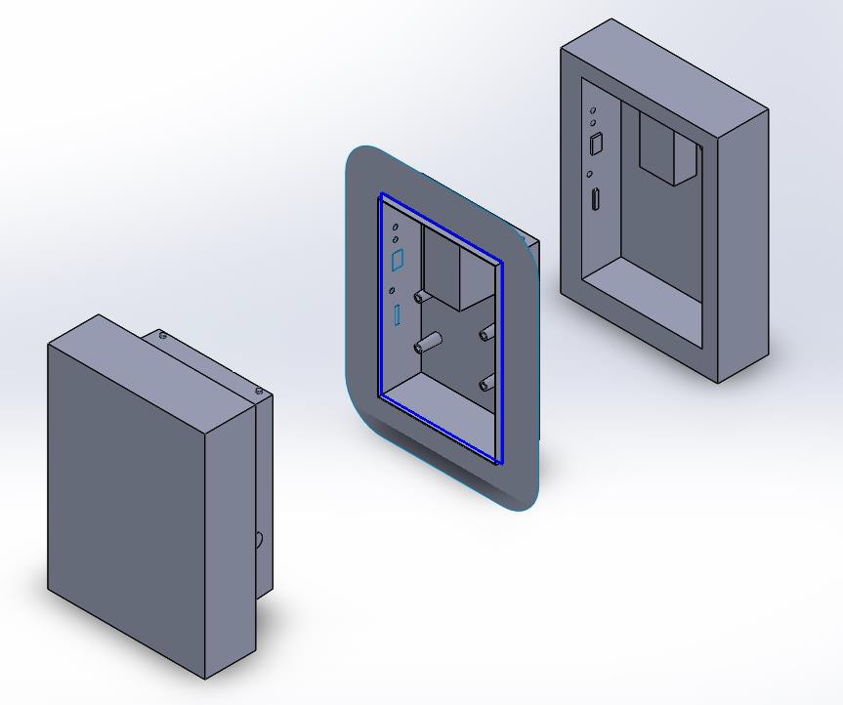

Exploded view of Mold

## Battery Cover

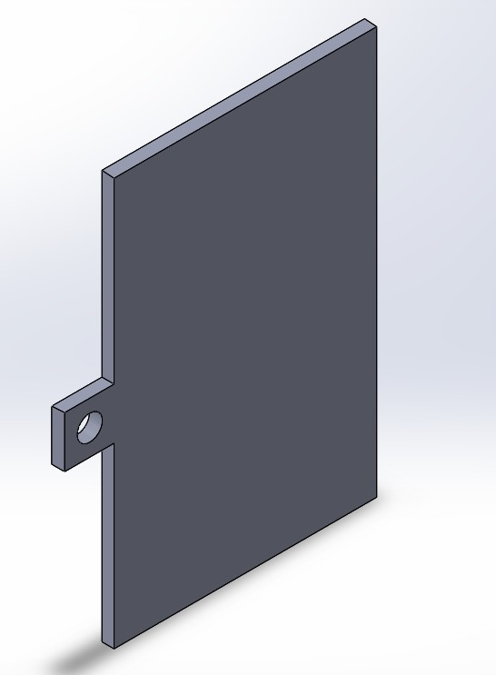

Draft Analysis of Battery Cover

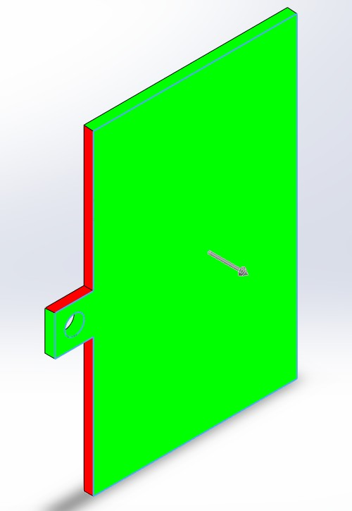

Mold Components of Battery Cover

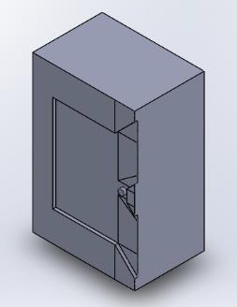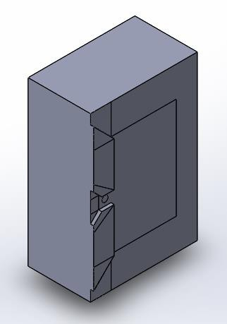

Core Cavity

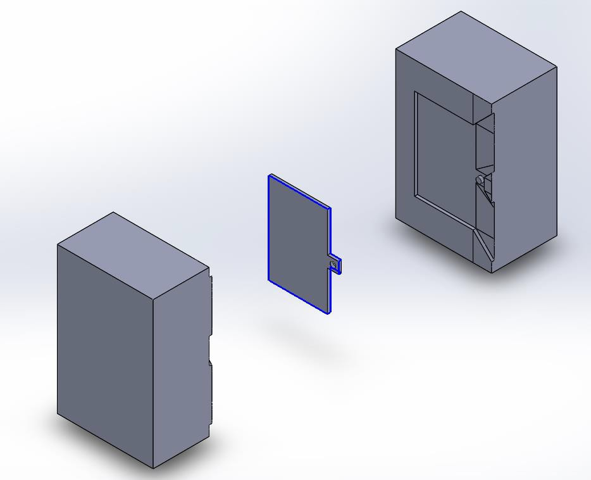

Exploded view of Mold

# Display Unit PCB Manufacture

|  |  |  |  |  |  |
| --- | --- | --- | --- | --- | --- |
| **SYM_NAME** | **COMP_DEVICE_TYPE** | **COMP_VALUE** | **COMP_TOL** | **COMP_CLASS** | **REFDES** |
| RESISTOR | C_RESISTOR_0.33UF | 0.33uF |  | IC | C1 |
| RESISTOR | C_RESISTOR_0.33UF | 0.33uF |  | IC | C2 |
| RESISTOR | C_RESISTOR_22PF | 22pF |  | IC | C3 |
| RESISTOR | C_RESISTOR_22PF | 22pF |  | IC | C4 |
| RESISTOR | 1N4740A_RESISTOR_1N4740A | 1N4740A |  | IC | D1 |
| JACK | HEADER 2_JACK_HEADER 2 | HEADER 2 |  | IC | J1 |
| CONN16 | HEADER 16_CONN16_LCD | LCD |  | IC | J2 |
| CON6 | HEADER 6_CON6_HEADER 6 | HEADER 6 |  | IC | J3 |
| CONN2 | HEADER 2_CONN2_HEADER 2 | HEADER 2 |  | IC | J4 |
| CONN2 | HEADER 2_CONN2_HEADER 2 | HEADER 2 |  | IC | J5 |
| CONN8 | HEADER 8_CONN8_HEADER 8 | HEADER 8 |  | IC | J6 |
| CONN2 | HEADER 2_CONN2_HEADER 2 | HEADER 2 |  | IC | J7 |
| OPTO | CONN MOD 6-4_J_OPTO_CONN MOD 6- | CONN MOD 6-4_J |  | IC | J8 |
| CONN2 | CON2_CONN2_CON2 | CON2 |  | IC | J9 |
| CONN4 | HEADER 4_CONN4_HEADER 4 | HEADER 4 |  | IC | J10 |
| BC547 | BC547A_BC547_BC547A | BC547A |  | IC | Q1 |
| BC547 | BC547A_BC547_BC547A | BC547A |  | IC | Q2 |
| TRIMPOT | POT_TRIMPOT_1K | 1K |  | IC | R1 |
| RESISTOR | R_RESISTOR_1K | 1k |  | IC | R2 |
| RESISTOR | R_RESISTOR_1K | 1k |  | IC | R3 |
| RESISTOR | R_RESISTOR_680 | 680 |  | IC | R4 |
| RESISTOR | R_RESISTOR_680 | 680 |  | IC | R5 |
| RESISTOR | R_RESISTOR_30K | 30K |  | IC | R6 |
| RESISTOR | R_RESISTOR_39K | 39K |  | IC | R7 |
| RESISTOR | R_RESISTOR_7.5K | 7.5K |  | IC | R8 |
| RESISTOR | R_RESISTOR_10K | 10K |  | IC | R9 |
| RESISTOR | SW_PB_SPST_RESISTOR_SW_PB_SPST | SW_PB_SPST |  | IC | SW1 |
| REGULATOR | LM7805C_0_REGULATOR_LM7805C | LM7805C |  | IC | U1 |
| ICSOCKET | ATMEGA32A-PU_ICSOCKET_ATMEGA32A | ATMEGA32A-PU |  | IC | U2 |
| CRYSTAL | CRYSTAL_CRYSTAL_CRYSTAL | CRYSTAL |  | IC | Y1 |

## Bill of Materials

### 

### External Component Bill of Materials

|  |  |  |
| --- | --- | --- |
| **Component Name** | **Manufacturer** | **Quantity** |
| ATMega32A | Microchip | 1 |
| Rocker Switch | NTE Electronics | 1 |
| 433 MHz Receiver | AdaFruit | 1 |
| SD Card Reader | Kingston | 1 |
| 16x2 LCD | XIAMEN AMOTEC | 1 |
| 4x4 Keypad | XIAMEN AMOTEC | 1 |

## Circuit Schematics

### Hierarchical View

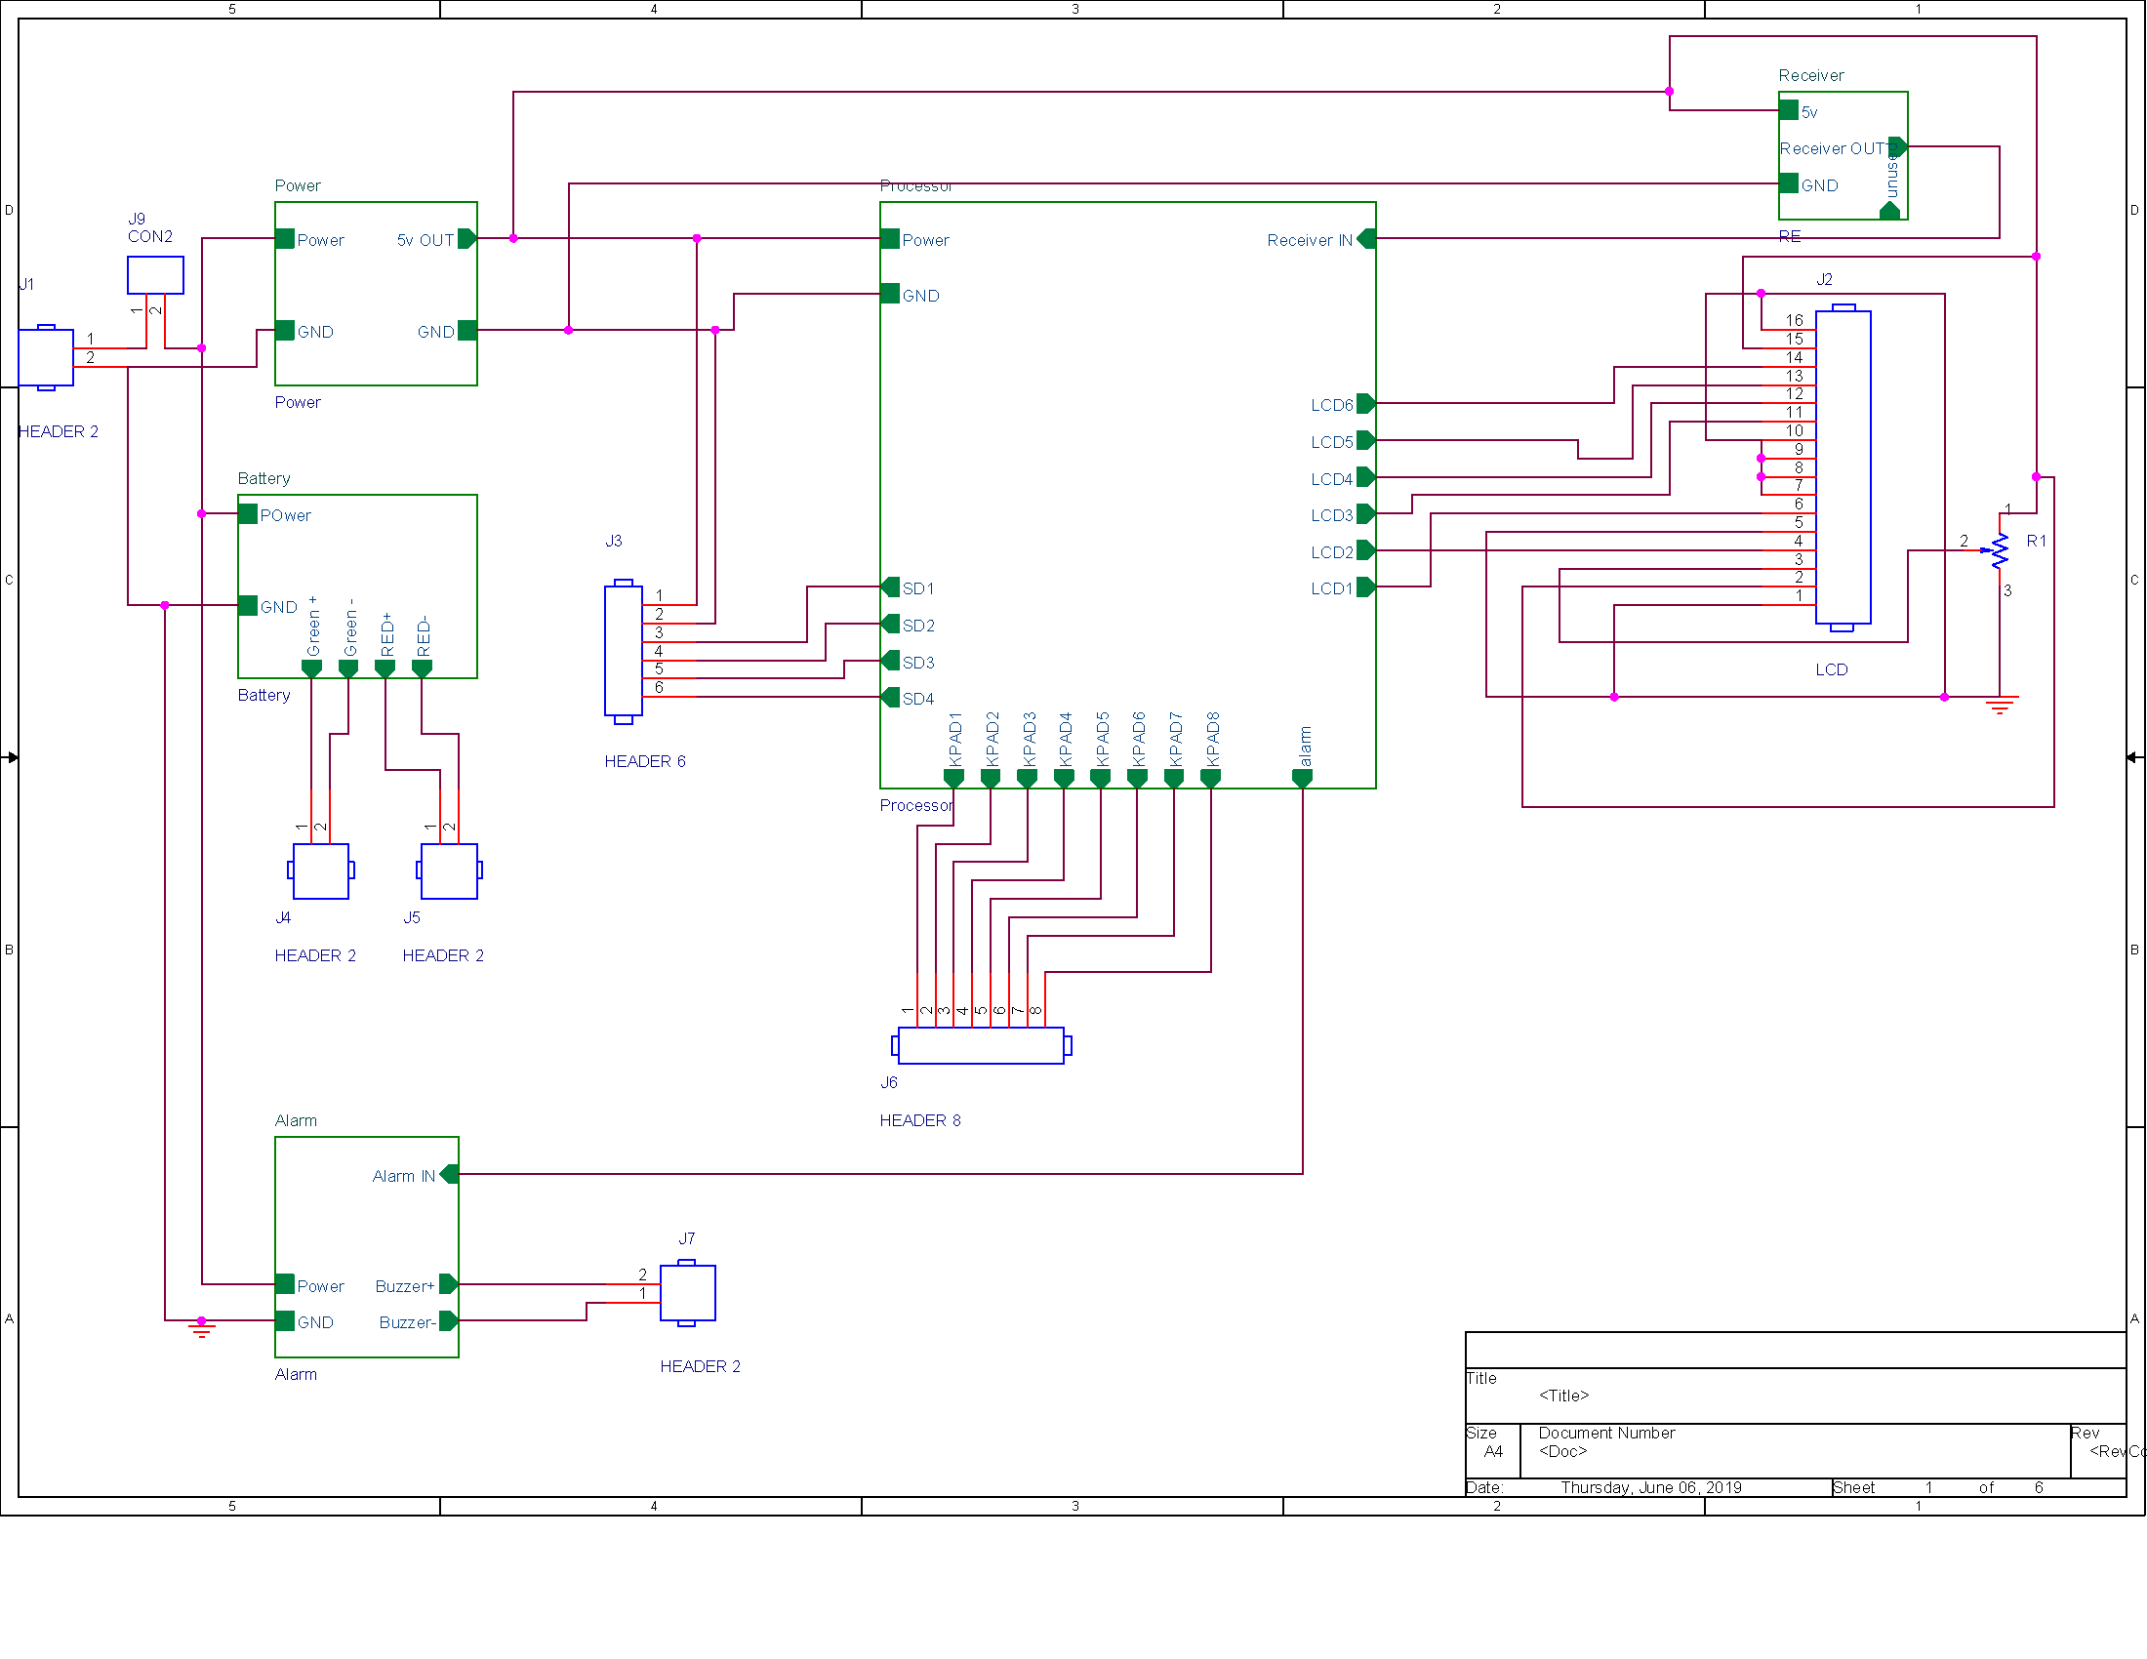

### Alarm Unit

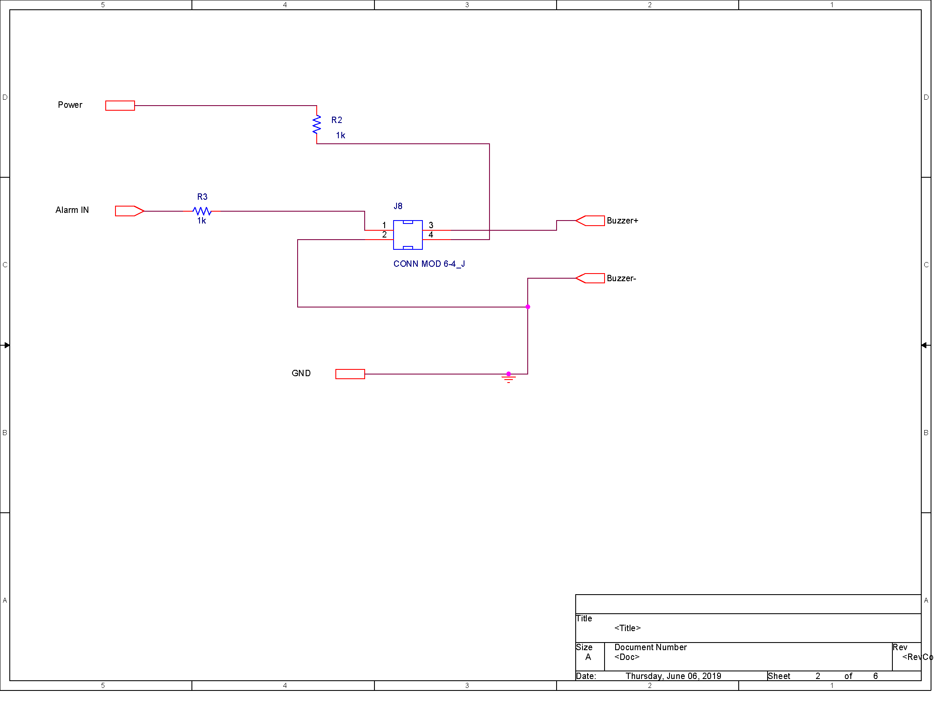

### Battery Indicator

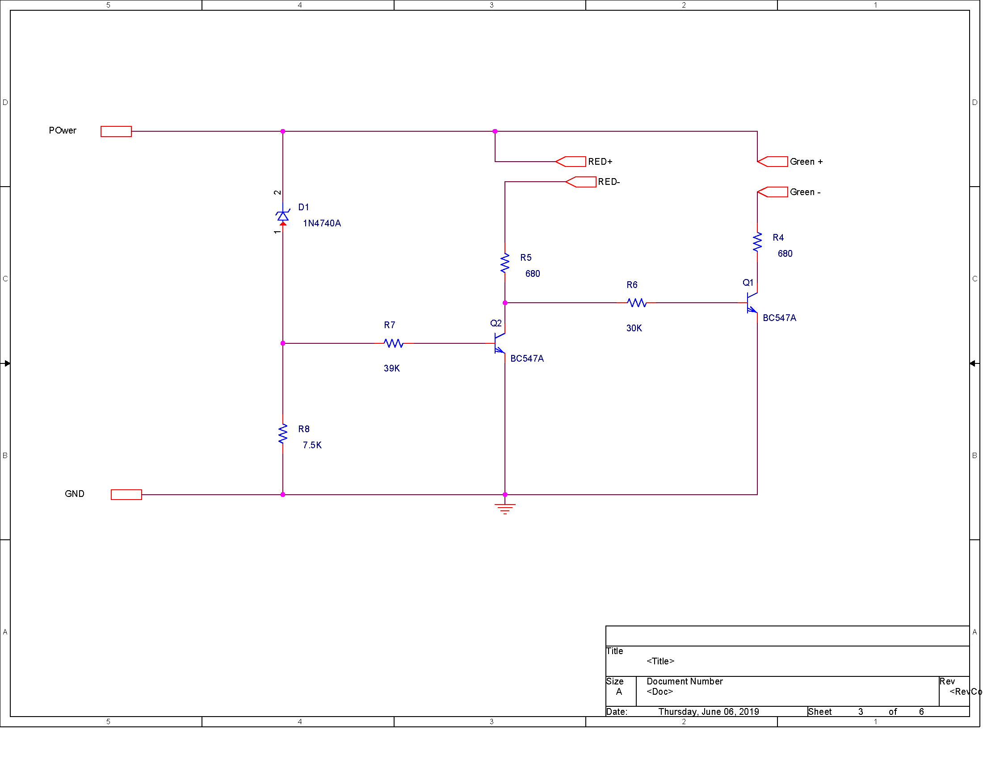

### RF communication

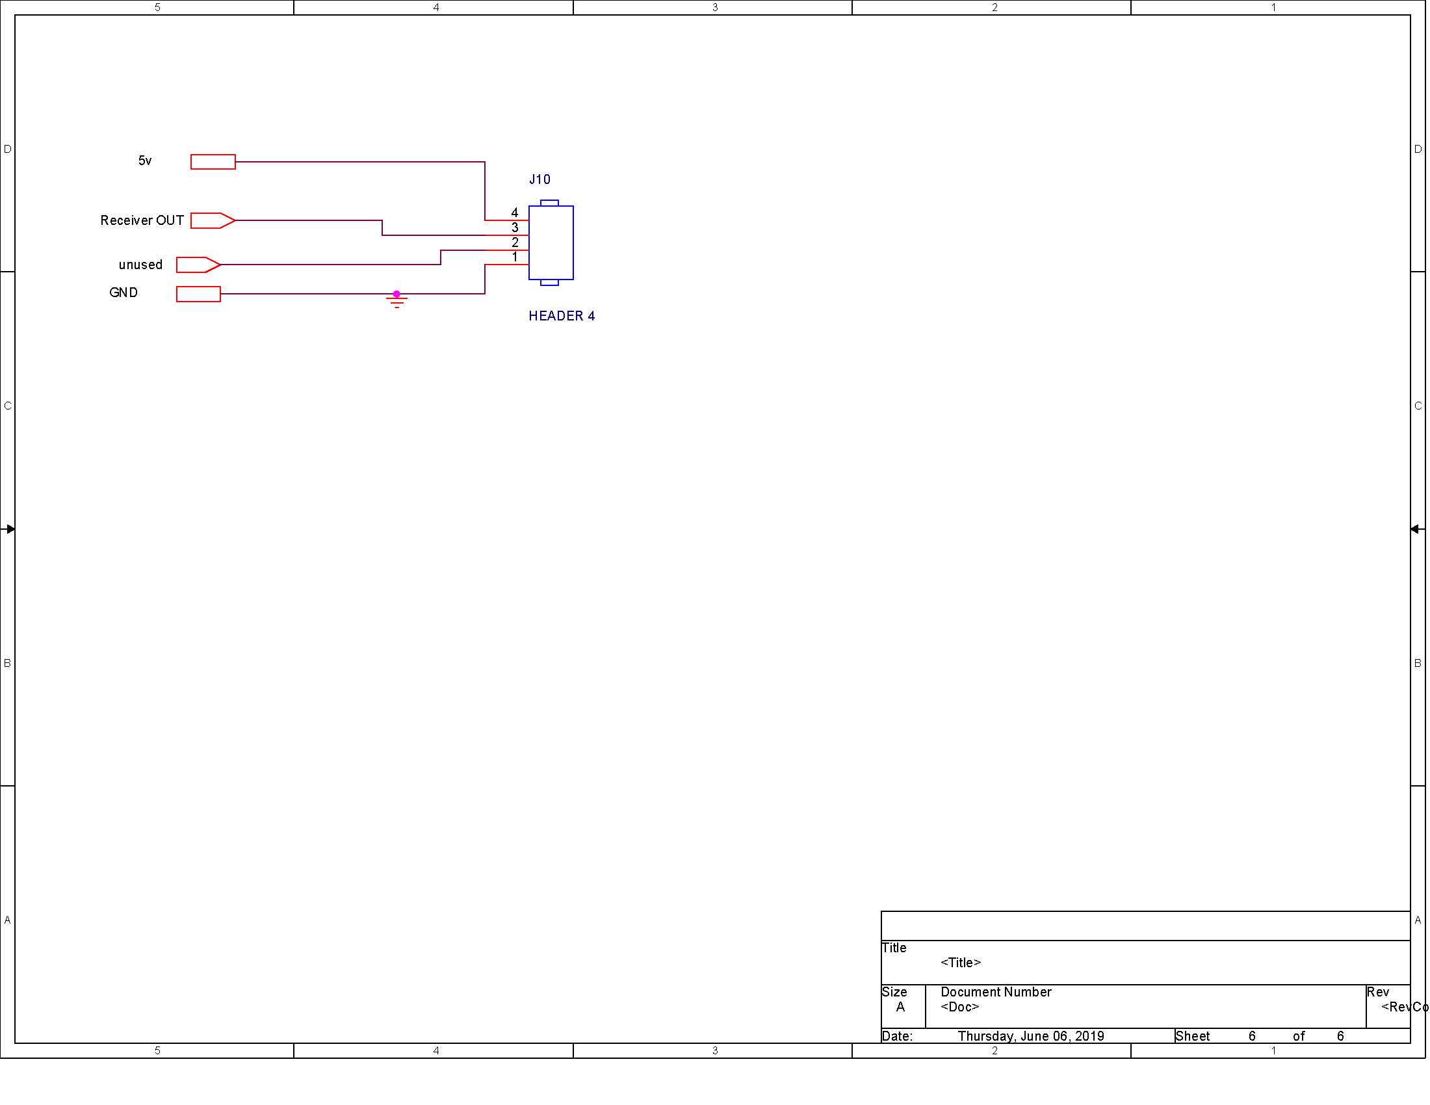

### Power regulator

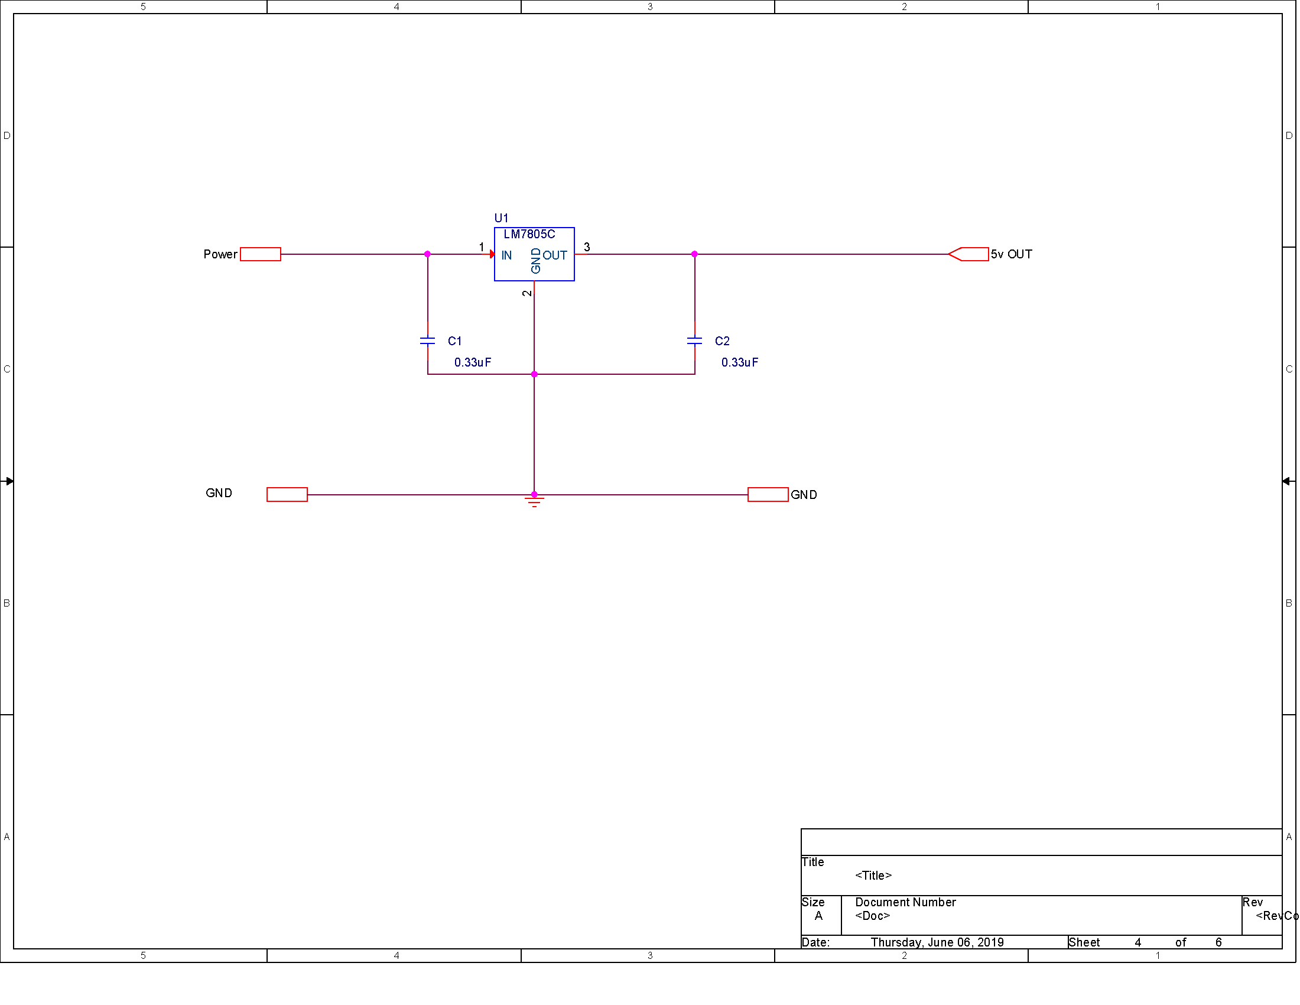

### Processor

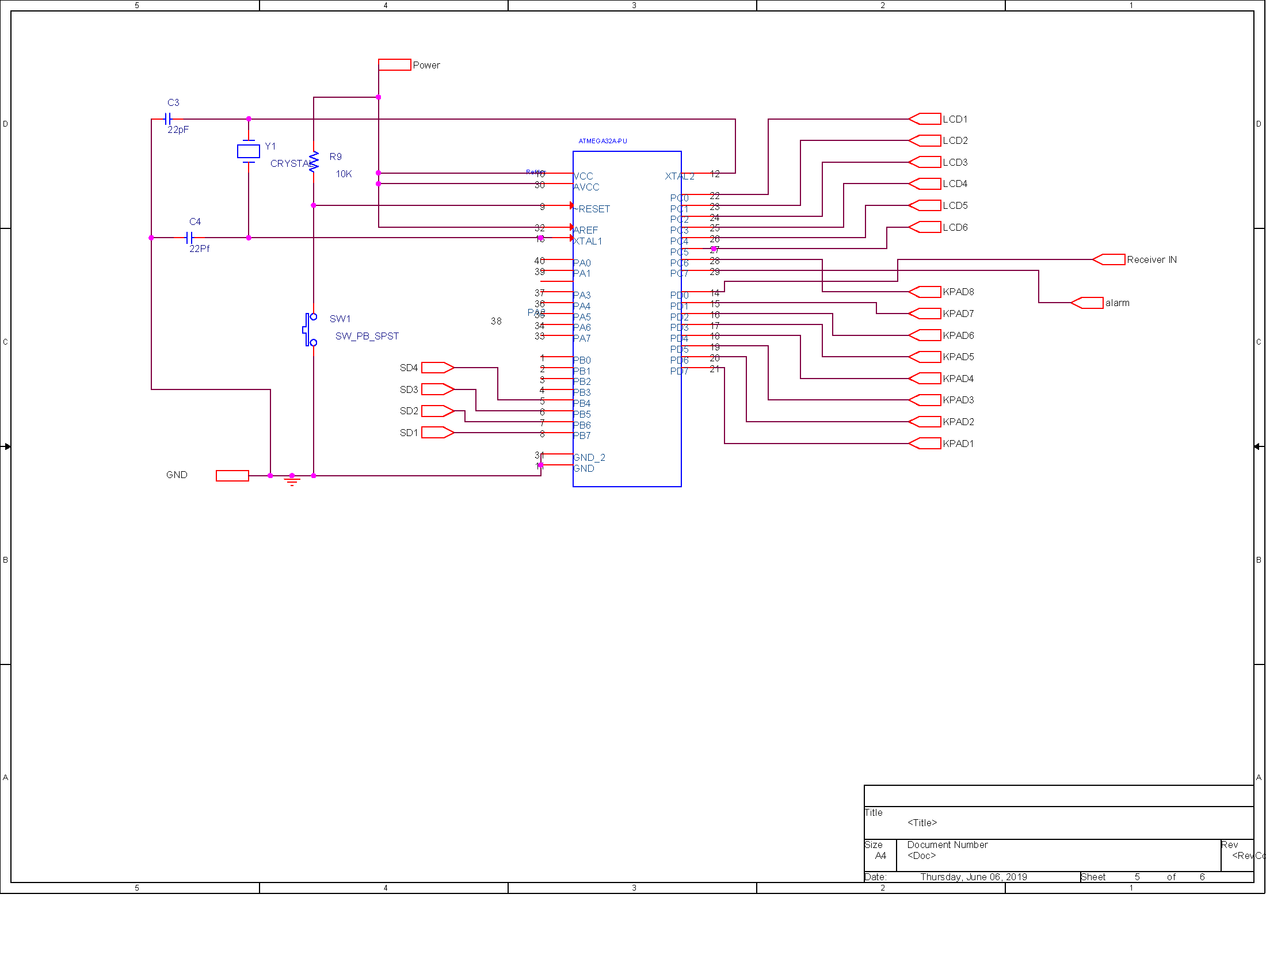

## Circuit Layout

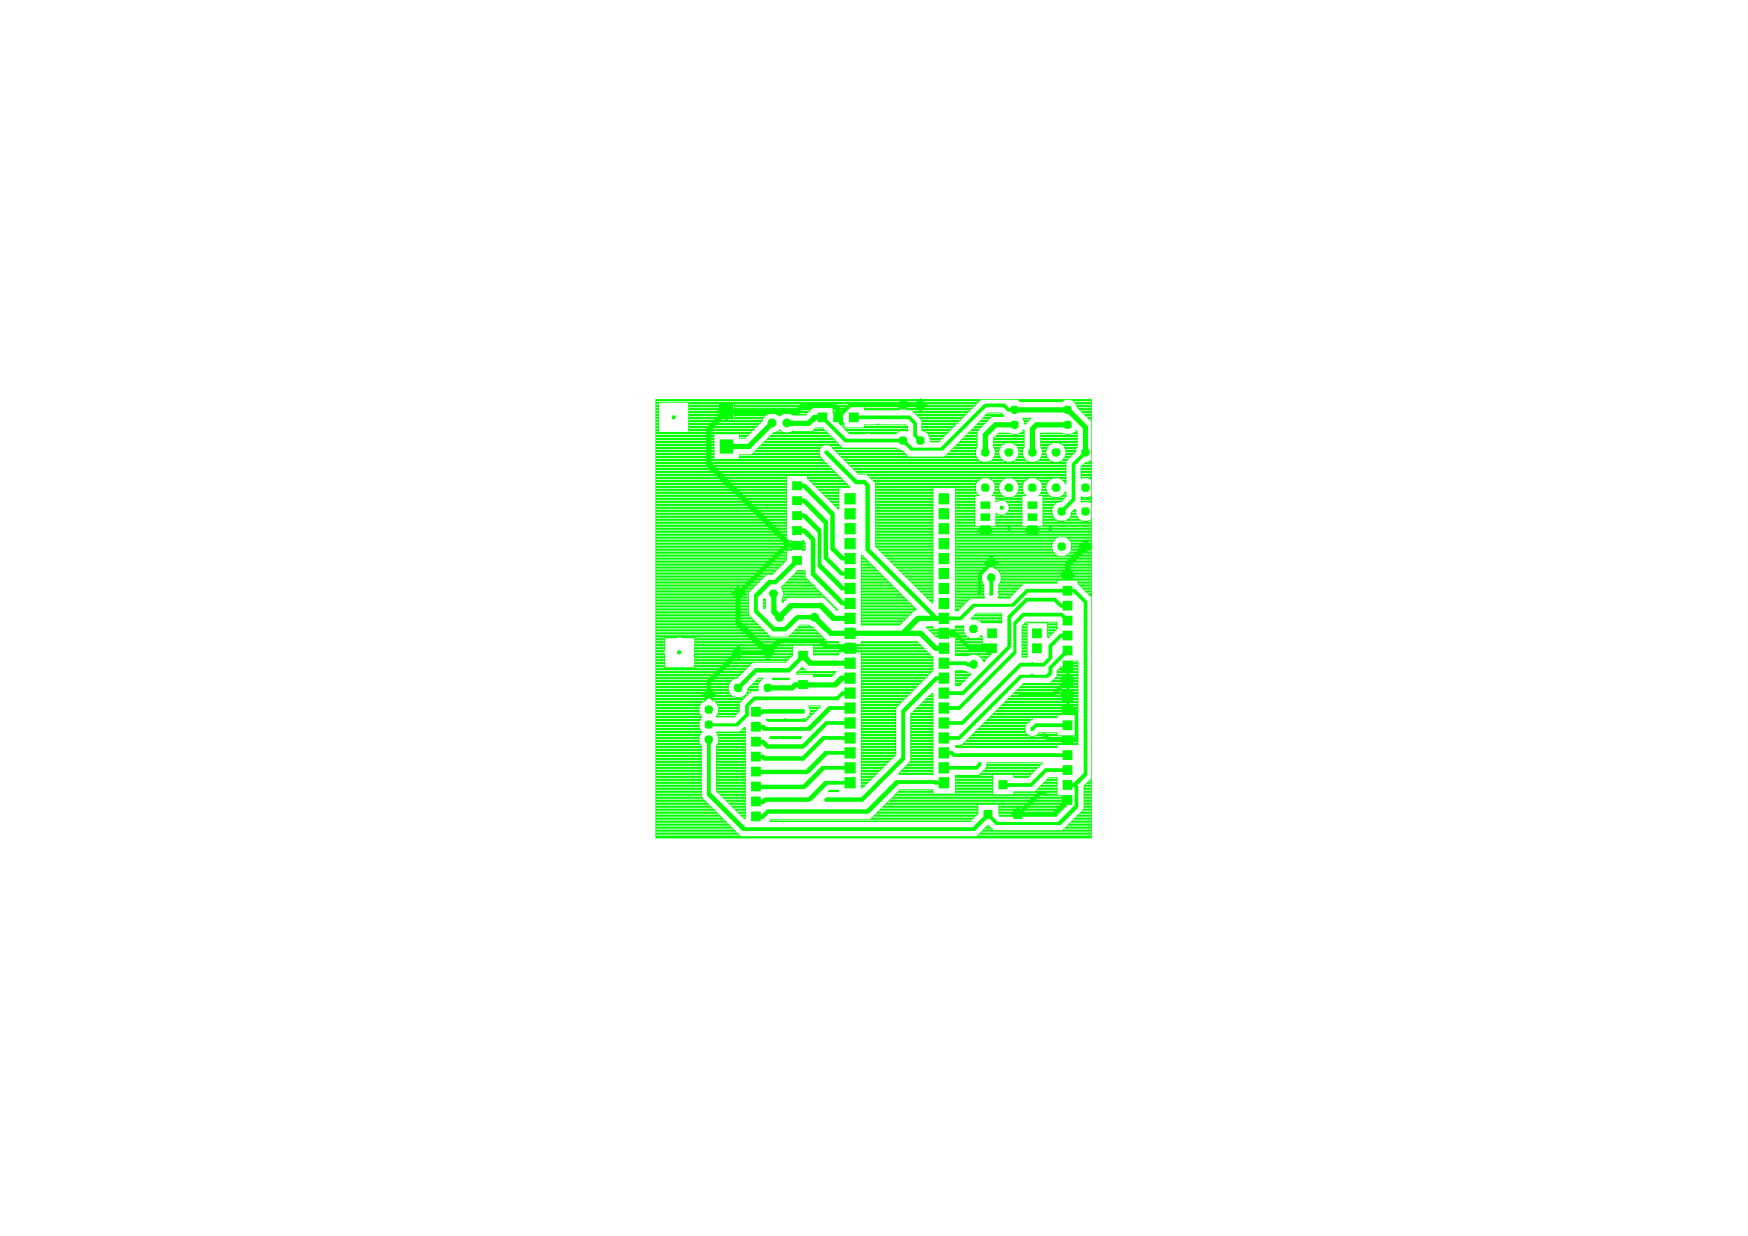Display Unit BottomSilkscreen

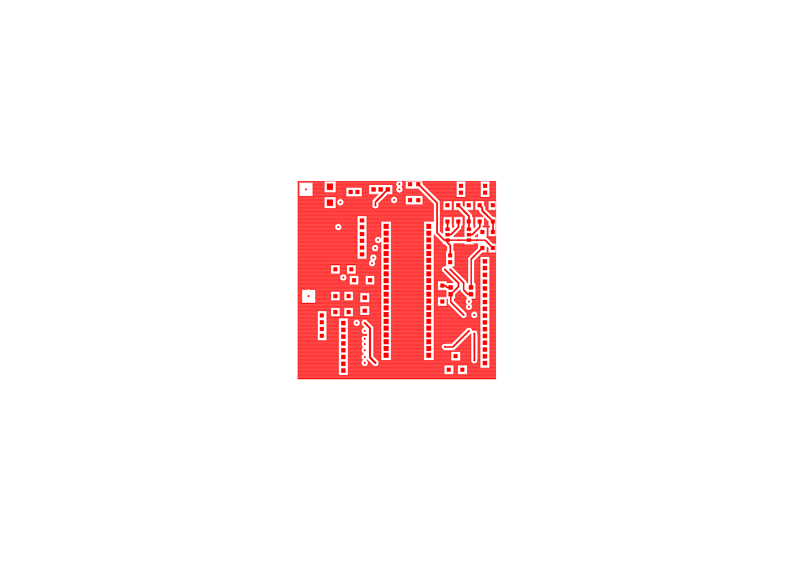Display Unit Top

INSert 5 pages

|  |
| --- |
| Group 1 |
| Controlled Environment Monitors |
| **Testing** |

## Sensor Unit PCB Testing

Testprep General Analysis ...

|  |  |  |
| --- | --- | --- |
| Total number of nets | ... | 19 |
| Total number of nets tested | ... | 3 |
| Total number of nets not tested | ... | 15 |
| Total number of nets flagged with NO_TEST property | ... | 1 |
| Total number of nets testable (tested + not tested) | ... | 18 |
| Percentage of all nets tested | ... | 15.79 percent |
| Percentage of testable nets tested | ... | 16.67 percent |
| Nets requiring more than one testprobe: |  |  |

Required Actual Net Name

-------- ------ --------

6 0 N06627

6 0 N07080

6 0 N07092

|  |  |  |
| --- | --- | --- |
| Total number of testprobes on TOP side | ... | 0 ( 0.00 percent) |
| Total number of testprobes on BOTTOM side | ... | 6 (100.00 percent) |
| Total number of testprobes on pins | ... | 0 |
| Total number of testprobes on vias | ... | 6 |

WARNING: There are 6 testprobes with no assigned probe type. Minimum pad size for probing ... 0 MM

|===========================================================================================================================================================

| |

| Nets currently under test for TOP side ...

| |

|===========================================================================================================================================================

| Net Name | QUANTITY | Number | Type | Pad Size | Location | Reference Designation |

|===========================================================================================================================================================

Total number of testpoints on TOP side = 0

|==========================================================================================================================================================

| |

| Nets currently under test for BOTTOM side ...

| |

|===========================================================================================================================================================

| Net Name | QUANTITY | Number | Type | Pad Size | Location | Reference Designation |

|===========================================================================================================================================================

|  |  |  |  |  |  |  |
| --- | --- | --- | --- | --- | --- | --- |
| | N05812 | | | | | 1 | Via | | | 0.6096 | (-44.0000 -33.0000) | N05812 | | |
| | | | | | | 2 | Via | | | 0.6096 | (-38.0000 -10.0000) | N05812-A | | |
| | | | | | | 3 | Via | | | 0.6096 | (-43.2700 -2.0000) | N05812-B | | |
| | | | | | | 4 | Via | | | 0.6096 | (-39.0000 15.0836) | N05812-C | | |

|-----------------------------------------------------------------------------------------------------------------------------------------------------------

| N06064 | | 1 | Via | 0.6096 | (-40.7300 -2.0000) | N06064 |

|-----------------------------------------------------------------------------------------------------------------------------------------------------------

| N06072 | | 1 | Via | 0.6096 | (-40.7300 9.0000) | N06072 |

|-----------------------------------------------------------------------------------------------------------------------------------------------------------

Total number of testpoints on BOTTOM side = 6

|==========================================================================================================================================================

| |

| Nets currently not tested ...

| |

|===========================================================================================================================================================

| Net Name | QUANTITY |

|============================================|

| N01461 | |

|--------------------------------------------|

| N01481 | |

|--------------------------------------------|

| N01545 | |

|--------------------------------------------|

| N01565 | |

|--------------------------------------------|

| N01577 | |

|--------------------------------------------|

| N01607 | |

|--------------------------------------------|

| N03368 | |

|--------------------------------------------|

| N03420 | |

|--------------------------------------------|

| N06627 | 6 |

|--------------------------------------------|

| N06779 | |

|--------------------------------------------|

| N07080 | 6 |

|--------------------------------------------|

| N07092 | 6 |

|--------------------------------------------|

| N07402 | |

|--------------------------------------------|

| N07414 | |

|--------------------------------------------|

| N09349 | |

|--------------------------------------------|

Total number of nets not currently tested = 15

|==========================================================================================================================================================

| |

| Nets currently with NO_TEST property ...

| |

|===========================================================================================================================================================

| Net Name | QUANTITY |

|============================================|

| N05864 | |

|--------------------------------------------|

Total number of nets with NO_TEST property = 1

|  |  |  |  |  |
| --- | --- | --- | --- | --- |
|  | **Test Report for Sensor Unit** | |  |  |
|  |  |  |  |  |
| **Testpoints on the Top Side** | |  |  |  |
| Tespoint | Delivered Input (V) | Expected Output (V) |  |  |
|  |  |  |  |  |
|  |  |  |  |  |
|  |  |  |  |  |
|  |  |  |  |  |
|  |  |  |  |  |
|  |  |  |  |  |
|  |  |  |  |  |
|  |  |  |  |  |
|  |  |  |  |  |
|  |  |  |  |  |
|  |  |  |  |  |
|  |  |  |  |  |
|  |  |  |  |  |
|  |  |  |  |  |
|  |  |  |  |  |
|  |  |  |  |  |
|  |  |  |  |  |
|  |  |  |  |  |
| Testpoints on the Bottom Side | |  |  |  |
| Testpoint | Input (V) | Expected Output(V) |  |  |
| NO6072 | 4.65±7.5% | 4.65±7% |  |  |
| NO6064 | 4.65±7.5% | 4.65±7.5% |  |  |
| NO5812 | 4.65±7.5% | 4.65±7.5% |  |  |
|  |  |  |  |  |
|  | **Test Report for Power** | |  |  |
| Voltage Supplied by the Battery | |  | 8±15% |  |
| Regulated Voltage | |  | 4.65±7.5% |  |
| Expected Current out from Regulator | | | 3A |  |

## Display Unit PCB Testing

Testprep General Analysis ...

|  |  |  |
| --- | --- | --- |
| Total number of nets | ... | 39 |
| Total number of nets tested | ... | 18 |
| Total number of nets not tested | ... | 21 |
| Total number of nets flagged with NO_TEST property | ... | 0 |
| Total number of nets testable (tested + not tested) | ... | 39 |
| Percentage of all nets tested | ... | 46.15 percent |
| Percentage of testable nets tested | ... | 46.15 percent |
| Nets requiring more than one testprobe: |  |  |
| (None) |  |  |
| Total number of testprobes on TOP side | ... | 3 ( 13.04 percent) |
| Total number of testprobes on BOTTOM side | ... | 20 ( 86.96 percent) |
| Total number of testprobes on pins | ... | 0 |
| Total number of testprobes on vias | ... | 23 |

WARNING: There are 23 testprobes with no assigned probe type. Minimum pad size for probing ... 0 MM

|===========================================================================================================================================================

| |

| Nets currently under test for TOP side ...

| |

|===========================================================================================================================================================

| Net Name | QUANTITY | Number | Type | Pad Size | Location | Reference Designation |

|===========================================================================================================================================================

|  |  |  |  |  |  |  |  |
| --- | --- | --- | --- | --- | --- | --- | --- |
| | GND | | | | | 4 | Via | | | 0.6096 | (23.0000 13.9680) | | GND-3 | | |
| | | | | | | 5 | Via | | | 0.6096 | (30.0000 13.9680) | | GND-4 | | |

|-----------------------------------------------------------------------------------------------------------------------------------------------------------

| N00686 | | 1 | Via | 0.6096 | (21.7688 17.6298) | N00686 |

|-----------------------------------------------------------------------------------------------------------------------------------------------------------

Total number of testpoints on TOP side = 3

|==========================================================================================================================================================

| |

| Nets currently under test for BOTTOM side ...

| |

|===========================================================================================================================================================

| Net Name | QUANTITY | Number | Type | Pad Size | Location | Reference Designation |

|===========================================================================================================================================================

|  |  |  |  |  |  |  |  |
| --- | --- | --- | --- | --- | --- | --- | --- |
| | GND | | | | | 1 | Via | | | 0.6096 | (-21.8797 18.8797) | | GND | | |
| | | | | | | 2 | Via | | | 0.6096 | (1.0000 35.0000) | | GND-1 | | |
| | | | | | | 3 | Via | | | 0.6096 | (29.0000 -14.0000) | | GND-2 | | |

|-----------------------------------------------------------------------------------------------------------------------------------------------------------

| N00391 | | 1 | Via | 0.6096 | (-1.0000 29.0000) | N00391 |

|-----------------------------------------------------------------------------------------------------------------------------------------------------------

|  |  |  |  |  |  |  |  |
| --- | --- | --- | --- | --- | --- | --- | --- |
| | N00588 | | | | | 1 | Via | | | 0.6096 | (1.0000 33.0000) | | N00588 | | |
| | | | | | | 2 | Via | | | 0.6096 | (-20.0000 0.0000) | | N00588-1 | | |

|-----------------------------------------------------------------------------------------------------------------------------------------------------------

| N01074 | | 1 | Via | 0.6096 | (-9.2603 5.3187) | N01074 |

|-----------------------------------------------------------------------------------------------------------------------------------------------------------

| N01110 | | 1 | Via | 0.6096 | (-8.7983 7.3967) | N01110 |

|-----------------------------------------------------------------------------------------------------------------------------------------------------------

| N01146 | | 1 | Via | 0.6096 | (-8.1003 11.0000) | N01146 |

|-----------------------------------------------------------------------------------------------------------------------------------------------------------

| N01180 | | 1 | Via | 0.6096 | (-7.0000 14.0000) | N01180 |

|-----------------------------------------------------------------------------------------------------------------------------------------------------------

| N01995 | | 1 | Via | 0.6096 | (-12.0000 -32.0000) | N01995 |

|-----------------------------------------------------------------------------------------------------------------------------------------------------------

| N02035 | | 1 | Via | 0.6096 | (-12.0000 -29.8100) | N02035 |

|-----------------------------------------------------------------------------------------------------------------------------------------------------------

| N02075 | | 1 | Via | 0.6096 | (-12.0000 -27.2700) | N02075 |

|-----------------------------------------------------------------------------------------------------------------------------------------------------------

| N02113 | | 1 | Via | 0.6096 | (-12.0000 -25.0000) | N02113 |

|-----------------------------------------------------------------------------------------------------------------------------------------------------------

| N02151 | | 1 | Via | 0.6096 | (-12.0000 -23.0000) | N02151 |

|-----------------------------------------------------------------------------------------------------------------------------------------------------------

| N02192 | | 1 | Via | 0.6096 | (-12.0000 -20.0000) | N02192 |

|-----------------------------------------------------------------------------------------------------------------------------------------------------------

| N02230 | | 1 | Via | 0.6096 | (-15.0000 -17.0000) | N02230 |

|-----------------------------------------------------------------------------------------------------------------------------------------------------------

| N03383 | | 1 | Via | 0.6096 | (27.0000 -9.0000) | N03383 |

|-----------------------------------------------------------------------------------------------------------------------------------------------------------

| N03418 | | 1 | Via | 0.6096 | (27.0000 -11.0000) | N03418 |

|-----------------------------------------------------------------------------------------------------------------------------------------------------------

| N06708 | | 1 | Via | 0.6096 | (-21.1271 28.1429) | N06708 |

|-----------------------------------------------------------------------------------------------------------------------------------------------------------

Total number of testpoints on BOTTOM side = 20

|==========================================================================================================================================================

| |

| Nets currently not tested ...

| |

|===========================================================================================================================================================

| Net Name | QUANTITY |

|============================================|

| N00181 | |

|--------------------------------------------|

| N00255 | |

|--------------------------------------------|

| N00282 | |

|--------------------------------------------|

| N00339 | |

|--------------------------------------------|

| N00522 | |

|--------------------------------------------|

| N00636 | |

|--------------------------------------------|

| N00688 | |

|--------------------------------------------|

| N00715 | |

|--------------------------------------------|

| N00717 | |

|--------------------------------------------|

| N00827 | |

|--------------------------------------------|

| N00890 | |

|--------------------------------------------|

| N01521 | |

|--------------------------------------------|

| N01957 | |

|--------------------------------------------|

| N02340 | |

|--------------------------------------------|

| N03028 | |

|--------------------------------------------|

| N03303 | |

|--------------------------------------------|

| N03341 | |

|--------------------------------------------|

| N03460 | |

|--------------------------------------------|

| N03495 | |

|--------------------------------------------|

| N03676 | |

|--------------------------------------------|

| UNUSED | |

|--------------------------------------------|

Total number of nets not currently tested = 21

|==========================================================================================================================================================

| |

| Nets currently with NO_TEST property ...

| |

|===========================================================================================================================================================

| Net Name | QUANTITY |

|============================================|

Total number of nets with NO_TEST property = 0

|  |  |  |  |
| --- | --- | --- | --- |
|  | **Test Report for Display Unit** | |  |
|  |  |  |  |
| **Testpoints on the Top Side** | |  |  |
| Testpoint | Delivered Input (V) | Expected Output(V) |  |
| N00391 | 4.65±7.5% | 4±0.5% |  |
| N00588 | 4.65±7.5% | 4±0.5% |  |
| N01074 | 4.65±7.5% | 4±0.5% |  |
| N01110 | 4.65±7.5% | 4±0.5% |  |
| N01146 | 4.65±7.5% | 4±0.5% |  |
| N01180 | 4.65±7.5% | 4.65±7.5% |  |
| N01995 | 4.65±7.5% | 4.65±7.5% |  |
| N02035 | 4.65±7.5% | 4.65±7.5% |  |
| N02075 | 4.65±7.5% | 4.65±7.5% |  |
| N02113 | 4.65±7.5% | 4.65±7.5% |  |
| N02151 | 4.65±7.5% | 4.65±7.5% |  |
| N02192 | 4.65±7.5% | 4.65±7.5% |  |
| N02230 | 4.65±7.5% | 4.65±7.5% |  |
| N03383 | 4.65±7.5% | 4.65±7.5% |  |
| N03418 | 4.65±7.5% | 4.65±7.5% |  |
| N06708 | 4.65±7.5% | 4±0.5% |  |
| GND | 0 | 0 |  |
|  |  |  |  |
| Nets on The Bottom Side | |  |  |
| Testpoint | Input (V) | Expected Output(V) |  |
| GND | 0 | 0 |  |
| N00686 | 4.65±7.5% | 4.65±7.5% |  |
|  |  |  |  |
|  |  |  |  |
|  | **Test Report for Power** | |  |
| Voltage Supplied by the Battery | |  | 8±15% |
| Regulated Voltage | |  | 4.65±7.5% |
| Expected Current out from Regulator | |  | 1A |

|  |
| --- |
| Group 1 |
| Controlled Environment Monitors |
| **Assembly** |

# Sensor Unit Assembly

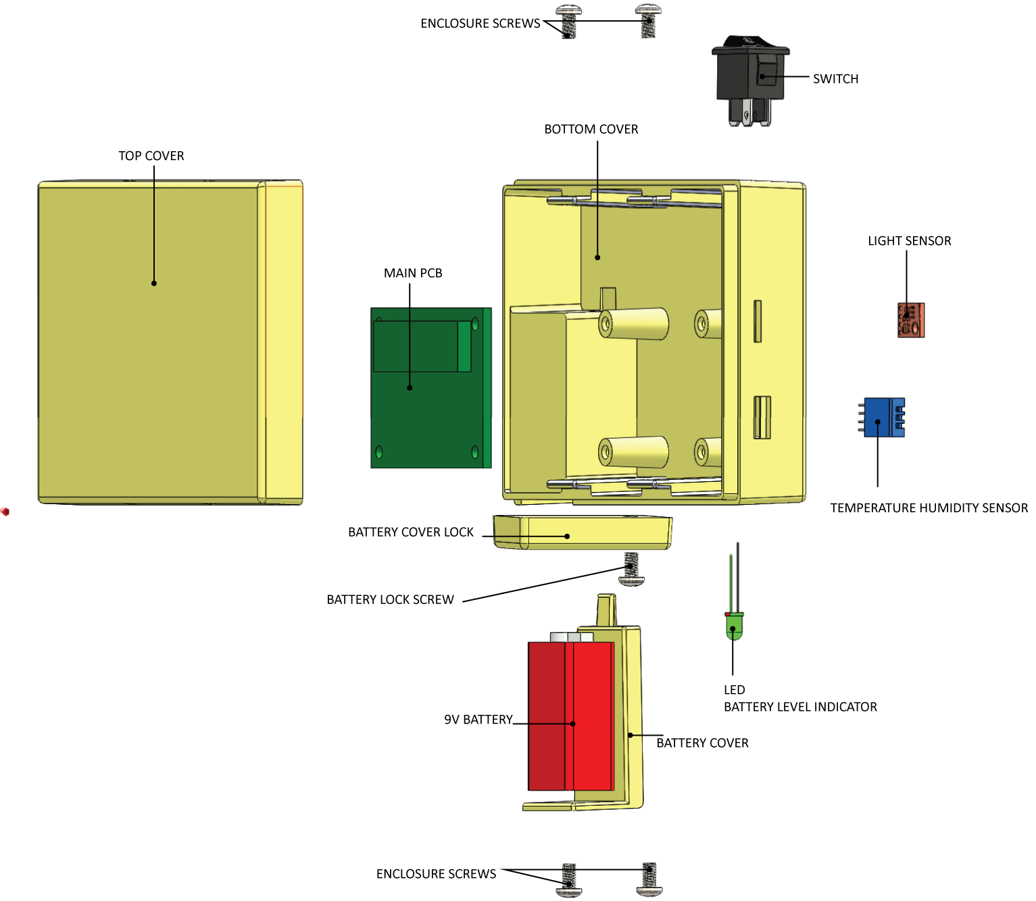

## Assembly Steps

1. Connect the LCD’s to the corresponding headers on the PCB (Refer Circuit Diagram).
2. Insert and secure the LCD’s into corresponding sockets
3. Mount the Fully soldered and tested PCB on the corresponding mounting holes
4. Insert screws and secure the PCB
5. Insert the Temperature, RH, Light and Soil Moisture Sensors into their corresponding sockets and secure.
6. Connect the above sensors using their corresponding polarized headers (See Circuit Diagrams for more information)
7. Insert the rocker switch and secure the battery connector in their corresponding positions.
8. Connect the rocker switch and battery connector to the corresponding places on the PCB
9. Insert the Battery Cover into the Battery Cover slot
10. Screw the Battery Lock into position, and rotate clockwise to secure the battery cover
11. Fit the top cover into position and secure the sides with screws.

# A picture containing screenshot Description automatically generatedDisplay Unit Assembly

## Assembly Steps

1. Connect the LCD’s to the corresponding headers on the PCB (Refer Circuit Diagram).
2. Insert and secure the LCD’s into corresponding sockets
3. Mount the Fully soldered and tested PCB on the corresponding mounting holes
4. Insert screws and secure the PCB
5. Connect the SD card Reader to the corresponding connector on the PCB and insert the SD card reader into its corresponding position and secure.
6. Insert the rocker switch and secure the battery connector in their corresponding positions.
7. Connect the rocker switch and battery connector to the corresponding places on the PCB.
8. Insert the Battery Cover into the Battery Cover slot, and screw into position.
9. Secure the LCD Screen to the inside of the Top Cover.
10. Secure the Keypad to its slot on the top cover, while taking its connector in through the front slot.
11. Connect both LCD and Keypad to the PCB in their correct positions.
12. Fit the top cover into position and secure the sides with locking screws.

# Processor Code

/* ---------------------------------------------------------------------------------------------------

[FILE NAME]: <Configuration Files.c>

[AUTHOR(S)]: <T.T.N Bahavan>

[DATE CREATED]: <6/19/2019>

[DESCRIPTION]: <Contains configuration files for LCD Unit>

---------------------------------------------------------------------------------------------------*/

#ifndef MICRO_CONFIG_H_

#define MICRO_CONFIG_H_

#ifndef F_CPU

#define F_CPU 10000000UL //8MHz Clock frequency

#endif

#include <avr/io.h>

#include <avr/interrupt.h>

#include <util/delay.h>

#include <string.h>

#include "std_types.h"

#include "common_macros.h"

#include "lcd.h"

#include "keypad.h"

#include "IntEEPROM.h"

#include "password.h"

#endif

/* MICRO_CONFIG_H_ */

/* ---------------------------------------------------------------------------------------------------

[FILE NAME]: <EEPROMCODE.c>

[AUTHOR(S)]: <T.T.N Bahavan>

[DATE CREATED]: <6/19/2019>

[DESCRIPTION]: <EEPROM>

---------------------------------------------------------------------------------------------------*/

#include "IntEEPROM.h"

void eepromWriteByte(unsigned short a_addr, unsigned char a_data)

{

/* Wait for completion of previous write */

while (EECR & (1 << EEWE))

;

/* Set up address and data registers */

EEAR = a_addr;

EEDR = a_data;

/* Write logical one to EEMWE */

EECR |= (1 << EEMWE);

/* Start EEPROM write by setting EEWE */

EECR |= (1 << EEWE);

}

unsigned char eepromReadByte(unsigned short a_addr)

{

/* Wait for completion of previous write */

while (EECR & (1 << EEWE))

;

/* Set up address register */

EEAR = a_addr;

/* Start EEPROM read by writing EERE */

EECR |= (1 << EERE);

/* Return data from data register */

return EEDR;

}

/* ---------------------------------------------------------------------------------------------------

[FILE NAME]: <KEYPAD CODE.c>

[AUTHOR(S)]: <T.T.N Bahavan>

[DATE CREATED]: <6/19/2019>

[DESCRIPTION]: <Contains the main function of the program>

---------------------------------------------------------------------------------------------------*/

#include "keypad.h"

uint8 KeyPad_getPressedKey(void){

uint8 col,row;

while(1)

{

for(col=0;col<N_col;col++) /* loop for columns */

{

/*

* each time only one of the column pins will be output and

* the rest will be input pins include the row pins

*/

KEYPAD_PORT_DIR = (0b00010000<<col);

/*

* clear the output pin column in this trace and enable the internal

* pull up resistors for the rows pins

*/

KEYPAD_PORT_OUT = (~(0b00010000<<col));

for(row=0;row<N_row;row++) /* loop for rows */

{

if(BIT_IS_CLEAR(KEYPAD_PORT_IN,row)) /* if the switch is press in this row */

{

#if (N_col == 3)

return KeyPad_4x3_adjustKeyNumber((row*N_col)+col+1);

#elif (N_col == 4)

return KeyPad_4x4_adjustKeyNumber((row*N_col)+col+1);

#endif

}

}

}

}

}

#if (N_col == 3)

uint8 KeyPad_4x3_adjustKeyNumber(uint8 button_number)

{

switch(button_number)

{

case 10: return '*'; // ASCII Code of =

break;

case 11: return 0;

break;

case 12: return '#'; // ASCII Code of +

break;

default: return button_number;

}

}

#elif (N_col == 4)

uint8 KeyPad_4x4_adjustKeyNumber(uint8 button_number)

{

switch(button_number)

{

case 1: return 7;

break;

case 2: return 8;

break;

case 3: return 9;

break;

case 4: return '%'; // ASCII Code of %

break;

case 5: return 4;

break;

case 6: return 5;

break;

case 7: return 6;

break;

case 8: return '*'; /* ASCII Code of '*' */

break;

case 9: return 1;

break;

case 10: return 2;

break;

case 11: return 3;

break;

case 12: return '-'; /* ASCII Code of '-' */

break;

case 13: return 13; /* ASCII of Enter */

break;

case 14: return 0;

break;

case 15: return '='; /* ASCII Code of '=' */

break;

case 16: return '+'; /* ASCII Code of '+' */

break;

default: return button_number;

}

}

#endif

/* ---------------------------------------------------------------------------------------------------

[FILE NAME]: <UART.c>

[AUTHOR(S)]: <T.T.N Bahavan>

[DATE CREATED]: <6/19/2019>

[DESCRIPTION]: <UART CODE>

---------------------------------------------------------------------------------------------------*/

#include "uart.h"

extern volatile uint8 g_choice;

void UART_init(void) {

UCSRA = (1 << U2X); /* U2X = 1 for double transmission speed */

/************************** UCSRB Description **************************

* RXCIE = 1 Enable USART RX Complete Interrupt Enable

* TXCIE = 0 Disable USART Tx Complete Interrupt Enable

* UDRIE = 0 Disable USART Data Register Empty Interrupt Enable

* RXEN = 1 Receiver Enable

* RXEN = 1 Transmitter Enable

* UCSZ2 = 0 For 8-bit data mode

* RXB8 & TXB8 not used for 8-bit data mode

***********************************************************************/

UCSRB = (1 << RXEN) | (1 << TXEN) | (1 << RXCIE);

/************************** UCSRC Description **************************

* URSEL = 1 The URSEL must be one when writing the UCSRC

* UMSEL = 0 Asynchronous Operation

* UPM1:0 = 00 Disable parity bit

* USBS = 0 One stop bit

* UCSZ1:0 = 11 For 8-bit data mode

* UCPOL = 0 Used with the Synchronous operation only

***********************************************************************/

UCSRC = (1 << URSEL) | (1 << UCSZ0) | (1 << UCSZ1);

/* baud rate=9600 & Fosc=8MHz --> UBBR=( Fosc / (8 * baud rate) ) - 1 = 103 */

UBRRH = 0;

UBRRL = 103;

}

void UART_sendByte(const uint8 data) {

/* UDRE flag is set when the Tx buffer (UDR) is empty and ready for

* transmitting a new byte so wait until this flag is set to one */

while (BIT_IS_CLEAR(UCSRA, UDRE)) {

}

/* Put the required data in the UDR register and it also clear the UDRE flag as

* the UDR register is not empty now */

UDR = data;

/************************* Another Method *************************

UDR = data;

while(BIT_IS_CLEAR(UCSRA,TXC)){} // Wait until the transimission is complete TXC = 1

SET_BIT(UCSRA,TXC); // Clear the TXC flag

*******************************************************************/

}

uint8 UART_recieveByte(void) {

/* RXC flag is set when the UART receive data so wait until this

* flag is set to one */

while (BIT_IS_CLEAR(UCSRA, RXC)) {

}

/* Read the received data from the Rx buffer (UDR) and the RXC flag

will be cleared after read this data */

return UDR;

}

void UART_sendString(const uint8 *Str) {

uint8 i = 0;

while (Str[i] != '\0') {

UART_sendByte(Str[i]);

i++;

}

/************************* Another Method *************************

while(*Str != '\0')

{

UART_sendByte(*Str);

Str++;

}

*******************************************************************/

}

void UART_receiveString(uint8 *Str) {

uint8 i = 0;

Str[i] = UART_recieveByte();

while (Str[i] != '#') {

i++;

Str[i] = UART_recieveByte();

}

Str[i] = '\0';

}

/* ---------------------------------------------------------------------------------------------------

[FILE NAME]: <Main Control Unit.c>

[AUTHOR(S)]: <T.T.N Bahavan>

[DATE CREATED]: <6/19/2019>

[DESCRIPTION]: <Contains the main function of the program>

---------------------------------------------------------------------------------------------------*/

#ifndef STD_TYPES_H_

#define STD_TYPES_H_

typedef unsigned char uint8;

typedef signed char sint8;

typedef unsigned short uint16;

typedef signed short sint16;

typedef unsigned long uint32;

typedef signed long sint32;

#endif /* STD_TYPE_H_ */

/* ---------------------------------------------------------------------------------------------------

[FILE NAME]: <ADC Unit for sensors.c>

[AUTHOR(S)]: <T.T.N Bahavan>

[DATE CREATED]: <6/19/2019>

[DESCRIPTION]: <ADC Conversion>

---------------------------------------------------------------------------------------------------*/

#include "atmega-adc.h"

void (*_adc_handler)(*uint8_t* pin, *uint16_t*);

volatile *uint8_t* _adc_pin_qty;

*uint16_t* adc_read(*uint8_t* prescaler, *uint8_t* vref, *uint8_t* pin) {

#ifdef MUX5

if (pin > 7) {

ADCSRB |= _BV(MUX5);

ADMUX = vref | (pin - 8);

} else {

ADCSRB &= ~(_BV(MUX5));

ADMUX = vref | pin;

}

#else

ADMUX = vref | pin;

#endif

ADCSRA = _BV(ADEN) | _BV(ADSC) | prescaler;

while(!(ADCSRA & _BV(ADIF)));

return (ADCL | (ADCH<<8));

}

void adc_start(*uint8_t* prescaler, *uint8_t* vref, *uint8_t* pin_qty, void (*handler)(*uint8_t*, *uint16_t*)) {

_adc_handler = handler;

_adc_pin_qty = pin_qty;

ADMUX = vref;

#ifdef MUX5

ADCSRB &= ~(_BV(MUX5));

#endif

ADCSRA = _BV(ADEN) | _BV(ADSC) | _BV(ADIE) | prescaler;

}

void adc_stop() {

ADCSRA = 0;

}

#ifdef ENABLE_ADC_INT

ISR(ADC_vect) {

static *uint8_t* cur_pin = 0;

_adc_handler(cur_pin, ADCL | (ADCH<<8));

cur_pin++;

if (cur_pin >= _adc_pin_qty)

cur_pin = 0;

#ifdef MUX5

if (cur_pin > 7) {

ADCSRB |= _BV(MUX5);

ADMUX = (ADMUX & 0xe0) | (cur_pin - 8);

} else {

ADCSRB &= ~(_BV(MUX5));

ADMUX = (ADMUX & 0xe0) | cur_pin;

}

#else

ADMUX = (ADMUX & 0xe0) | cur_pin;

#endif

ADCSRA |= _BV(ADSC);

}

#endif

## Sensor Unit Code

/* ---------------------------------------------------------------------------------------------------

[FILE NAME]: <Sensor UNIT.c>

[AUTHOR(S)]: <T.T.N Bahavan>

[DATE CREATED]: <6/19/2019>

[DESCRIPTION]: <Contains the code in the sensor unit>

---------------------------------------------------------------------------------------------------*/

#include "micro_config.h"

#include <avr/io.h>

#include <util/delay.h>

#include <stdio.h>

#include "atmega-adc.h"

#include <stdint.h>

/*------------------------------------------------All Variables---------------------------------------------------*/

uint8 flag = 0;

uint8 val; /*to read the value from EEPROM in it*/

uint8 TEMP[6];

uint8 HUMID[6];

uint8 SOILMOISTURE[6];

uint8 LIGHTLEVEL[6];

uint8 COMPOSITEDATA[24];

int main(void)

{

UART_init(); /* initialize UART */

sei();

while (1)

{

TEMP[6]=adc_read(128, aref, 0) ;

HUMID[6]=adc_read(128, aref, 1) ;

SOILMOISTURE[6]=adc_read(128, aref, 2) ;

LIGHTLEVEL[6]=adc_read(128, aref, 3) ;

COMPOSITEDATA = MakeComposite(TEMP[6],HUMID[6],SOILMOISTURE[6],LIGHTLEVEL[6],COMPOSITEDATA[24]);

UART_sendString(COMPOSITEDATA) {

}

}

## LCD CODE

/* ---------------------------------------------------------------------------------------------------

[FILE NAME]: <Sensor UNIT.c>

[AUTHOR(S)]: <T.T.N Bahavan>

[DATE CREATED]: <6/19/2019>

[DESCRIPTION]: <Contains the code in the sensor unit>

---------------------------------------------------------------------------------------------------*/

#include "micro_config.h"

#include <avr/io.h>

#include <util/delay.h>

#include <stdio.h>

#include "atmega-adc.h"

#include <stdint.h>

/*------------------------------------------------All Variables---------------------------------------------------*/

uint8 flag = 0;

uint8 val; /*to read the value from EEPROM in it*/

uint8 TEMP[6]; //DETERMINED BY UART DATA

uint8 HUMID[6];

uint8 SOILMOISTURE[6];

uint8 LIGHTLEVEL[6];

uint8 MAXTEMP[6]; //SET BY THE USER ACCORDING TO SPECIFICATIONS REQUIRED

uint8 MINHUMID[6];

uint8 MINSOILMOISTURE[6];

uint8 MAXLIGHTLEVEL[6];

int main(void)

{

UART_init(); /* initialize UART */

LCD_init();

sei();

if !(UART_RECEIVED){

LCD_DISPLAY(0,0,"Waiting");

}

else {

while (1)

{//Display the stuff

//If button press start the other program

LCD_clearScreen();

LCD_displayStringRowColumn(0, 0, "Temp : "+TEMP);

LCD_displayStringRowColumn(0, 0, "Temp : "+HUMID);

LCD_displayStringRowColumn(0, 0, "Temp : "+SOILMOISTURE);

LCD_displayStringRowColumn(0, 0, "Temp : "+LIGHTLEVEL);

inputChoise1 = KeyPad_getPressedKey();

//Start changing the data

if (inputChoise1 == '+')

{

//Display Choices

LCD_clearScreen();

LCD_displayStringRowColumn(0, 0, "- : Change Temp");

LCD_displayStringRowColumn(1, 0, "+ : Change RH");

LCD_displayStringRowColumn(0, 5, "- : Change Soil Moisture");

LCD_displayStringRowColumn(1, 5, "+ : Change Light Level");

inputChoise2 = KeyPad_getPressedKey();

if (inputChoise2 == '+')

{ LCD_clearScreen();

LCD_displayStringRowColumn(0, 0, "RH");

getValue(RH);

}else{

LCD_clearScreen();

LCD_displayStringRowColumn(0, 0, "Temp");

getValue(Temp);

LCD_displayStringRowColumn(0, 0, "Soil Moisture");

getValue(RH);

}else{

LCD_clearScreen();

LCD_displayStringRowColumn(0, 0, "Light Level");

getValue(Temp);

}

}}

}

}

|  |
| --- |
| Group 1 |
| Controlled Environment Monitors |
| **Usage** |

# Basics

## Product View

Sensor Unit

Display Unit

## Overview

Controlled Environment Monitors are designed to raise an alarm when surrounding parameters exceed pre-set thresholds. Unlike household sensors CEM is designed to work off the grid. This makes it suitable to be used for monitoring closed agricultural environments like propagators and green houses.

# Key Features

* Wireless transmission between sensor unit and display.
* Possibility of using micro SD cards
* Battery level indicator displays the battery levels
* Buzzer is loud enough to indicate the threshold exceeding status.

# Getting Started

## Location

You need to place the sensor units inside of the control environment that need to be monitored. The display unit should be placed outside of the control environment as required by the user within 3m radius. Otherwise the interferences may cause errors in the values read inside the control environment.

## Setting up

Both the sensor unit and the display unit work with DC power*.* ***DO NOT CONNECT ANY AC POWER ADAPTERS TO THE UNITS.*** Recommended battery voltage is 9V but can use up to 12V.

## Installing the sensor unit

1. Turn the battery lever down and remove the battery cover form the back of the sensor unit and insert either rechargeable or non-rechargeable rectangular shaped 9V battery. Please ensure that the battery is properly connected to the correct terminals.

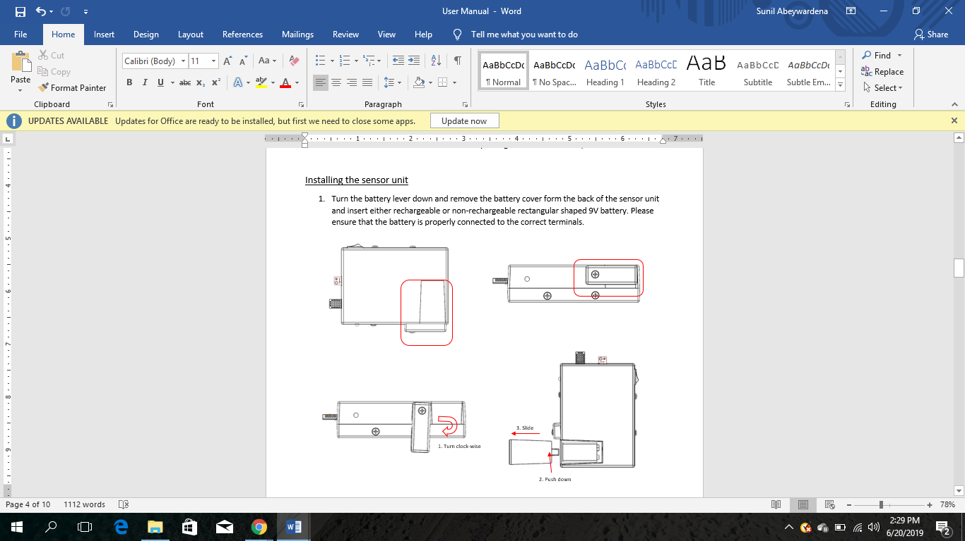

1. Slide the battery cover back into the place and turn the lever and lock the battery cover
2. When the battery voltage is above 6.8V, the green LED will be on
3. When the red LED turns on, need to replace the battery with a fully charged battery
4. No in-product battery charging capability is provided

## Installing the display unit

1. Turn the battery cover counter clock-wise in the back of the display unit and insert a rectangular 9V battery
2. Turn the battery cover clock wise into the place
3. When the battery voltage is above 6.8V, the green LED will be on
4. When the red LED is on, battery should be replaced with a fully charged battery
5. No in-product battery charging capability is provided

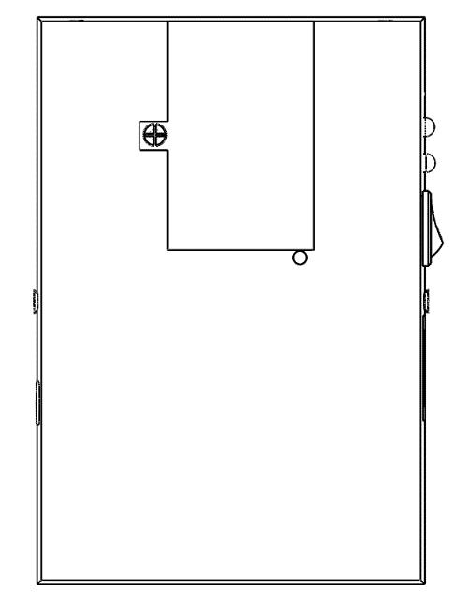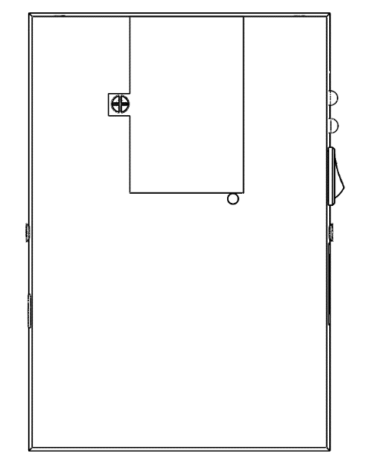

1. Turn counter clock-wise

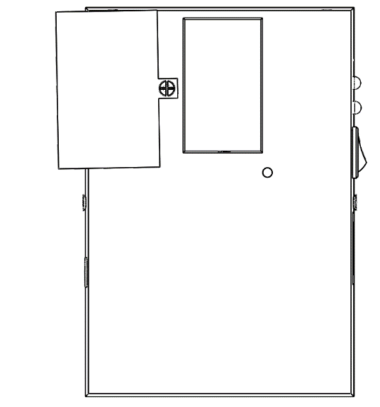

## Battery Performance

With the fully functions activated, a ***full-charged battery can last min. of 2 days***. When the LEDs change to red, should replace the battery. Otherwise the units will not be functioning as required.

Now the product is ready to measure the environment conditions and function at its full capacity.

# Getting to know your product

## Sensor Unit

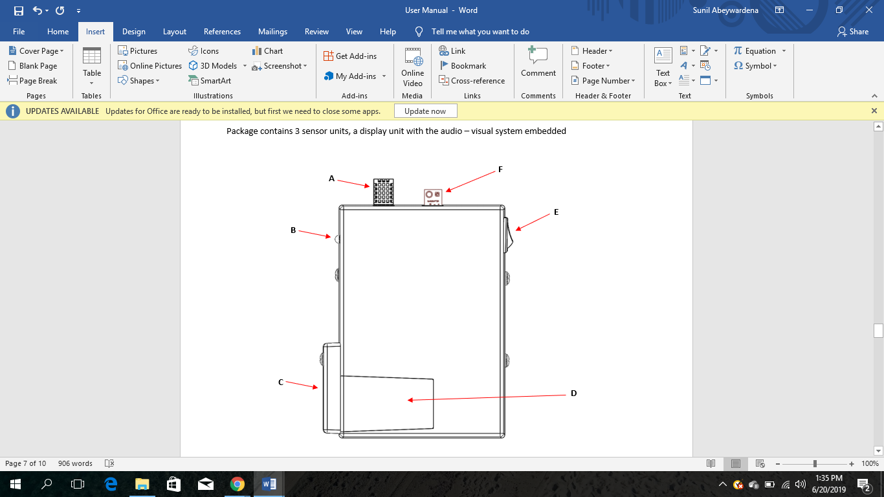

**A: RH and temperature sensor**

Measures the relative humidity of the air inside the environment you are monitoring and the temperature of it.

**B: Battery Level Indicator LEDs**

Green and red LEDs are set up here. Green LED is on when the battery voltage is higher than 6.8V and red when its lower than 6.8V. Both will be turned off when the battery level drops to 4V.

**C: Battery Lever**

**D: Battery Cover**

**E: Switch**

Turn on and off the entire sensor unit after the battery is being correctly installed as per section 1

**F: Light Intensity sensor**

This measures the light intensity inside the controlled environment.

Apart from these in-built parts of the sensor unit, the soil moisture sensor will be separately attached to the sensor unit through a connector.

## Display Unit

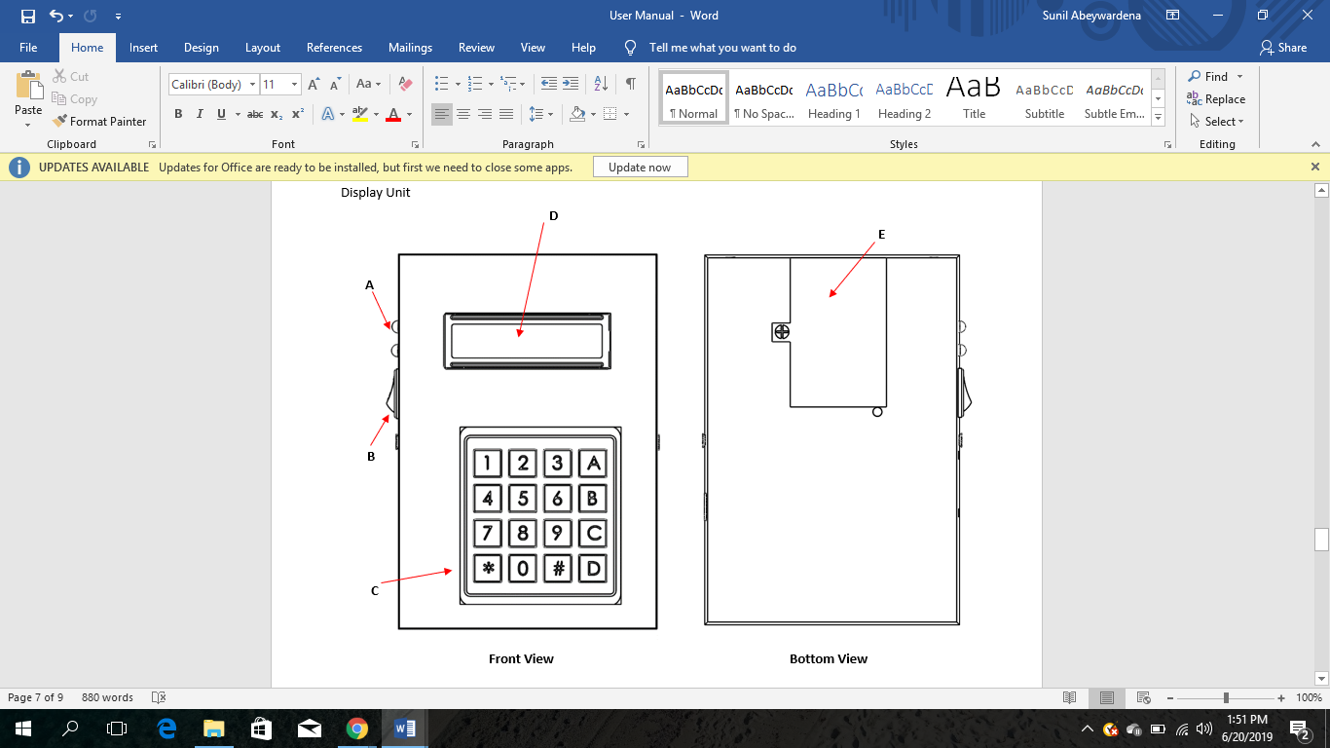

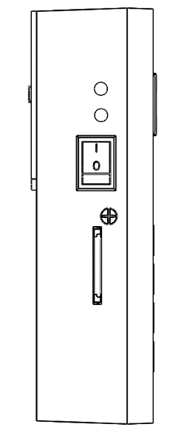

**A**

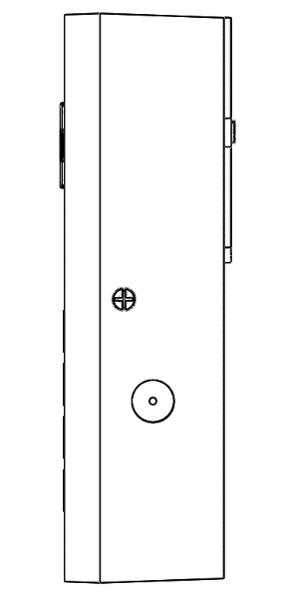

**B**

**G**

**F**

**A: Battery Level Indicator LEDs**

Green and red LEDs are set up here. Green LED is on when the battery voltage is higher than 6.8V and red when its lower than 6.8V. Both will be turned off when the battery level drops to 4V.

**B: Switch**

**C: Keypad**

Can be used to set the threshold values manually, to enter the inputs to display the environment condition values one by one on the LCD display and turn on the LCD screen

**D: LCD Screen**

Shows the requested values from the key pad.

**E: Battery Cover**

**F: Buzzer**

This is internally triggered to alarm the users that the conditions inside the controlled environment has gone to a undesired state

**G: Micro SD Card slot**

Use to insert the micro SD card through here and get the values saved.

# Using the product

## Sensor Unit

1. Switch the sensor unit on/off using the switch in the side of the sensor unit
2. Replace the battery when the red LED lights up
3. If the two LEDs are switched off first try replacing the battery. If it does not light up the Green LED, contact an agent from our company.

## Display Unit

1. Switch the display unit on/off using the switch on the side of the display unit
2. Setting the Thresholds

* Press any key to begin
* Select the Sensor (1,2 or 3)
* Select the reading for which the threshold needs to be changed
* Press A to set the limit
* Input the new limit
* Limit is set

1. Setting the Alarm On/Off

* Alarm On

There is no option given to set the alarm inside manually. It gets On once at least one of the environmental conditions exceed the set threshold values.

* Alarm Off

Once the alarm is triggered, it will keep on with some refreshing periods until the condition is being rectified or manually switching the alarm off. Once the alarm is set off, the unit will wait 1 min and check the condition inside the controlled environment and if the condition persists again the alarm will be triggered.

Press A to turn of the alarm.

Press B to change the threshold immediately (See above for instructions)

1. Getting the data on to the Micro SD card

Insert the Micro SD card to the Micro SD card slot

The values received from the sensor units will be written in the SD card periodically with a period of 10mins.

1. Displaying the values received on the LCD screen
   * Selecting the sensor unit out of the three sensor units connected

* Press any key to begin
* Select the Sensor (1,2 or 3)
  + Selecting the environmental condition to be displayed
* Select the corresponding number for the value

1: Temperature

2: Relative Humidity

3: Soil Moisture Level

4: Light

|  |
| --- |
| Group 1 |
| Controlled Environment Monitors |
| **Servicing** |

# Display Unit

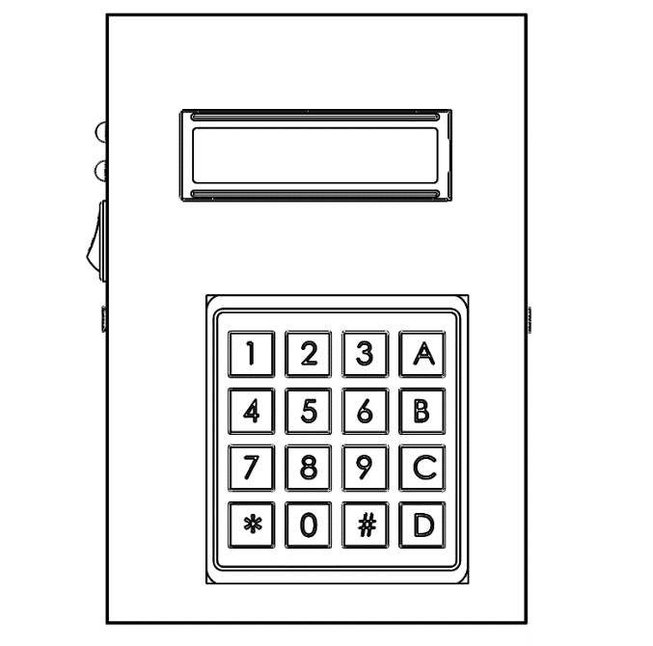

# Tools

* Clean non-marring work surface
* #2 Phillips screwdriver (magnetized)
* Needle nose pliers
* Soft cloth (to protect removed parts from scratches)
* Screw tray
* Razor knife
* Glue Gun
* Rubbing Alcohol and Cotton Swabs (for removing Hot glue)

# Warning

In this manual, graphics or photos are intended to help illustrate procedures or information only, and may show different levels of disassembly, board colours, configurations than your device.

# Disassembly and Repair

## Replacing the Battery

### Part Location

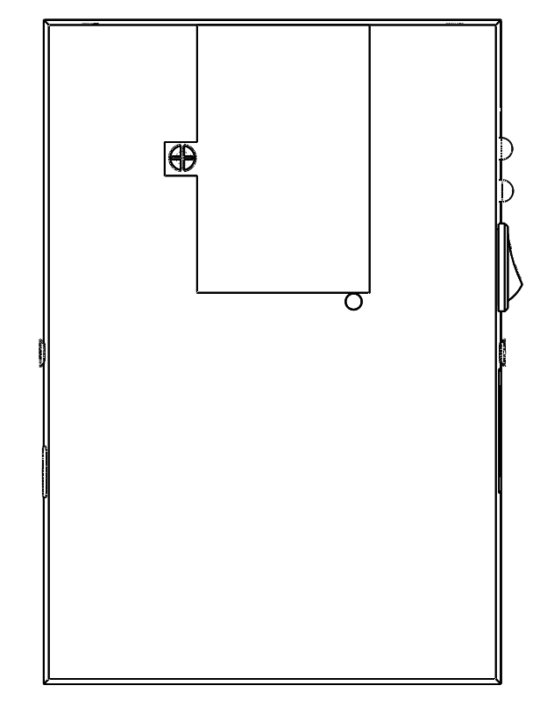

### Procedure

1. Turn off the Display unit
2. Place the Display unit with the LCD screen face down.
3. Rotate the battery cover

 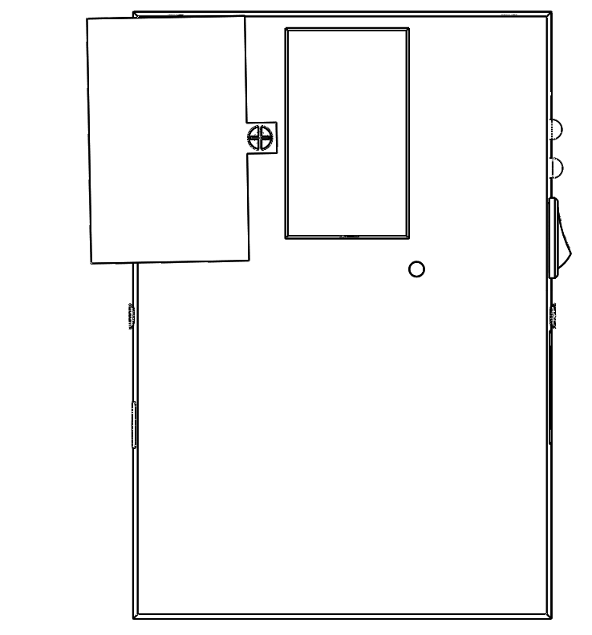

1. Disconnect the battery connector and remove the battery
2. Insert new battery (9V Alkaline recommended)

## Opening the Display Unit

1. Remove the Battery (see Replacing Battery)
2. Remove the screw on each side
3. Pry open* the top case by holding from the edges

*Warning: DO NOT pull apart the top cover without removing the connectors

1. Disconnect the Keypad connector and LCD connector from the PCB

## Closing the Display Unit

1. Connect the Keypad Connector and LCD connector
2. Align the Top cover and press down until it snaps
3. Insert the screws on each side.

## Replacing the LCD

### Part Location

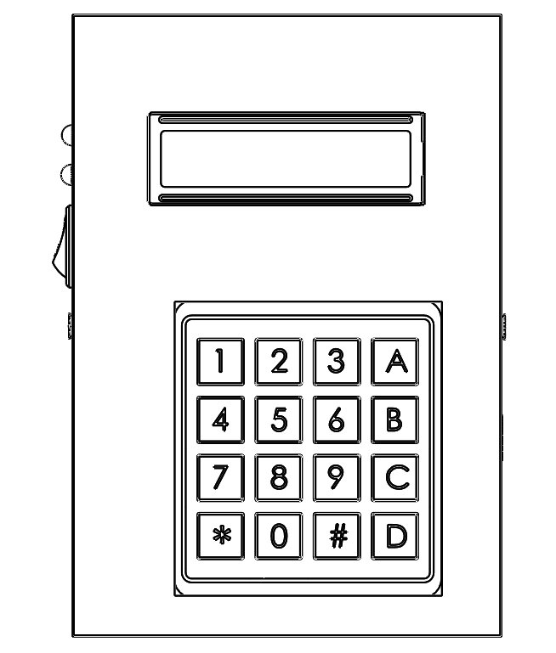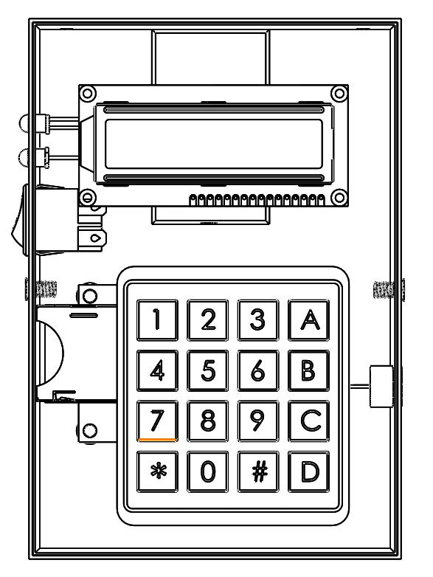

### Procedure

1. Open up the Display unit (See Opening the Display Unit)
2. Press firmly on the LCD and pop it out
3. Pop in the new display
4. Close the Display Unit (See Closing the Display Unit)

## Replacing the Keypad

### Part Location



### Procedure

1. Open up the Display unit (See Opening the Display Unit)
2. Use the Razor Knife to peel off the Keypad
3. Pull out the keypad and Ribbon
4. Insert the new keypad ribbon through the slot in the top cover
5. Apply Glue to the bottom of the keypad and paste it
6. Close the Display Unit (See Closing the Display Unit)

## Replacing the Buzzer

### Part Location

 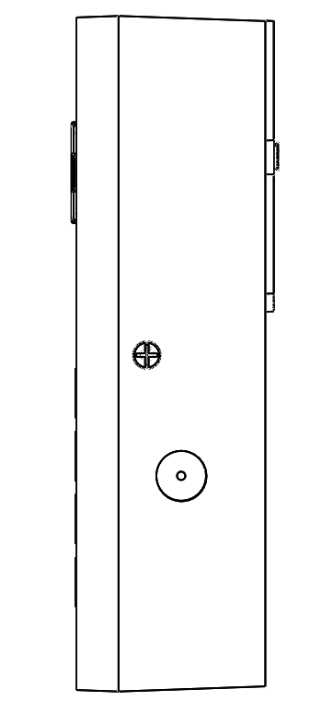 

### Procedure

1. Open up the Display unit (See Opening the Display Unit)
2. Disconnect the Buzzer connector
3. Press firmly on the Buzzer and pop it out
4. Pop in the new Buzzer
5. Reconnect the Buzzer connector
6. Close the Display Unit (See Closing the Display Unit)

## Replacing the SD Card Reader

### Part Location

 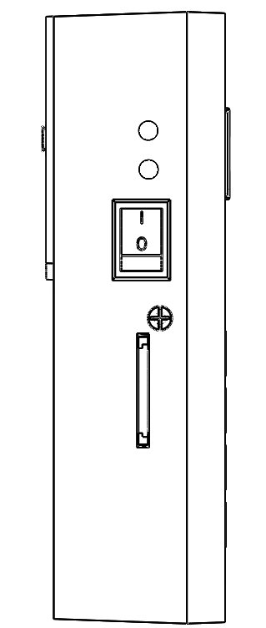 

### Procedure

1. Open up the Display unit (See Opening the Display Unit)
2. Disconnect the SD Card Reader connector
3. Use Rubbing Alcohol to remove the glue holding the SD Card Reader in place
4. Slide out the SD card reader
5. Slide in the New SD Card Reader
6. Use a Glue Gun to fix the new SD Card Reader in place
7. Reconnect the SD Card Reader connector
8. Close the Display Unit (See Closing the Display Unit)

## Replacing the Switch / LEDs

### Part Location

  

### Procedure

1. Open up the Display unit (See Opening the Display Unit)
2. Disconnect the Switch / LED connector
3. Press firmly on the Switch / LED and pop it out
4. Pop in the new Switch / LED
5. Reconnect the Switch / LED connector
6. Close the Display Unit (See Closing the Display Unit)

## Replacing Printed Circuit Board

### Part Location Procedure

1. Open up the Display unit (See Opening the Display Unit)
2. Disconnect the all connectors (SD Card Reader, LEDs, Buzzer, Switch )
3. Remove the 4 screws in the corners of the PCB
4. Pull out the PCB taking note of the orientation
5. Place new PCB in the correct orientation
6. Insert the screws and fix the PCB.
7. Reconnect all the connectors
8. Close the Display Unit (See Closing the Display Unit)

# Sensor Unit

# Parts and Procedures

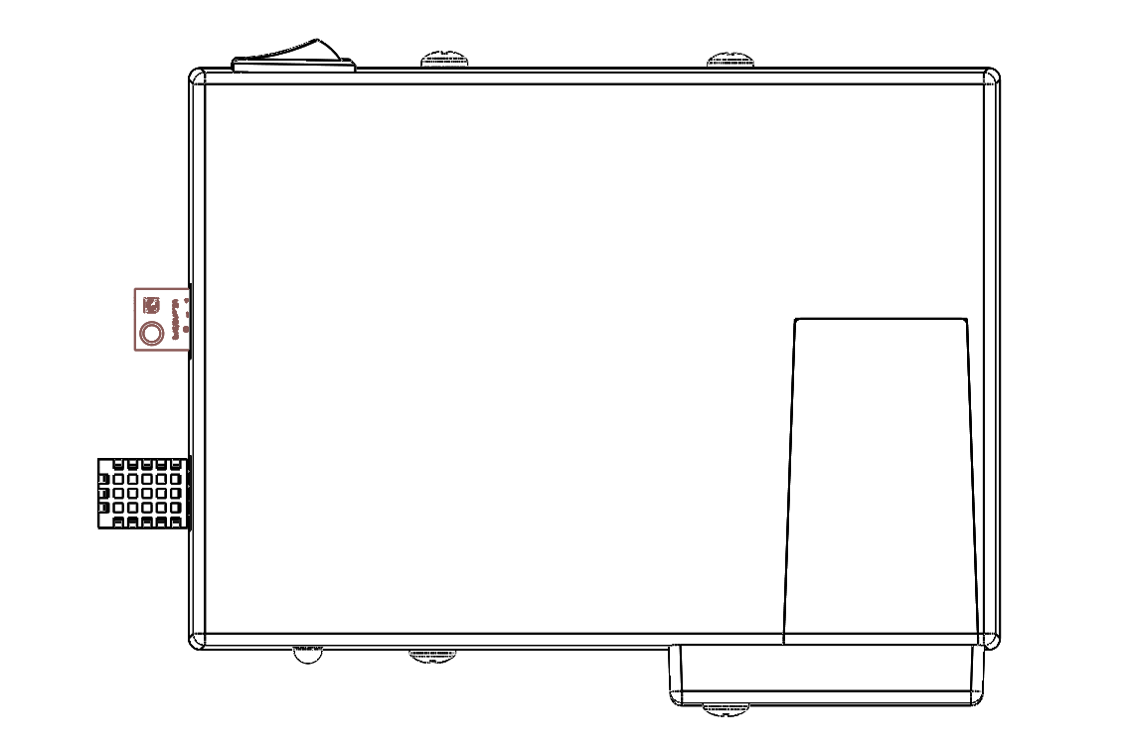

# Tools

* Clean non-marring work surface
* #2 Phillips screwdriver (magnetized)
* Needle nose pliers
* Soft cloth (to protect removed parts from scratches)
* Screw tray
* Putty knife (922-6761),1.5 inch (38 mm), flexible blade

# Warning

In this manual, graphics or photos are intended to help illustrate procedures or information only, and may show different levels of disassembly, board colors, configurations than your device.

# Disassembly and Repair

## Replacing the Battery

### Part Location

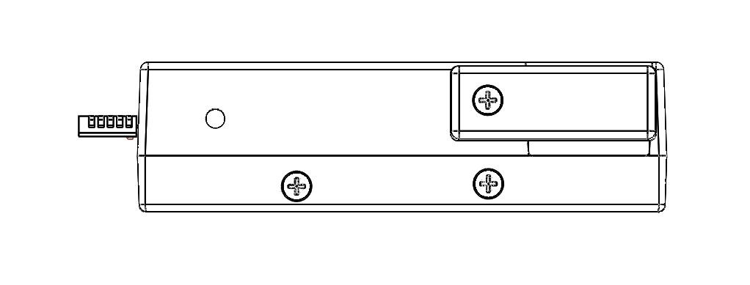

### Procedure

1. Turn off the Sensor unit
2. Place the Sensor unit on a side
3. Rotate the battery cover lock

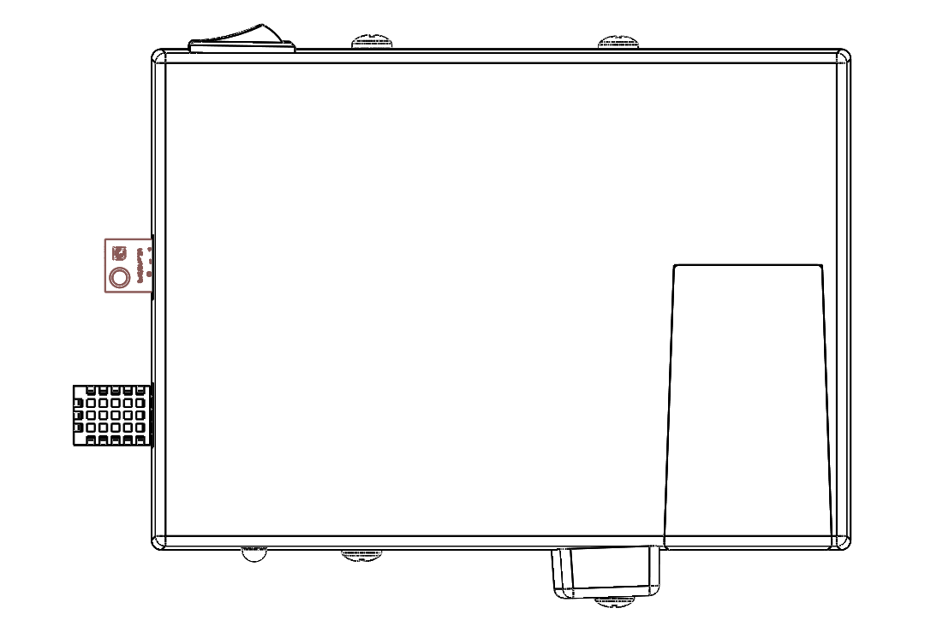 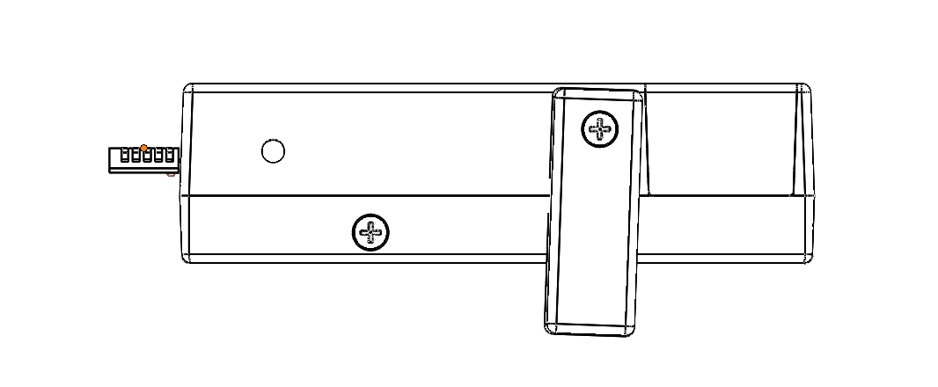

1. Slide the battery cover

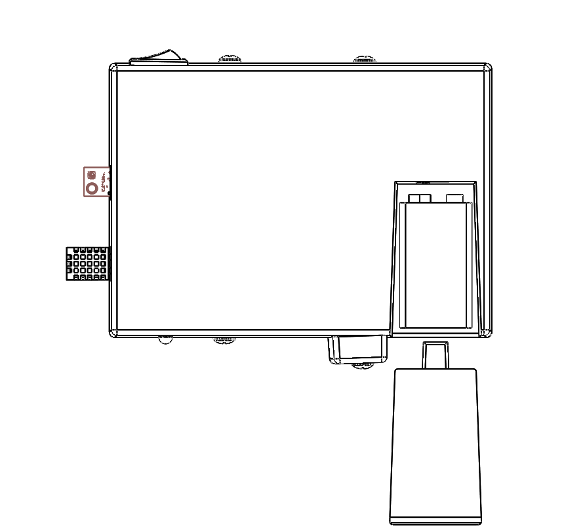

1. Disconnect the battery connector and take out the battery
2. Insert new battery
3. Slide in the battery cover and lock it in place by rotating the battery cover lock

## Accessing Internal Components

1. Remove the battery (See Replacing Battery)
2. Remove the 2 screws from each side
3. Pry open the top case by holding from the edges

## Replacing the Humidity Sensor / Light Sensor

### Part Location



Temperature and

Humidity Sensor

Light Sensor

### Procedure

1. Open up the Sensor unit (See Accessing Internal Components)
2. Disconnect the Humidity Sensor/ Light Sensor connector
3. Pull out the Humidity Sensor / Light Sensor
4. Insert the new Humidity Sensor / Light Sensor
5. Reconnect the sensor connector
6. Close the Sensor Unit (See Closing the Sensor Unit)

## Replacing the Switch / LED

### Part Location

Switch

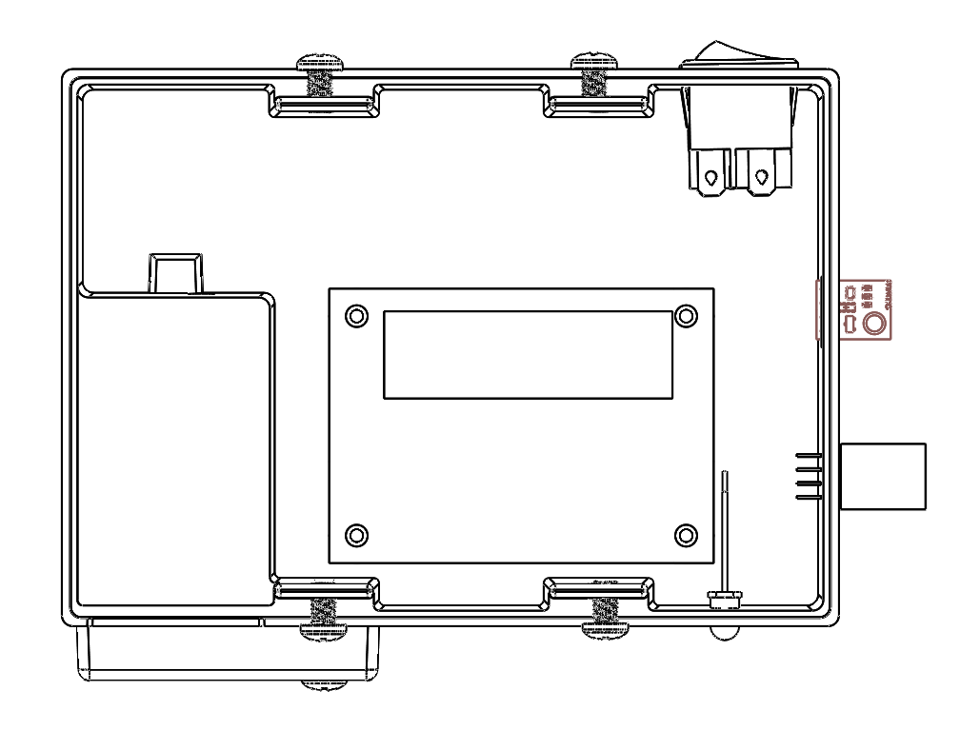

LED Battery Indicator

### Procedure

1. Open up the Sensor unit (See Accessing Internal Components)
2. Disconnect the Switch / LED connector
3. Press firmly on the Switch / LED and pop it out
4. Pop in the new Switch / LED
5. Reconnect the Switch / LED connector
6. Close the Sensor Unit (See Closing the Sensor Unit)

## Replacing Printed Circuit Board

### Part Location



### Procedure

1. Open up the Sensor unit (See Accessing Internal Components)
2. Disconnect the all connectors (Humidity Sensor, Light Sensor, LEDs, Switch)
3. Remove the 4 screws in the corners of the PCB
4. Pull out the PCB taking note of the orientation
5. Place new PCB in the correct orientation
6. Insert the screws and fix the PCB.
7. Reconnect all the connectors
8. Close the Sensor Unit (See Closing the Sensor Unit)

# Exploded Views



# Exploded View

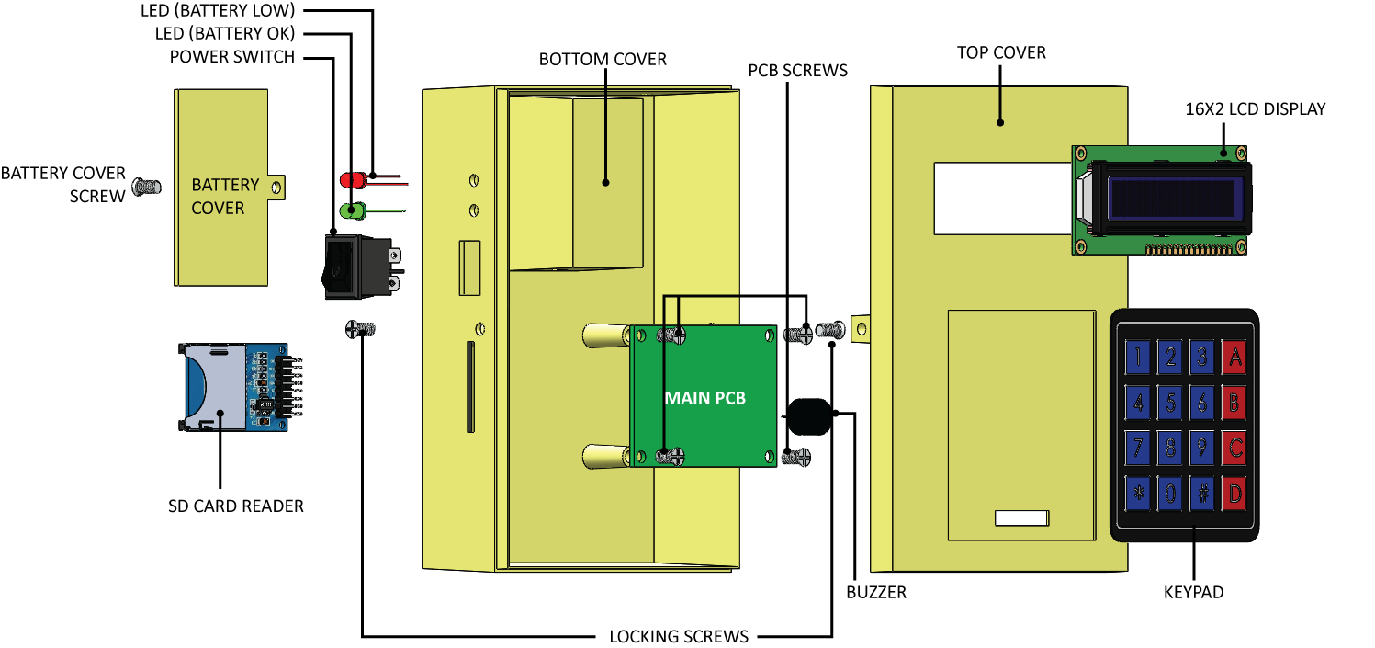

|  |
| --- |
| Group 1 |
| Controlled Environment Monitors |
| **Datasheets** |